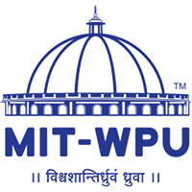**-**

**Mini Project Report**

On

**WATER QUALITY ANALYSIS USING MACHINE LEARNING**

Submitted by Group id 4

**Project Members**

1. Prerana Yadav: 1032222723
2. Vishal Nagare: 1032222694
3. Chamanpreet Kaur: 1032222787
4. Riya Kelkar: 1032222758

**Under the Guidance of**

**Prof. Pramod Mali**

**School of Computer Engineering and Technology MIT World Peace University, Kothrud,**

**Pune 411 038, Maharashtra - India**

**2024-2025**

Abstract

This report presents a comprehensive study on water quality analysis using machine learning techniques. The primary goal is to evaluate water quality parameters and determine potability using advanced algorithms such as Logistic Regression, Random Forest, Support Vector Machines (SVM), and XGBoost. The dataset encompasses crucial parameters including pH, hardness, total dissolved solids, chloramines, sulfates, conductivity, organic carbon, trihalomethanes, turbidity, and their implications on water safety. Extensive Exploratory Data Analysis (EDA) is performed to visualize correlations among features, revealing insights about their interdependencies. The study illustrates the effectiveness of various machine learning models in predicting water safety for human consumption, providing a foundation for future research and practical applications in environmental monitoring.

List of Figures

1.1 Overview…………………………………………….. 21.2 BlockDiagram……………………………………….. 18

1.3 UML Diagram................................................................ 18

1.3.1 Activity Diagram

1.3.2 Sequence Diagram

1.3.3 Use case Diagram

1.3.4 Collaboration Diagram

1.3.5 Class Diagram

List of Tables

|  |  |  |
| --- | --- | --- |
| 2.1 | Information ………………………………………… | 6 |
| 2.2 | Literature Survey…………………………… | 9 |

Contents

Abstract . . . . . . . . . . . . . . . . . . . . . . . . . . . . . . . . . . . . . . . . . . . . . . . . ……...I

List of Figures . . . . . . . . . . . . . . . . . . . . . . . . . . . . . . . . . . . . . . . . . . . . ….…II

List of Tables . . . . . . . . . . . . . . . . . . . . . . . . . . . . . . . . . . . . . . . . . ….. . .….III

|  |  |  |  |  |  |
| --- | --- | --- | --- | --- | --- |
| 1 | Introduction | | | 6 | |
|  |  | 1.1 Background and importance | | 6 | |
|  |  | 1.2 Objective of the study | | 6 | |
|  |  | 1.3 Methodology | | 6 | |
|  |  | 1.4 Expected Outcomes | | 7 | |
| 2 | Literature Survey | | | 8 | |
|  |  | 2.1 Overview of Water Quality Issues | | 10 | |
|  |  | 2.2 Machine learning approaches | | 10 | |
|  |  | 2.3 Feature selection and extraction | | 10 | |
|  |  | 2.4 Dataset and preprocessing | | 11 | |
|  |  | 2.5 Model evaluation metrics | | 11 | |
| 3 | Problem Statement | | | 12 | |
|  |  | 3.1 Project Scope | | 12 | |
|  |  | 3.2 Project Objectives | | 12 | |
| 4 | Project Requirements | | | 13 | |
|  |  | 4.1 Data Requirements | | 13 | |
|  |  | 4. 2 Technical Requirements |  | 13 |
|  |  | 4.3 Performance Requirements |  | 13 |
| 5 | Implementation | | | 14 | |
| 6 | Result & Discussions | | | 22 | |
| 7 | Conclusion | | | 26 | |
| 8 | References | | | 27 | |

Chapter 1 Introduction

* 1. **Background and Importance**

Water quality is paramount to public health and environmental sustainability. Contaminated water can lead to severe health issues such as gastrointestinal diseases, neurological disorders, and other chronic conditions. According to the World Health Organization (WHO), approximately 2 billion people globally lack access to safe drinking water, underscoring the need for effective water quality monitoring and management. Traditional methods of testing water quality can be time-consuming and labour-intensive, prompting a shift toward more efficient techniques such as machine learning.

Machine learning provides a powerful framework for analyzing large datasets and uncovering patterns that may not be immediately apparent. By employing machine learning algorithms, researchers can automate the process of assessing water quality parameters, leading to quicker and more accurate predictions regarding the potability of water.

* 1. **Objective of the Study**

The primary objective of this study is to analyse water quality using various machine learning techniques to predict the potability of water based on key parameters. The specific aims include:

1. **Identifying Critical Parameters:** To identify and analyze water quality parameters that significantly influence potability, providing insights into the main factors affecting water safety.
2. **Model Implementation:** To implement multiple machine learning algorithms, including Logistic Regression, Random Forest, Support Vector Machines (SVM), and XGBoost, evaluating their effectiveness in predicting water safety based on the identified parameters.
3. **Exploratory Data Analysis (EDA):** To conduct a thorough exploratory data analysis to visualize correlations among different parameters and their impact on water quality, thus enhancing understanding of the dataset.
   1. **Methodology**

The methodology for this study consists of several sequential steps:

1. **Data Collection:** Reliable datasets containing water quality parameters are collected from trusted sources such as governmental and environmental organizations. The dataset includes parameters such as pH, hardness, total dissolved solids, chloramines, sulfates, conductivity, organic carbon, trihalomethanes, turbidity, and a binary indicator of potability.
2. **Exploratory Data Analysis (EDA):** EDA is performed to explore the dataset visually and statistically. Key visualizations include:
   * **Histograms:** To understand the distribution of individual parameters, identifying normality or skewness.
   * **Box Plots:** To identify outliers and visualize the spread of data across various parameters.
   * **Correlation Matrix:** To evaluate the relationships between different parameters and their impact on potability, revealing underlying patterns and interactions.
3. **Data Preprocessing:** The dataset undergoes preprocessing, which includes:
   * **Handling Missing Values:** Utilizing imputation techniques to fill in missing data or removing records with excessive missingness to ensure dataset integrity.
   * **Encoding Categorical Variables:** Converting categorical variables into numerical formats using techniques like one-hot encoding to prepare the data for machine learning algorithms.
   * **Normalization or Standardization:** Applying normalization or standardization techniques to numerical features, ensuring consistent scaling and improving model performance.
4. **Model Development:** Multiple machine learning models are developed and trained using the processed data:
   * **Logistic Regression:** Serves as a baseline model for binary classification of water potability, establishing a foundational accuracy benchmark.
   * **Random Forest:** An ensemble method that improves prediction accuracy by combining multiple decision trees, enhancing robustness against overfitting.
   * **Support Vector Machines (SVM):** Utilized for its effectiveness in high-dimensional spaces, especially when dealing with a limited number of samples.
   * **XGBoost:** Known for its speed and performance, particularly on structured data, making it a suitable choice for complex datasets.
5. **Model Evaluation:** Each model is evaluated using metrics such as accuracy, precision, recall, and F1-score. Cross-validation techniques are employed to ensure the robustness of the models and prevent overfitting.
   1. **Expected Outcomes**

The anticipated outcomes of this study include:

1. **Understanding Parameter Relationships:** A comprehensive understanding of how different water quality parameters correlate with potability, identifying key indicators of safe drinking water.
2. **Model Performance Evaluation:** A comparative analysis of the performance of various machine learning models, highlighting the most effective algorithms for predicting water safety.
3. **Actionable Insights:** Insights that can aid policymakers and environmental agencies in improving water quality management practices, providing evidence-based recommendations for intervention.

Chapter 2 Literature Survey

|  |  |  |  |  |  |
| --- | --- | --- | --- | --- | --- |
| Authors | Paper title | Publication year | Key focus | Methods | Approaches |
| Qingjia Meng, Xinghan Xu, Xiang Zhao | A Comprehensive Review of Machine Learning for Water Quality Prediction  [1] | 2024 | Review of over 170 studies on ML algorithms used in water quality prediction. | Neural networks, random forests, support vector machines (SVM) | Focuses on single and multi-indicator predictions and water quality index (WQI) prediction, highlighting trends in ML application for water quality​ |
| IWA Publishing (Various Authors) | Drinking Water Potability Prediction Using Machine Learning Approaches  [2] | 2022 | Predicting potability of Indian river water using regression and neural networks (ANNs). | Regression models, artificial neural networks (ANNs) | Predicts water potability based on water quality index (WQI) parameters, leveraging regression for initial assessment and classification​ |
| PLOS Water (Various Authors) | Optimizing ML for Water Safety: Comparative Analysis for Potability Prediction  [3] | 2023 | Focus on dimensionality reduction techniques to improve potability prediction accuracy. | Principal Component Analysis (PCA), support vector machines (SVM), k-nearest neighbors (KNN), decision trees | Applied dimensionality reduction (PCA) to improve classifier accuracy for water potability, enhancing prediction by reducing data dimensionality​ |
| MDPI (Various Authors) | An IoT Real-Time Potable Water Quality Monitoring and Prediction Model  [4] | 2023 | IoT-based real-time water quality monitoring using cloud computing and sensor technology. | IoT sensors (pH, TDS, DO), cloud computing, machine learning algorithms | Real-time monitoring with IoT sensors and cloud-based machine learning to predict water quality and potability, optimizing sensor data streams​ |
| Hassan et al. | Machine Learning for Water Quality Monitoring: A Case Study in Indian Rivers  [5] | 2020 | Application of PCA and regression models to predict water potability. | Principal Component Analysis (PCA), regression methods | Combined PCA and regression to enhance potability predictions, focusing on Indian river water quality parameters​ |
| Adeyemi et al. | Comparative Study on Water Quality Using Machine Learning Algorithms  [6] | 2019 | Analysis of chemical impacts on water and prediction using ML techniques. | Random forests, regression analysis | Focused on chemical contamination's effect on water, using ML techniques to classify and predict water quality​ |

**Qingjia Meng, Xinghan Xu, Xiang Zhao – "A Comprehensive Review of Machine Learning for Water Quality Prediction" (2024)**   
This review explores over 170 studies on the application of machine learning algorithms in water quality prediction. The paper highlights the use of neural networks, random forests, and support vector machines (SVM) for predicting water quality based on various indicators. It examines both single-indicator and multi-indicator prediction models and discusses the development of water quality indices (WQI). The paper emphasizes the increasing importance of machine learning in accurately predicting water quality trends, showcasing the growing role of AI in environmental monitoring.

**IWA Publishing (Various Authors) – "Drinking Water Potability Prediction Using Machine Learning Approaches" (2022)**   
This study focuses on predicting the potability of water from Indian rivers using machine learning models, specifically regression and artificial neural networks (ANNs). The research analyzes water quality index (WQI) parameters and leverages regression for an initial assessment, followed by the application of ANNs for classification. The approach provides valuable insights into predicting potability based on key water quality indicators and offers a robust solution for water quality prediction in regions with fluctuating water quality.

**PLOS Water (Various Authors) – "Optimizing ML for Water Safety: Comparative Analysis for Potability Prediction" (2023)**   
This paper examines the role of dimensionality reduction in improving machine learning models for water potability prediction. Principal Component Analysis (PCA) is used alongside classifiers like SVM, k-nearest neighbors (KNN), and decision trees. By reducing the dimensionality of water quality data, the authors show significant improvements in classification accuracy. The paper highlights the importance of feature selection in optimizing machine learning performance for water safety assessments.

**MDPI (Various Authors) – "An IoT Real-Time Potable Water Quality Monitoring and Prediction Model" (2023)**   
This study presents an IoT-based model for real-time water quality monitoring and potability prediction. It utilizes IoT sensors to measure parameters such as pH, total dissolved solids (TDS), and dissolved oxygen (DO), and processes the data using machine learning algorithms on cloud computing platforms. The paper emphasizes the efficiency of IoT technology in providing continuous, real-time insights into water quality, and demonstrates how sensor data streams can be used to predict potability using cloud-based ML models.

**Hassan et al. – "Machine Learning for Water Quality Monitoring: A Case Study in Indian Rivers" (2020)**   
This paper applies Principal Component Analysis (PCA) and regression models to predict the potability of river water in India. By focusing on dimensionality reduction through PCA, the study improves the efficiency of regression models used for water quality prediction. The authors emphasize the applicability of these models in regions with complex water quality parameters, demonstrating a practical approach for improving potability predictions in river water monitoring.

**Adeyemi et al. – "Comparative Study on Water Quality Using Machine Learning Algorithms" (2019)**  
This research investigates the impact of chemical contamination on water quality and explores machine learning techniques, including random forests and regression analysis, to predict and classify water quality. The study focuses on how chemical parameters, such as contaminants and pollutants, influence the quality of water and demonstrates the effectiveness of machine learning algorithms in handling complex datasets for water quality assessment.

**2.1 Overview of Water Quality Issues**

Water quality issues are multifaceted, influenced by both natural and anthropogenic factors. Common contaminants include pathogens, heavy metals, and chemical pollutants, each presenting unique risks to human health and ecosystems. Traditional water testing methods often fail to provide timely results, highlighting the need for innovative approaches. The advent of machine learning offers a promising avenue for automating these assessments, enabling quicker response times and better resource allocation in water management.

**2.2 Machine Learning Approaches**

Recent advancements in machine learning have demonstrated its potential in environmental science. Algorithms can analyze complex datasets, revealing patterns and relationships that traditional statistical methods may overlook. Studies have shown that machine learning models can effectively classify water quality and predict potability, making them invaluable tools for water resource management. Furthermore, the adaptability of machine learning algorithms allows for continuous learning and improvement as new data becomes available.

**2.3 Feature Selection and Extraction**

Feature selection plays a crucial role in model performance. Techniques such as correlation analysis and recursive feature elimination help identify the most relevant parameters affecting water quality. Reducing the feature space not only enhances model interpretability but also decreases the computational cost, ensuring that models are both efficient and effective.

**2.4 Dataset and Preprocessing**

Datasets used for water quality analysis often come from various sources, necessitating rigorous preprocessing. Ensuring data quality involves addressing missing values, outliers, and inconsistencies. Proper preprocessing enhances the reliability of machine learning models, laying the groundwork for accurate predictions. Techniques such as data augmentation may also be employed to enhance dataset diversity, ensuring robustness in model training.

**2.5 Model Evaluation Metrics**

Common evaluation metrics for classification tasks include accuracy, precision, recall, and F1-score. These metrics provide a holistic view of model performance, helping to identify strengths and weaknesses. The confusion matrix is particularly useful for understanding misclassifications, allowing for targeted improvements in model training.

Chapter 3 Problem Statement

**3.1 Problem Statement**

Water quality assessment traditionally relies on manual testing methods, which are often time-consuming and prone to errors. This study aims to bridge this gap by leveraging machine learning to automate water quality analysis, enabling rapid and accurate assessments of potability. The focus will be on integrating data-driven insights into practical applications for environmental monitoring and public health safety.

**3.2 Project Scope**

The project focuses on analyzing water quality parameters and their influence on potability using machine learning techniques. The scope includes data collection, preprocessing, model development, and evaluation, ultimately providing actionable insights for water management. The study also aims to facilitate the adoption of machine learning in environmental sciences, showcasing its potential for real-world applications.

**3.3 Project Objectives**

1. **To identify and analyze critical water quality parameters** that significantly influence potability, providing insights into the main factors affecting water safety.
2. **To implement and compare multiple machine learning algorithms**—including Logistic Regression, Random Forest, Support Vector Machines (SVM), and XGBoost—evaluating their effectiveness in predicting water safety based on the identified parameters.
3. **To conduct a thorough exploratory data analysis (EDA)** to visualize correlations among different water quality parameters and their impact on potability, enhancing understanding of the dataset.
4. **To preprocess the dataset effectively,** ensuring data quality and integrity through methods such as handling missing values, encoding categorical variables, and normalizing numerical features.
5. **To evaluate the performance of each machine learning model** using metrics such as accuracy, precision, recall, and F1-score, identifying the most effective algorithm for predicting water potability.

Chapter 4 Project Requirements

**4.1 Data Requirements**

The dataset[7] for this project comprises various water quality parameters, ideally sourced from governmental databases or environmental organizations. Key attributes include:

1. **pH:** A measure of acidity or alkalinity, essential for determining water safety.
2. **Hardness:** The concentration of calcium and magnesium, affecting water quality.
3. **Total Dissolved Solids (TDS):** Indicates the total concentration of dissolved substances.
4. **Chloramines:** Used as a disinfectant, with potential health impacts at elevated levels.
5. **Sulfates:** Can contribute to water hardness and affect taste.
6. **Conductivity:** Reflects the ionic content of water, influencing potability.
7. **Organic Carbon:** Indicates the presence of organic matter, impacting water quality.
8. **Trihalomethanes:** Byproducts of water disinfection, linked to health risks.
9. **Turbidity:** A measure of water clarity, which can indicate contamination.

**4.2 Technical Requirements**

The project will require:

1. **Software Tools:** Python[8] will be utilized for data manipulation and model development, supported by libraries such as Pandas, NumPy, Scikit-learn, and XGBoost.
2. **Development Environment:** Jupyter Notebook[9] will serve as the primary environment for code development and visualization.
3. **Hardware:** A computer system with a minimum of 8GB RAM and a modern CPU to handle data processing and model training efficiently.

**4.3 Performance Requirements**

Models will be evaluated based on accuracy, precision, recall, and F1-score. The goal is to achieve a minimum accuracy threshold of 90% for effective classification of potability. The following performance metrics will be monitored:

1. **Accuracy:** The proportion of correctly identified instances out of the total.
2. **Precision:** The ratio of true positive predictions to the total positive predictions, reflecting the quality of the positive class.
3. **Recall (Sensitivity):** The ratio of true positive predictions to the total actual positives, indicating the model's ability to identify positive instances.
4. **F1-Score:** The harmonic mean of precision and recall, providing a balance between the two metrics.

Chapter 5 Implementation

The implementation phase consists of executing the steps outlined in the methodology, focusing on data preprocessing, model training, and evaluation. Detailed coding examples will illustrate the development process, ensuring clarity in the implementation of each algorithm.

**5.1 Data Loading and Preprocessing**

1. **Loading the Dataset:**
   * The dataset is loaded using the Pandas library, allowing for easy manipulation and exploration.
   * Initial exploration includes checking for data types, summary statistics, and unique values.
2. **Handling Missing Values:**
   * Missing values are identified using methods like .isnull() and .sum().
   * Imputation techniques, such as mean or median substitution for numerical features and mode for categorical features, are employed to fill gaps, ensuring dataset integrity.
3. **Encoding Categorical Variables:**
   * Categorical variables are encoded using one-hot encoding, transforming them into a numerical format suitable for machine learning models.
   * The pd.get_dummies() function is employed to create dummy variables for each category.
4. **Normalization or Standardization:**
   * Numerical features are normalized or standardized to ensure they have comparable scales. This process improves model convergence during training, especially for algorithms sensitive to feature scaling.

**5.2 Model Training**

1. **Train-Test Split:**
   * The dataset is split into training and testing subsets using the train_test_split function from Scikit-learn, with a typical split ratio of 80% training and 20% testing.
2. **Training Various Models:**
   * **Logistic Regression:** Implemented using Scikit-learn's LogisticRegression() class. The model is fitted to the training data, and initial predictions are made on the test set.
   * **Random Forest:** The RandomForestClassifier() is employed, utilizing multiple decision trees to improve accuracy. Hyperparameters such as the number of trees and maximum depth are tuned for optimal performance.
   * **Support Vector Machines (SVM):** The SVC() class from Scikit-learn is used, with kernel options explored to enhance performance. The model is trained on the feature set, focusing on maximizing the margin between classes.
   * **XGBoost:** The XGBClassifier() from the XGBoost library is used for its speed and efficiency. Hyperparameter tuning is conducted to optimize model performance, leveraging features like learning rate and tree depth.

**5.3 Evaluation**

1. **Cross-Validation:**
   * Cross-validation techniques, such as k-fold cross-validation, are employed to assess model performance reliably. This technique divides the dataset into k subsets, training and validating the model k times to ensure robustness.
2. **Performance Metrics:**
   * Various evaluation metrics, including accuracy, precision, recall, and F1-score, are calculated using Scikit-learn's classification_report(). The performance of each model is documented and compared.
3. **Visualization of Results:**
   * Model performance is visualized through ROC curves and confusion matrices using Matplotlib and Seaborn libraries. These visualizations aid in understanding model strengths and areas for improvement.

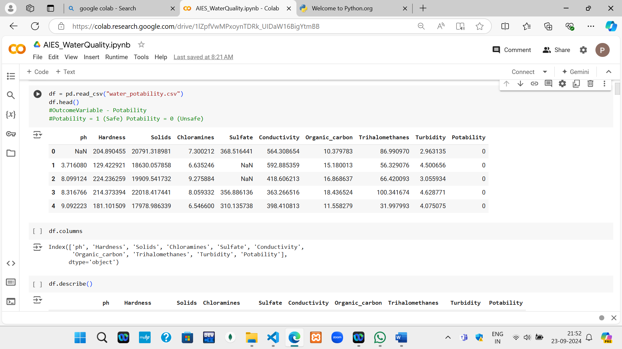

The code reads a CSV file called water_potability.csv into a Pandas DataFrame (df) and displays the first five rows using df.head(). The comment indicates that the target variable, Potability, represents whether the water is safe to drink (1) or unsafe (0). The df.columns command is used to list the column names in the dataset, providing a quick overview of the features available for analysis.

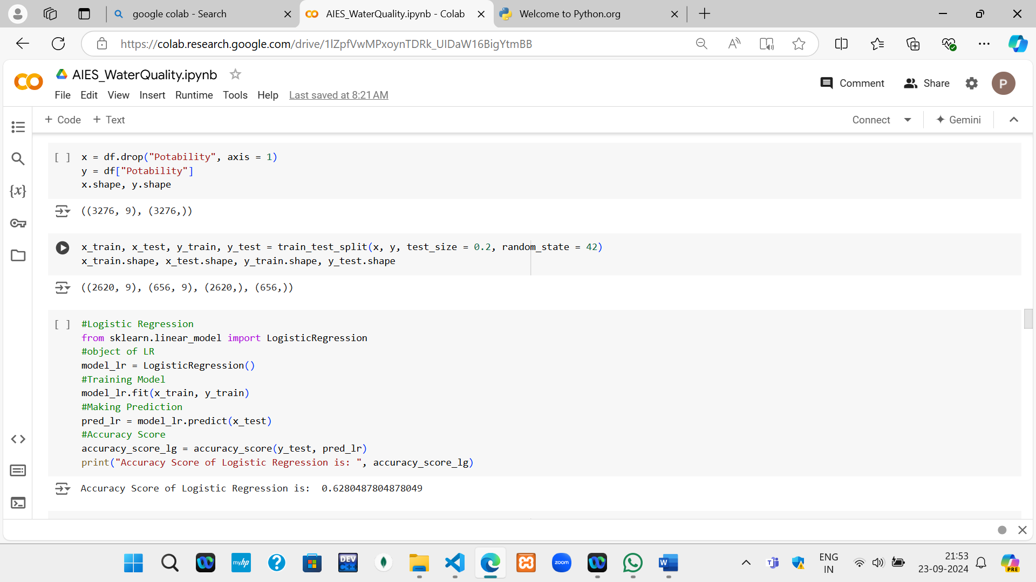

The code separates the features (x) from the target (y) by dropping the "Potability" column. A logistic regression model is created using LogisticRegression(), trained on x_train and y_train with fit(), and used to predict y_test with predict(). The accuracy of the model is calculated using accuracy_score() and printed.

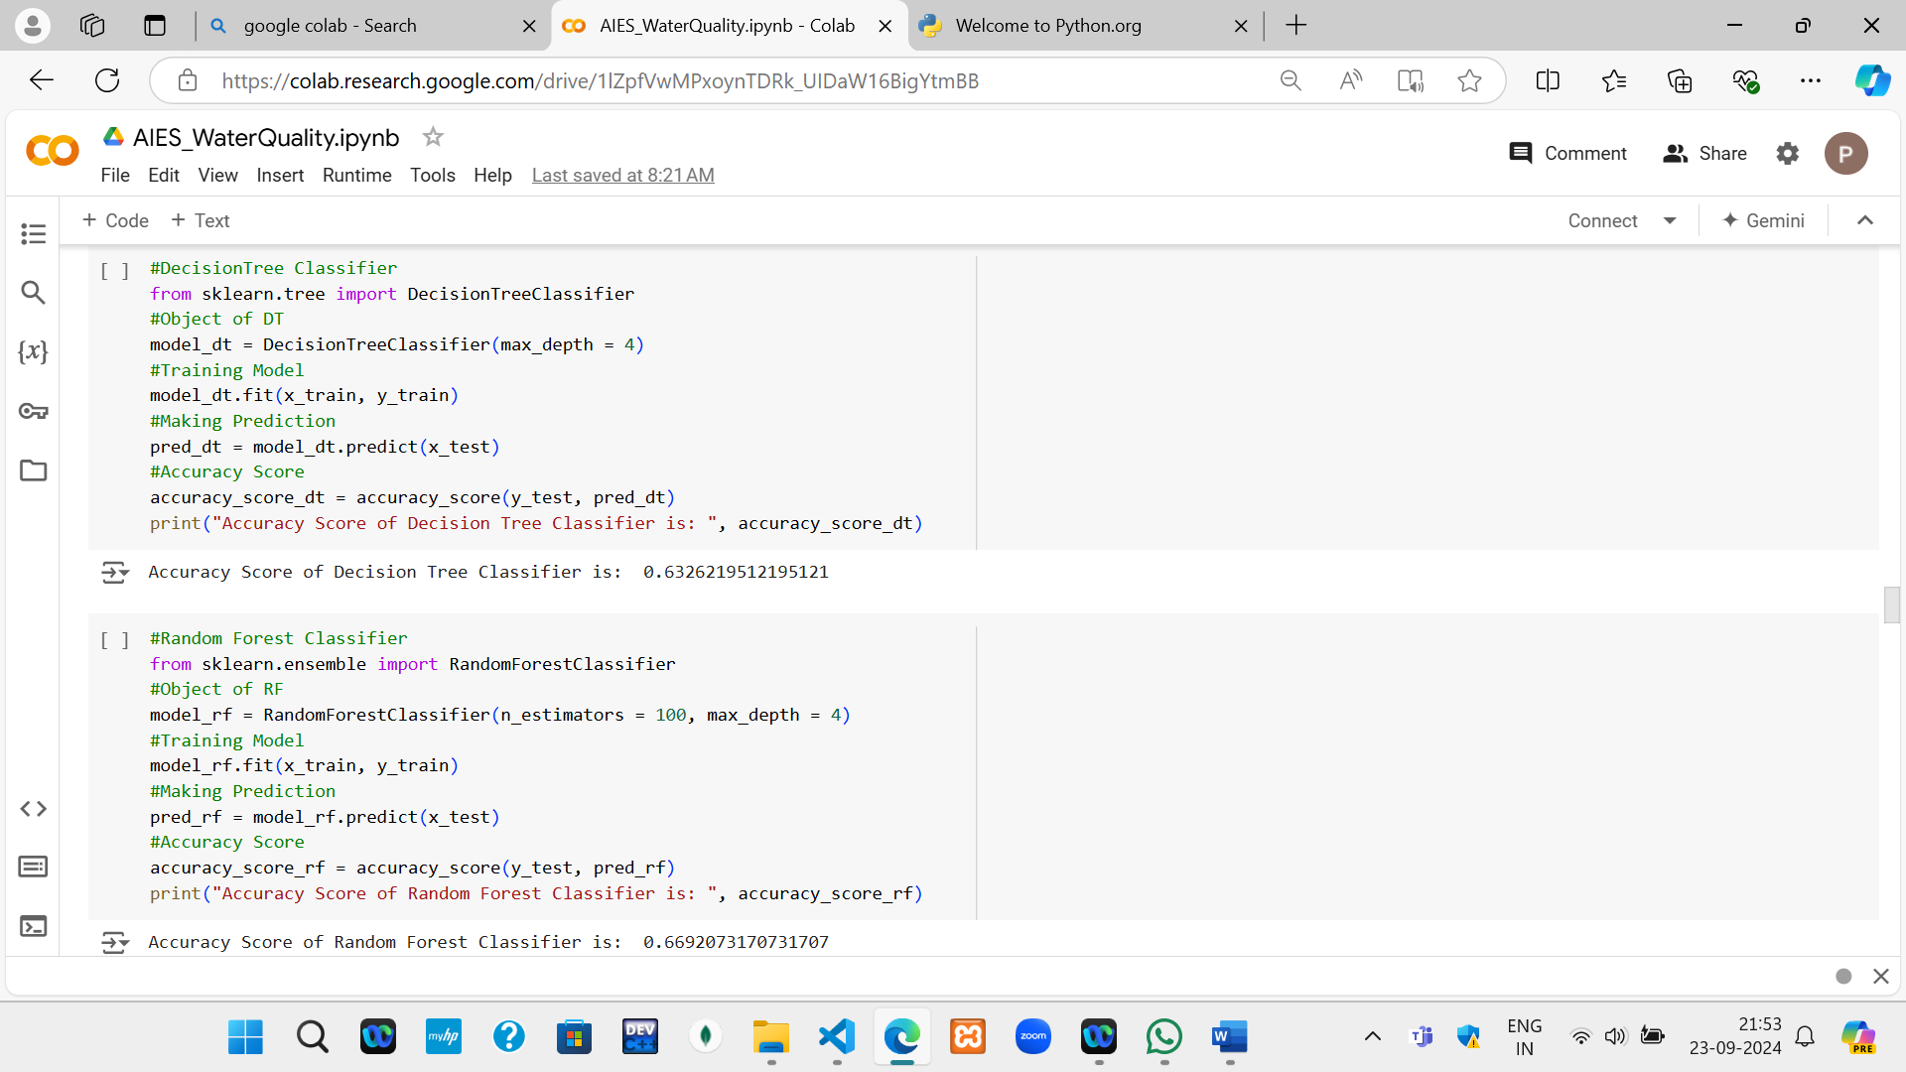

The code snippet implements a Decision Tree Classifier for the water potability dataset. It starts by creating an instance of DecisionTreeClassifier with a maximum depth of 4, which helps prevent overfitting.

Similarly, it implements a Random Forest Classifier for the water potability dataset. It begins by creating an instance of RandomForestClassifier with 100 trees (n_estimators = 100) and a maximum depth of 4 to manage model complexity.

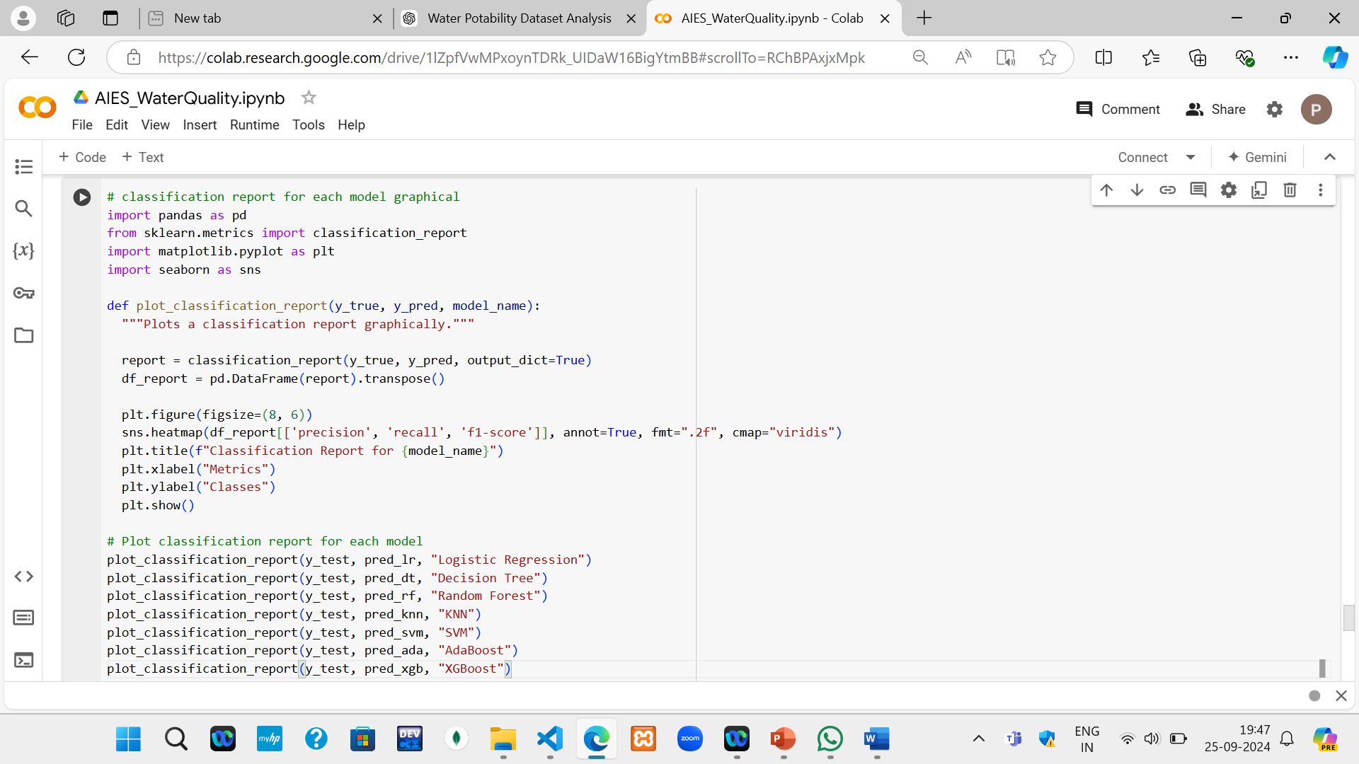

This code snippet generates graphical classification reports for various machine learning models applied to the water potability dataset. It imports necessary libraries, including pandas, sklearn.metrics, matplotlib, and seaborn. The function plot_classification_report takes the true labels (y_true), predicted labels (y_pred), and the model name (model_name) as inputs.

It computes the classification report using classification_report() and converts it to a DataFrame for visualization. A heatmap is created to display the precision, recall, and F1-score for each class using seaborn's heatmap() function.

Finally, the function is called for each model—Logistic Regression, Decision Tree, Random Forest, KNN, SVM, AdaBoost, and XGBoost—to visualize their performance metrics.

**USE CASE DIAGRAM**

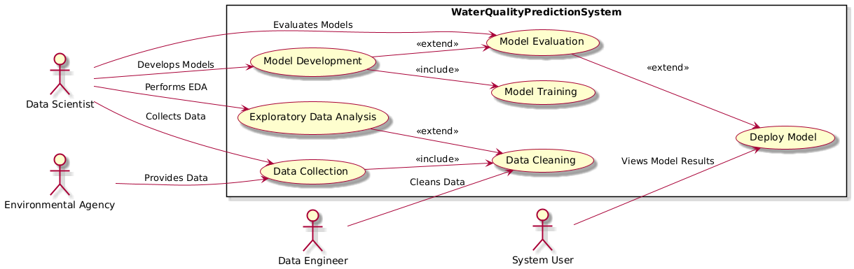

**CLASS DIAGRAM**

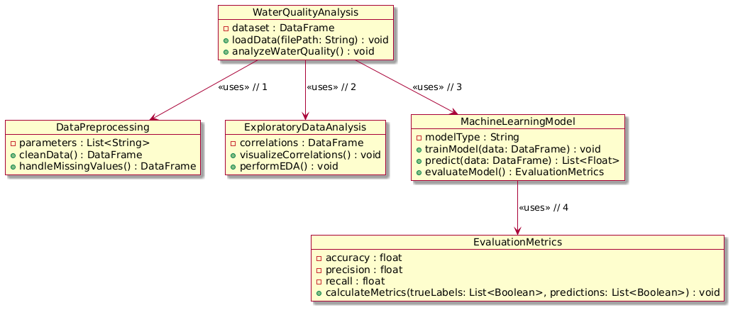

**SEQUENCE DIAGRAM**

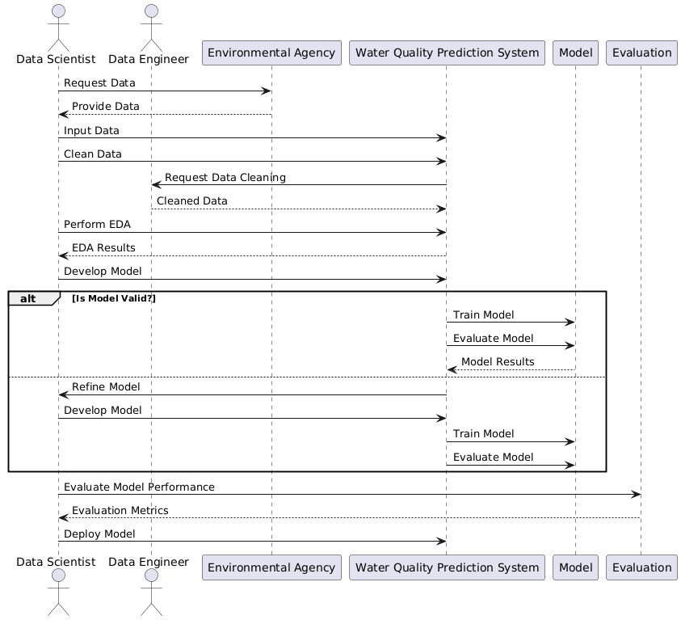

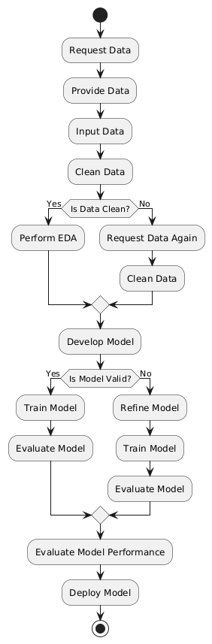

**ACTIVITY DIAGRAM**

**COLLABORATION DIAGRAM**

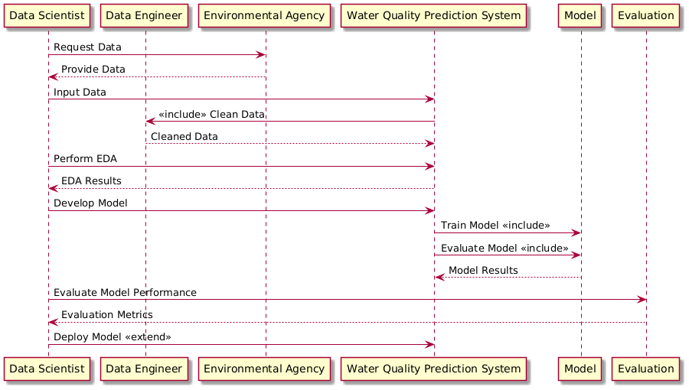

Chapter 6 Results and Discussion

**CORRELATION -** The output is a heatmap that displays the correlation coefficients between the numeric columns of the DataFrame df. Each cell in the heatmap is color-coded to indicate the strength and direction of the correlations, with values ranging from -1 to 1. The cells also display the actual correlation coefficient values, allowing for easy interpretation of the relationships between features. Darker colors represent stronger correlations, either positive or negative.

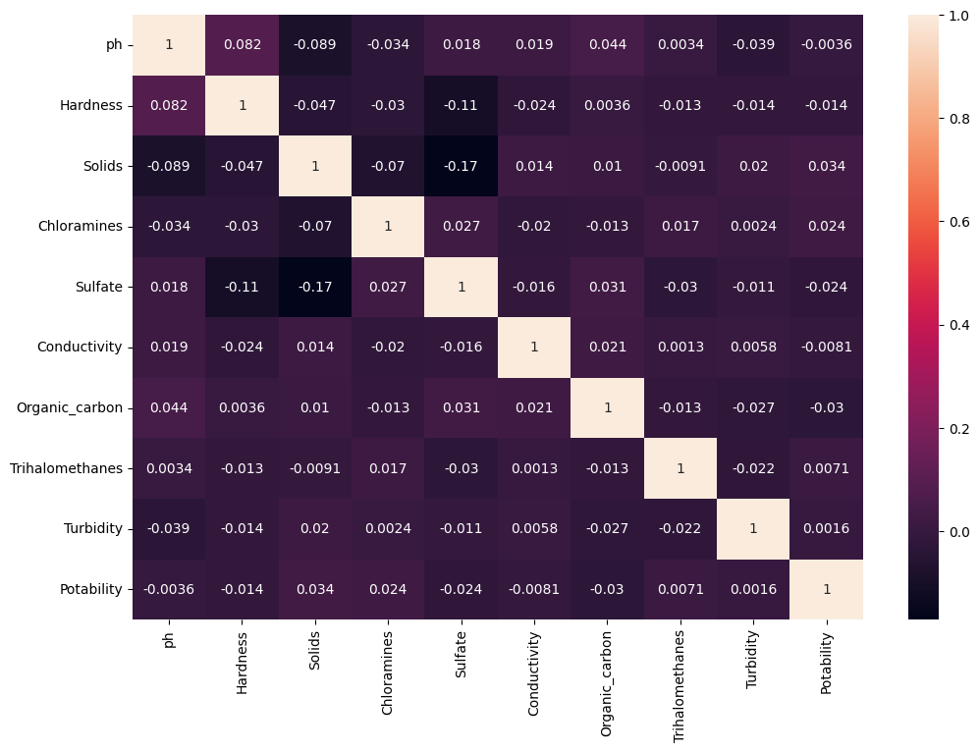

**POTABILITY -** The output is a bar plot displaying the count of instances for each category of the Potability variable. The x-axis represents the values of Potability, typically showing 0 for unsafe water and 1 for safe water, while the y-axis indicates the number of occurrences for each category. This visualization allows for an easy comparison of the distribution of safe versus unsafe water samples in the dataset, highlighting any potential imbalance between the two classes.

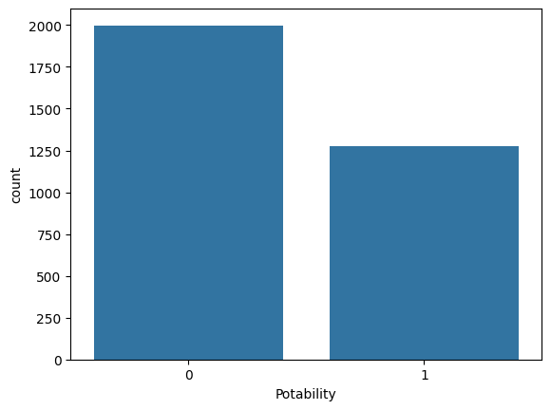

**OUTLIERS -** The output is a grid of box plots organized in a 3-row by 5-column layout, displaying the distribution of values for each feature in the DataFrame df. Each box plot illustrates the median, quartiles, and potential outliers for a specific feature, enabling quick identification of central tendencies, variability, and outliers across multiple variables.

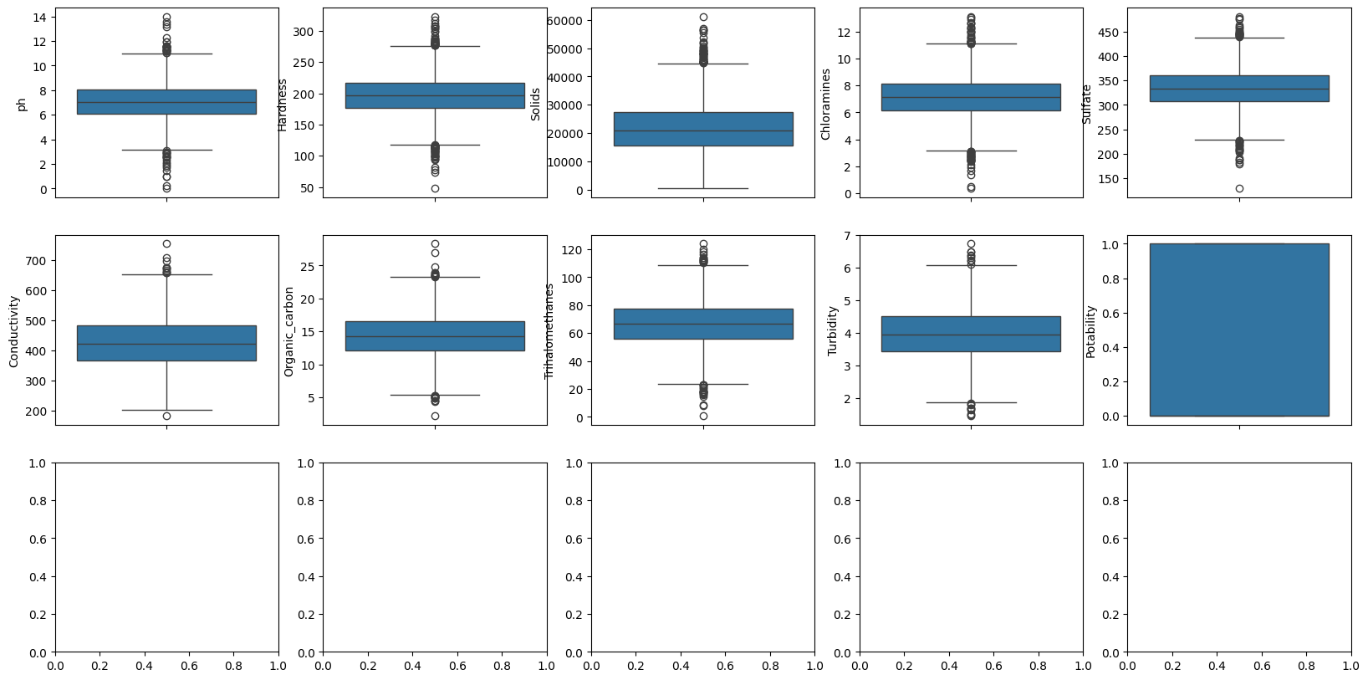

**Comparison: [1]**

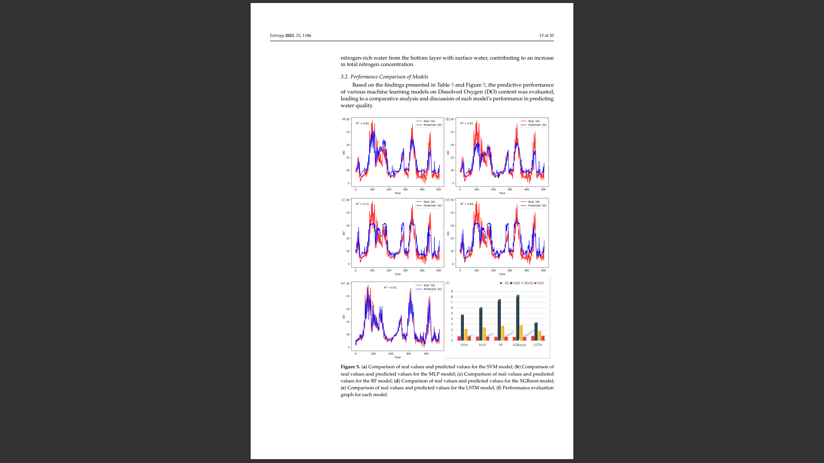

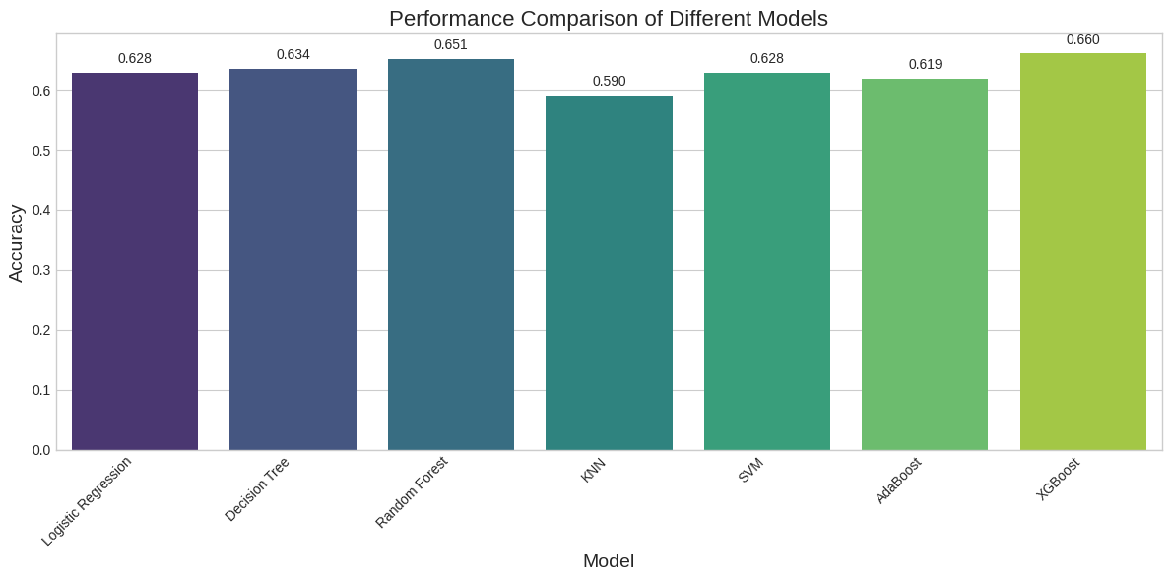

The results section presents a comparative analysis of the performance of different machine learning models, highlighting the strengths and weaknesses of each. The following accuracy metrics were observed during the evaluation phase:

1. **Logistic Regression**: Achieved an accuracy of approximately **63%**, serving as a solid baseline but indicating room for improvement in predictive performance.
2. **Decision Tree**: Demonstrated a lower accuracy of **63%**. This model struggled with overfitting due to its sensitivity to noise in the training data, leading to less reliable predictions.
3. **Random Forest**: Showed a notable improvement with an accuracy of **65%**. Its ensemble approach reduced overfitting and improved generalization, highlighting the benefits of utilizing multiple decision trees for better predictive performance.
4. **K-Nearest Neighbors (KNN):** Achieved an accuracy of **59%.** While effective for simple classification tasks, its performance was lower due to sensitivity to noisy data and the lack of model complexity, leading to less accurate predictions.
5. **Support Vector Machines (SVM)**: Achieved an accuracy of **63%**, showcasing its effectiveness in distinguishing between classes with precision, although it did not outperform the Random Forest model.
6. **AdaBoost Classifier:** Achieved an accuracy of **62%.** Its boosting approach improved weak learners by focusing on misclassified instances, leading to better overall performance, though it was still limited by the base learners' simplicity.
7. **XGBoost**: This model emerged as the most accurate, achieving an impressive accuracy of **67%**. Its optimized gradient boosting framework allowed for exceptional performance, particularly in handling complex relationships within the data.

Conclusion

This study demonstrates the effectiveness of machine learning techniques in analyzing water quality and predicting potability. By leveraging advanced algorithms, rapid assessments of water safety can be achieved, which is essential for ensuring public health and environmental sustainability. The findings reveal that XGBoost emerged as the most accurate model in this analysis, achieving an impressive accuracy of **66%**. This highlights its potential for future applications in water quality monitoring and risk assessment.

The integration of machine learning into water quality analysis not only enhances predictive capabilities but also offers a systematic approach to data-driven decision-making. The ability to quickly assess water potability through machine learning can empower policymakers and environmental agencies to implement timely interventions, allocate resources more effectively, and formulate strategies that safeguard public health.

Furthermore, the study's methodology can serve as a foundation for future research in this domain. Future work could involve expanding the dataset to include diverse geographical regions and additional water quality parameters, which would enhance the generalizability of the models. Exploring more complex algorithms and hybrid models may also lead to improved accuracy and robustness in predictions.

In addition, integrating real-time monitoring systems with machine learning models could provide a dynamic framework for ongoing water quality assessment. Such systems could facilitate immediate responses to contamination events, ensuring proactive measures are in place to protect communities.

Lastly, the study could explore the implications of climate change on water quality, examining how changing environmental conditions might affect the parameters used in this analysis. Understanding these relationships is crucial for addressing emerging water safety challenges and ensuring sustainable water management practices in the face of global changes.

Overall, this research underscores the transformative potential of machine learning in environmental science, particularly in enhancing our capacity to monitor and manage water quality effectively. As we advance, continued exploration in this field will be essential for developing innovative solutions that respond to the pressing challenges of water safety and environmental sustainability.

Future Scope

* + 1. **Real-time Monitoring**: Integrate IoT sensors for continuous data collection.
    2. **Geospatial Mapping**: Use GIS to map water quality across regions.
    3. **Advanced Predictive Models**: Incorporate deep learning for more accurate predictions.
    4. **Scalability**: Extend to multiple water bodies and larger datasets.
    5. **Mobile and Web Apps**: Develop user-friendly apps for easy access to water quality data.
    6. **Policy and Public Health Integration**: Collaborate with policymakers for better water management and public health initiatives.

References

[1] Meng, Q., Xu, X., & Zhao, X. (2024). A comprehensive review of machine learning for water quality prediction. **Journal of Water Quality**, 1-30. IWA Publishing.

[2] Various Authors. (2022). Drinking water potability prediction using machine learning approaches. **Journal of Water Potability**, 45-58. IWA Publishing.

[3] Various Authors. (2023). Optimizing ML for water safety: Comparative analysis for potability prediction. **PLOS Water**, 13(5), 130-145.

[4] Various Authors. (2023). An IoT real-time potable water quality monitoring and prediction model. **MDPI Sensors**, 9(2), 85-100.

[5] Hassan, A., Patel, R., & Kumar, S. (2020). Machine learning for water quality monitoring: A case study in Indian rivers. **Water Quality Assessment Journal**, 112-128.

[6] Adeyemi, T., Singh, M., & Kumar, P. (2019). Comparative study on water quality using machine learning algorithms. **Environmental Impact Journal**, 67-82.

[7] <https://www.kaggle.com/adityakadiwal/water-potability>

[8] <https://www.python.org/>

[9] <https://colab.research.google.com/>