**KATHMANDU UNIVERSITY**

**SCHOOL OF ENGINEERING**

**DEPARTMENT OF COMPUTER SCIENCE AND ENGINEERING**

**PROJECT REPORT ON**

**JOB FINDER**

A second year project report submitted in partial fulfillment

of the requirements for COMP 207

By:

Prerana Khatiwada (21)

Ashish Subedi( 66)

Sangam Pokharel (32)

Krishna Gaire (10)

Rajan Prasad kalwar(16)

Date of Submission :13th August

**CERTIFICATION**

SECOND YEAR PROJECT REPORT

on

**“JOB FINDER”**

**By:**

Prerana Khatiwada (21)

Ashish Subedi (17)

Sangam Pokharel ( 32)

Rajan Prasad Kalwar (16)

Krishna Gaire (10)

**Approved by:**

Project Supervisor

Mr.Sameer Tamrakar

__________________ ____________________ ________________

(Signature) (Name) (Date)

Project Coordinator

__________________ ____________________ ________________

(Signature) (Name) (Date)

# ABSTRACT

A **Job Finder website** is a [website](https://en.wikipedia.org/wiki/Website) that deals specifically with [employment](https://en.wikipedia.org/wiki/Employment) or [careers](https://en.wikipedia.org/wiki/Career). Job Finder is a web-based application, which has three main entities - Candidates, Employers and Admin.Candidates can register themselves, modify their details, search and apply for the jobs. Candidates can upload new resume, update his profile and can view his status of jobs he/she had Applied. The application provides the ability for job seekers to create and manage their accounts, upload their profile and resume, search for jobs, apply for jobs, view different job openings, view company’s profile. The site provides the features like User Profile, Company Profile, uploading CV, Company rating, vacancy posts, Forums, admin panel, search engine to search for the company names and many more.

The application will have 4 primary users:1) Job seeker2) Employer 3) Admin The system admin will have the ability to clean and clear and maintain database 4) Company

Many Job websites are designed to allow [employers](https://en.wikipedia.org/wiki/Employer) to post job requirements for a position to be filled and are commonly known as job boards. Other employment sites offer employer reviews, career and job-search advice, and describe different job descriptions or employers. Through a job website a prospective employee can locate and fill out a [job application](https://en.wikipedia.org/wiki/Application_for_employment) or submit [resumes](https://en.wikipedia.org/wiki/Resume) over the Internet for the advertised position.

Most job-seekers are using the Internet to look for another job, rather than spending their time circling ads in the Sunday edition of the newspaper. While online job-hunting can save the expenses associated with pounding the pavement looking for a job and connect you to more employers in a shorter time, This website allows job seekers and recruiters to connect.

1

# ACKNOWLEDGEMENT

We wish to express our sincere appreciation to the Department Of Computer Science And Engineering for including the COMP 207 project into our curriculum. We acknowledge and show appreciation to all who have facilitated us to complete this project. We extend our gratitude to all who have deliberately or unknowingly added a brick in the completion of this project. We enjoyed the duration of the work studying different modules and creating this report. Sharing of the ideas has been the most vital triumph during the development of this project.

First of all, we would like to express our heartfelt gratitude towards **Mr. SAMEER TAMRAKAR, Supervisor of our project** for letting us carry out this project and co-operating with us to help us carry our project smoothly. His experiences in the field have been a great asset for our project. His encouraging words and working techniques have made this project a successful one. We sincerely appreciate his openhandedness by taking us into his fold for which we shall remain indebted to him.

On this opportunity, we would like to thank all those individuals who directly or indirectly helped us in making this project a successful one be it by encouraging us throughout the project or else through their valuable suggestions which we have tried our best to assimilate within our work.

2

**TABLE OF CONTENTS**

|  |  |
| --- | --- |
| **CONTENTS** | **PAGE NO:** |
| ABSTRACT | 1 |
| ACKNOWLEDGEMENT | 2 |
| CHAPTER 1:INTRODUCTION  1.1 Background  1.2 About Project  1.3 Problems  1.4 Intended Solutions  1.5 Objectives  1.6 Features  1.7 Motivation | **3**  **4**  **4**  **5**  **5**  **6**  **6** |
| CHAPTER 2:RELATED WORKS  2.1 Case Study  2.2 Scope | **7**  **9** |
| CHAPTER 3:PROCEDURES AND METHODS  3.1 System Specifications  3.2 Algorithm  3.3 System Diagram  3.4 Tools Used | **10**  **10**  **11**  **14-15** |
| CHAPTER 4:SYSTEM SPECIFICATIONS  4.1 Software Specifications  4.2 Hardware Specificaions | **16**  **16** |
| CHAPTER 5:CONCLUSION AND RECOMMENDATION  5.1 Conclusion  5.2 Recommendation  5.3 References  5.4 Limitations  APPENDIX I :Screenshots  APPENDIX II : Work division | **17**  **17**  **18**  **18**  **19-21**  **22** |
| CHAPTER 6:PROJECT PLANNING AND SCHEDULING  6.1 Gantt Chart | **23** |

# CHAPTER 1

# INTRODUCTION

## 

# 1.1 BACKGROUND

For this project, Many Job portals or Job search websites were our major source of motivation and idea for our project which was to develop a website which can help people find jobs online. We don't need to see daily news paper to search for the jobs. If you search on Google you will find hundreds of Jobs portal website that are run by Nepali to find the jobs and apply it online. But among those some of them are only actively operated or updated daily.

There are many websites and social platforms built for finding jobs and for vacancies. However, most of them lack in aspects such as interaction, user-friendliness and accuracy. But among them only few has good features. JOB finder is an excellent resource for finding job openings that aren’t always listed on other sites. JOB finder uploads our resume and shows the job listings online that match our experience. Other tools like salary calculator and career descriptions are also available. It allows us to save jobs, resumes, and cover letters in our personal account. This project aims to solve all these shortcomings and get accurate result to their problems easily.

Job Finder  is a platform to find the  job of your choice. Even if you are not actively looking for a job, it can help you manage your career. This jobsite is a total recruitment solution to employers & career management solutions for all jobseekers.

# 

3

# 1.2 ABOUT PROJECT

This is a website which helps in the recruitment process by bringing together both the employer and the job seeking candidate. The candidate will have to create his profile by uploading his resume which will be then viewed by the company and employer as and when there is any opening. It is a simplified process of job hunting.

Twenty-five years ago, before the commercial rise of the internet job seekers attended career fairs, scanned the classified section of newspapers, or heard about openings through word-of-mouth referrals. Good, old-fashioned networking is still the number one way to land a job, but the way we look for jobs has changed dramatically. Today, it’s all online. So, Job finder is the best place if someone is looking for a job. It has the most new jobs posted, list of top companies in the country, vacancy announcement and major highlights and trending news related to jobs and vacancies. It complements that freshness with an in-depth look at the companies posting them. These eye-catching company profiles are balanced with anonymous feedback from current and former employees there are even charts to show how a company’s rating has changed over time. Job Finder gives you both the info you need to find job opportunities and the context to see if it’s a good fit for you too.

# 1.3 PROBLEMS:

Most of today's job seekers are filling out an online application for a particular post in an oragnaization.These automated applications ask candidates to input their personal and résumé information, That information becomes part of a vast database of applicants, of whom only a lucky few are ever actually contacted by employers.

Hence, the problems that the candidates can have with online job applications and with our website too are :-

* Candidates who apply online can be ignored.
* Online applications take too long to fill out.
* Employers don't stay in touch
* Candidates get an automated response, not a real person.

4

Nowadays, many people are facing challenges in finding jobs. Mainly, young people are finding it harder and harder to find permanent jobs. These days, everyone wants a respectable job after graduating from college or university; however, finding a permanent work has become difficult for youngsters. There are many reasons creating these issues regarding jobs. Hence in this case, our project can be considered as an obvious solution for this issue. This is going to help all experienced and qualified persons to get job easily.

# 1.4 INTENDED SOLUTIONS

There are many things that should be included in our job website with respect to the versatile and huge increasing demand of skillful employees in various Industries in order to increase the number of users of our website.Some of which are like:

* Quality of professional profiles
* Fake resumes should be avoided.
* There shouldn’t be Improper company descriptions
* Job providing sites acts like a mediator, instead they should give a complete end to end service and many more.
* Security measures, like a few cases are there in which people from the job portal services sell the valuable data of their customers to others.

# 1.5 OBJECTIVES

Our main objectives are:

.

* + To make easy for finding jobs.
  + To find new jobs that are best match for our skills, qualifications and interests and get career advice.
  + □ search for and apply for jobs online.
  + To find jobs quicker and faster and to save time.
  + Encourage interaction between users and different companies and organizations

                               

# 1.6 FEATURES:

The application will have the following features:

* The project has the home page which comprises of search bar, login form,image slider and navigation bar.
* This project will feature a page where users can post a resume, get career advice, and company and salary information.
* It will have separate sections of the site for employers/companies and employees.
* It will also offer a feature that will post job listings for employers.
* Users will be able to apply for jobs online and enable company to find users directly.
* Users will be able to sort their search by job type, title, companies and reviews, salaries and experience.
* Admin can remove the company if he/she thinks it’s fake
* Forum discussion section/Rating is also available in our website

# 1.7 MOTIVATION

We’ve always wanted to develop something that would be useful for the users through our field. This project turned out to be bliss to our thoughts from the very first day.We were highly motivated by some of the online job portals for our project.

Online job sites have certainly revolutionized the world of outsourcing and freelancing. Both employers and job seekers have gained benefits through this in significant ways.On the other side of the coin, freelancers who seek full-time and part-time positions can get to earn without being bind by any contract or fixed scheduling that comes in a routine (such as employment).

6

# CHAPTER 2

# RELATED WORKS

# 2.1 CASE STUDY

## 

We first got the concept of developing this site after research about on various online Job search engines and Job Portals. We found similar websites like “[LinkedIn](https://www.linkedin.com/) , [Glass door](https://www.glassdoor.com/index.htm)  ”of which we examined the system design and the coding. As they use PHP, HTML and CSS to develop their site, we just got the concept and self-motivated ourselves to develop similar project with the help of PHP programming language, Bootstrap, Ajax etc.

We extensively searched for the web looking for the application that could be made using PHP programming language. We browsed through different sites looking for ideas and inspirations on making a good and useful website application. We discover that, at present context many internet users prefer to seek jobs online according to their field of interest. Hence we decided to build a platform helping to those talented and curious minds in order to make ease in finding jobs online and also provide user friendly environment for their convenience.

Here are some list of the Online Job search in Nepal from which we took ideas and basic concepts on how to build similar type of pages.

7

1)

**JobsNepal.com**

[online job in nepal](http://2.bp.blogspot.com/-zjt5bZB_ZrE/UXTdY-gpsrI/AAAAAAAAFdQ/6i4YFjhDD5Q/s1600/jobs-nepal.png)

[JobsNepal.com](http://www.jobsnepal.com/) is the most popular employment website in Nepal that was started in the year 2000.It offers services to the recruiting and job-seeking community in Nepal and abroad, for those seeking Nepalese talent. JobsNepal.com is produced and managed by Web Soft International, one of Kathmandu's leading Web development houses.

2)

**MeroJob.com**

[](http://4.bp.blogspot.com/-aFKp-BqHopA/UXTePWzt7MI/AAAAAAAAFdY/ic5PcKVEsj0/s1600/merojob.gif)[MeroJob.com](http://www.merojob.com/)  is a platform to find the  job of your choice. It has started its venture since November 2009.Even if you are not actively looking for a job, it can help you manage your career. This jobsite is a total recruitment solution to employers & career management solutions for all jobseekers.

3)

**Jagire.com**

[](http://1.bp.blogspot.com/-V1lJXYt7L2s/UXTgTryCuoI/AAAAAAAAFdg/J7E22mtUyvA/s1600/jagire.png)

[Jagire.com](http://www.jagire.com/) – Job Vacancies Nepal is an updated database of daily vacancies in Nepal. It has started its service in 2011.Their ultimate listing covers all the development and public sector jobs and also includes private sector jobs in Nepal. The website is not so attractive but it can be useful for your guys to search for the jobs you like.

8

# 2.2 SCOPE

The application has the following scope:

1. It is usable by people from different educational backgrounds.
2. It helps solve curiosities of kin users who wish to apply for jobs online.

Searching for a job in the classified ad section of a newspaper is becoming less of a necessity, as employers increasingly list job openings for free on Internet sites and use form websites to conduct the application process entirely online. These methods are convenient for employers, but there are a number of disadvantages for job seekers.

## Competition is a Disadvantage

A major disadvantage to job hunting online is that everybody else is doing it. You're one of millions of people vying for jobs and perhaps thousands applying for the same job, because the convenience factor appeals to all of your competitors as well

## Convenience is an Advantage

One of the major advantages of our Job finder is convenience. From the comfort of your home, you can access thousands of job openings. You needn't drive to employers' offices to ask whether they have job openings.

## Saving Money is an Advantage

Job finder saves our money since it eliminates the cost of printing resumes and cover letters, and paying for postage to mail application packages to prospective employers.

**9**

# CHAPTER 3

# PROCEDURES AND METHODS

# 3.1 SYSTEM SPECIFICATIONS

The web application is developed by using HTML, CSS, JavaScript, Jquery for the user interface (UI) design; core PHP for the working of the application and Wampp/Xampp web server.

# 3.2 ALGORITHM

**Algorithm for user /company sign in**

1. Start
2. Ask For Email and Password
3. Check if the Email and Password Field is not empty
4. If Empty go to 2 Else proceed
5. Search for Password From database and check if the Email and Password matches
6. If Email and Password Do not match go to 2.
7. Else search for the profile info from the database for same Email and forward to the Profile Page.
8. End.

**Algorithm For Selecting Top Companies**

1. Start
2. Check the Highest Search Count for the company account
3. Show the company at top
4. End

10

# 3.3 SYSTEM DIAGRAM

User’s profile along with resume

User’s Profile

Organization

Home page

Registered User

Unregistered User

Home page

# 

11

Home Page

LOGIN PANEL

User Profile

Seach

**JOB FINDER**

Company Profile

Vacancy

Forum Section

About us and details

Rating

Fig : 2 Component Diagram

12

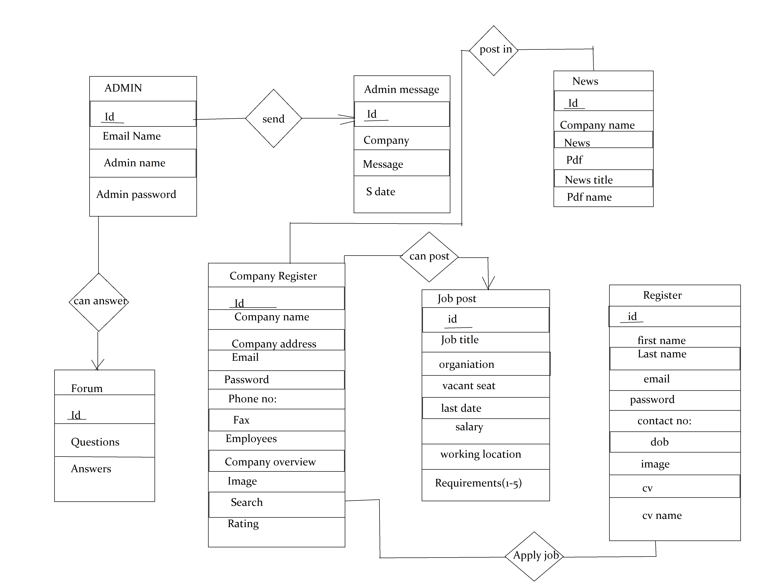

Fig:ER diagram

13

# 3.4 TOOLS USED

* 1. **Atom Text editor**



**Atom** is a free and open-source **text** and source code**editor** for macOS, Linux, and Microsoft Windows with support for plug-ins written in Node.js, and embedded Git Control, developed by GitHub. **Atom** is a desktop application built using web technologies.

Atom is a text editor that's modern, approachable, yet hackable to the core—a tool you can customize to do anything but also use productively without ever touching a config file.

14

* 1. **Xampp**



* [XAMPP is a local web server](http://a5theory.com/xampp-server-what-is-xampp-server/) which helps you to make the web application at your system and run at the browser at local environment at your local machine.
* In your local machine you would need to use specially Apache server and MySQL.
* That will be enough to make a web application and test it on your local server, and later you can shift this code to the live server.

**3) Browser**

Short for Web browser,*a*browser is a [software application](http://www.webopedia.com/TERM/A/application.html) used to locate, retrieve and display content on the [World Wide Web](http://www.webopedia.com/TERM/W/World_Wide_Web.html), including [Web pages](http://www.webopedia.com/TERM/W/web_page.html), images, video and other files. As a[client/server model](http://www.webopedia.com/TERM/C/client_server_architecture.html), the browser is the [client](http://www.webopedia.com/TERM/C/client.html) run on a computer that contacts the Web [server](http://www.webopedia.com/TERM/S/server.html) and requests information. The server sends the information back to the browser which displays the results on the computer or other Internet-enabled device that supports a browser.

15

# CHAPTER 4

# SYSTEM SPECIFICATIONS

# 4.1 SOFTWARE SPECIFICATIONS

**Programming Languages**

This website is based on:

**Front-End**: HTML5, CSS,Java script

**Back-End:** PHP, MySQL.

**Framework:** Bootstrap.

**Operating System**

Windows

**Platform**

Sublime Text editor

# 4.2 HARDWARE SPECIFICATIONS

Browser: Chrome, Mozilla Firefox, Opera

16

**CHAPTER 5**

# CONCLUSION AND REOMMNEDATION

# 5.1 CONCLUSION

On completion of the program we have achieved our destined results.

Although we have managed to complete this project, there are many places where expansion can be done .We believed that if given an opportunity we can implement the Project.

The future changes that can be done in this site is that it can be developed by adding various advance features which other online jobs providing system doesn’t have.

Thus, this project is based on group functioning and when completed could be one of the best website applications ever developed by the students. We will give our best to make this project a success. On the other hand, we believe that working in a group will make us more responsible and sharing during the entire time will help us learn things that wouldn't have been possible by an individual task. So this project is not only important from the view point of the final result but also the making will be equally beneficial to us

# 5.2 RECOMMENDATION

This project had been challenging in many ways. Each stage presented its own problems to overcome. With the experience of developing a website like this, we recommend following actions:

* A more detailed research can be done for improving the frontend .

# 

17

# 5.3 REFERENCES

* <https://www.thebalance.com/top-best-job-websites-2064080>
* <http://php.net/manual/en/tutorial.php>
* Tutorialspoint.com. (2017). *DBMS Tutorial*. [online] Available at: http://www.tutorialspoint.com/dbms/ [Accessed 12 June. 2017].
* W3schools.com. (2017). *SQL Tutorial*. [online] Available at: https://www.w3schools.com/sql/default.asp [Accessed 17 June. 2017].

# 5.4 LIMITATIONS

* It is unable to identify the fake accounts of user
* Company may not respond to every applicants hence they might feel ignored
* CV/Resume can only be uploaded in pdf form.

# 

18

# Appendix I: Screenshots

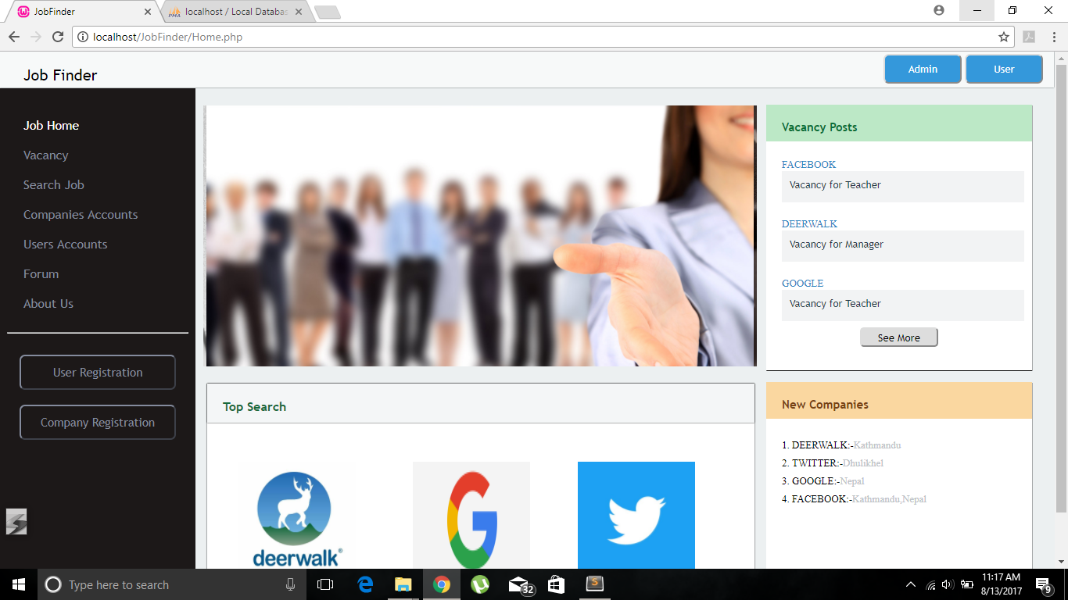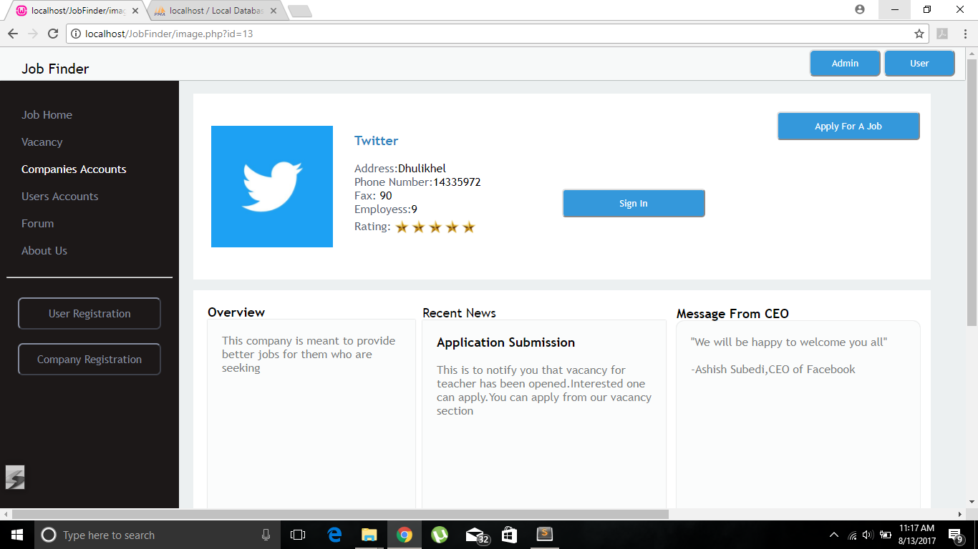

19

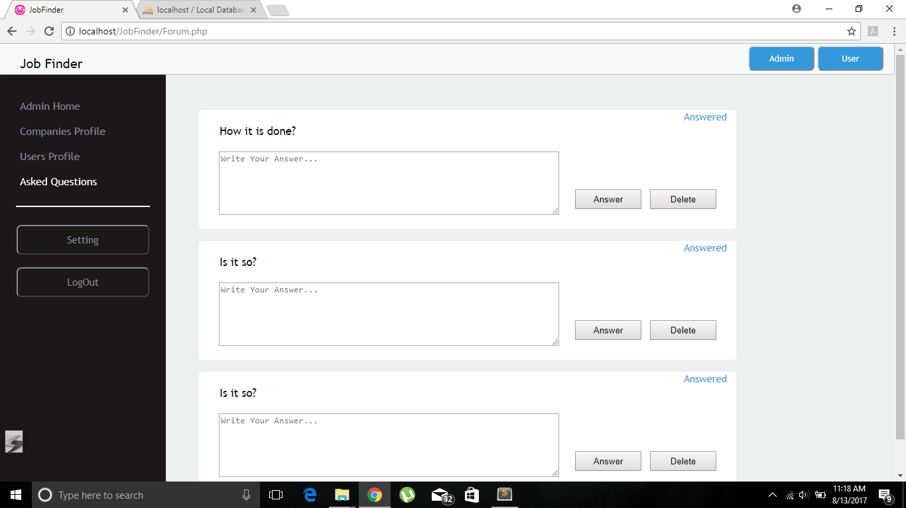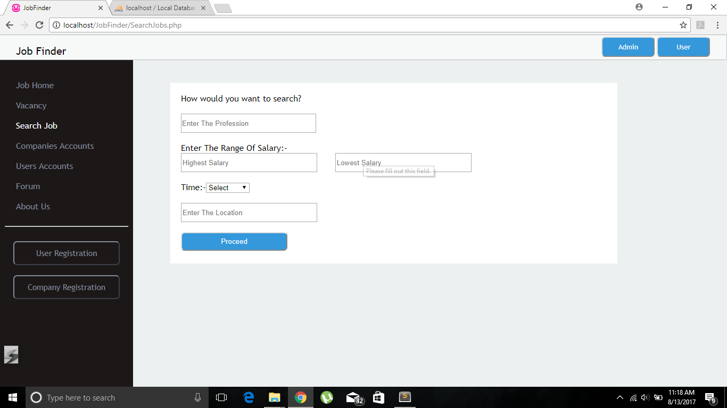

20

# 

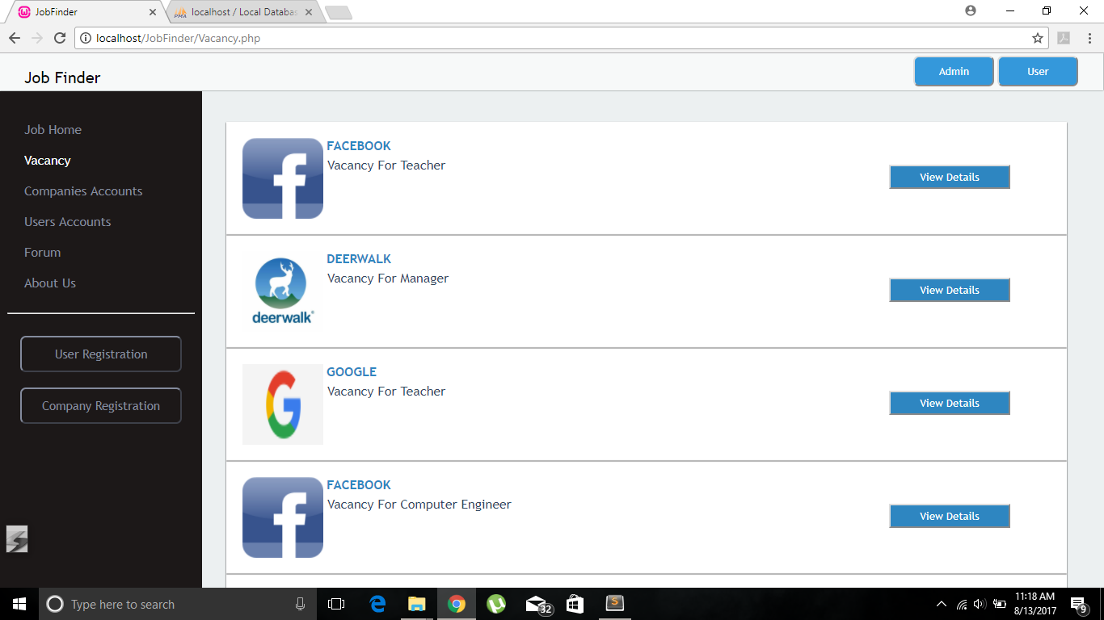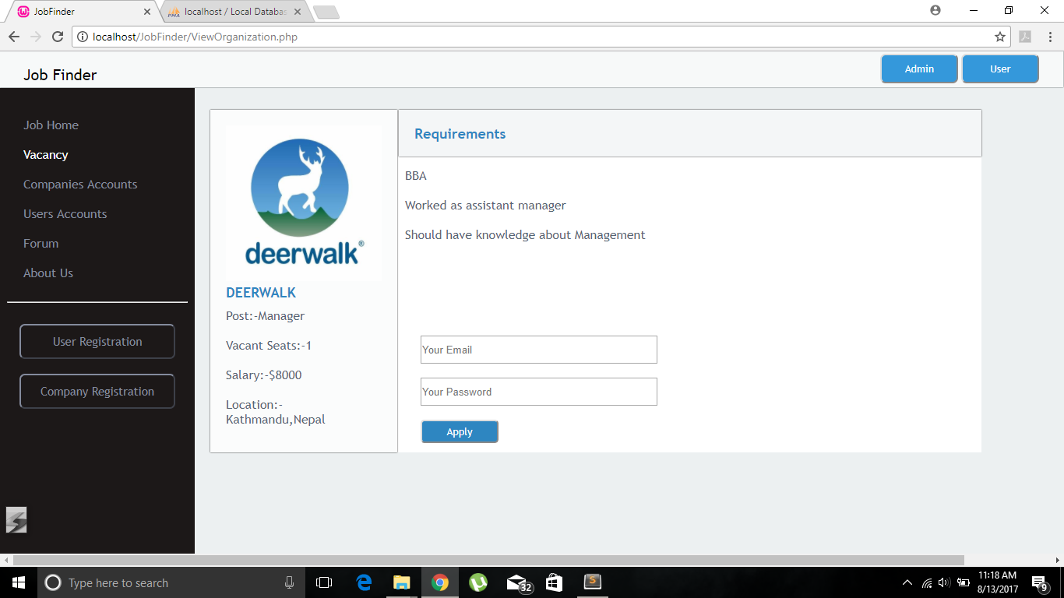

21

# Appendix II: Work Division

Most of the work is done in group. Everyone will be involved in some ways. The entire work is broken down into the following ways among our team mates.

|  |  |  |
| --- | --- | --- |
| **S. N** | **Task** | **Team Members** |
| 1 | Basic Learning | Ashish,Prerana,Sangam,Krishna,Rajan |
| 2 | UI Designing | Sangam,Prerana,Ashish |
| 3 | Coding and Testing | Ashish,Prerana,Sangam,Krishna,Rajan |
| 4 | Documentation | Prerana,Rajan,Ashish |
| 5 | Presentation Preparation | Krishna,Prerana,Ashish |

# 

22

# CHAPTER 6

# PROJECT PLANNING AND SCHEDULING

# 6.1 GANTT CHART

The work breakdown and time (in weeks) required to complete the speciﬁc tasks are shown as in the Gantt chart below:

|  |  |  |  |  |  |  |  |  |  |  |  |  |
| --- | --- | --- | --- | --- | --- | --- | --- | --- | --- | --- | --- | --- |
| **WORK** | **1** | **2** | **3** | **4** | **5** | **6** | **7** | **8** | **9** | **10** | **11** | **12** |

**WEEK**

**Research and basic learning**

**Platform Selection**

**Fundamental**

**Coding**

**Debugging and testing**

**Documentation**

**Presentation preparation**