1. Create a dbt project with snowflake connector

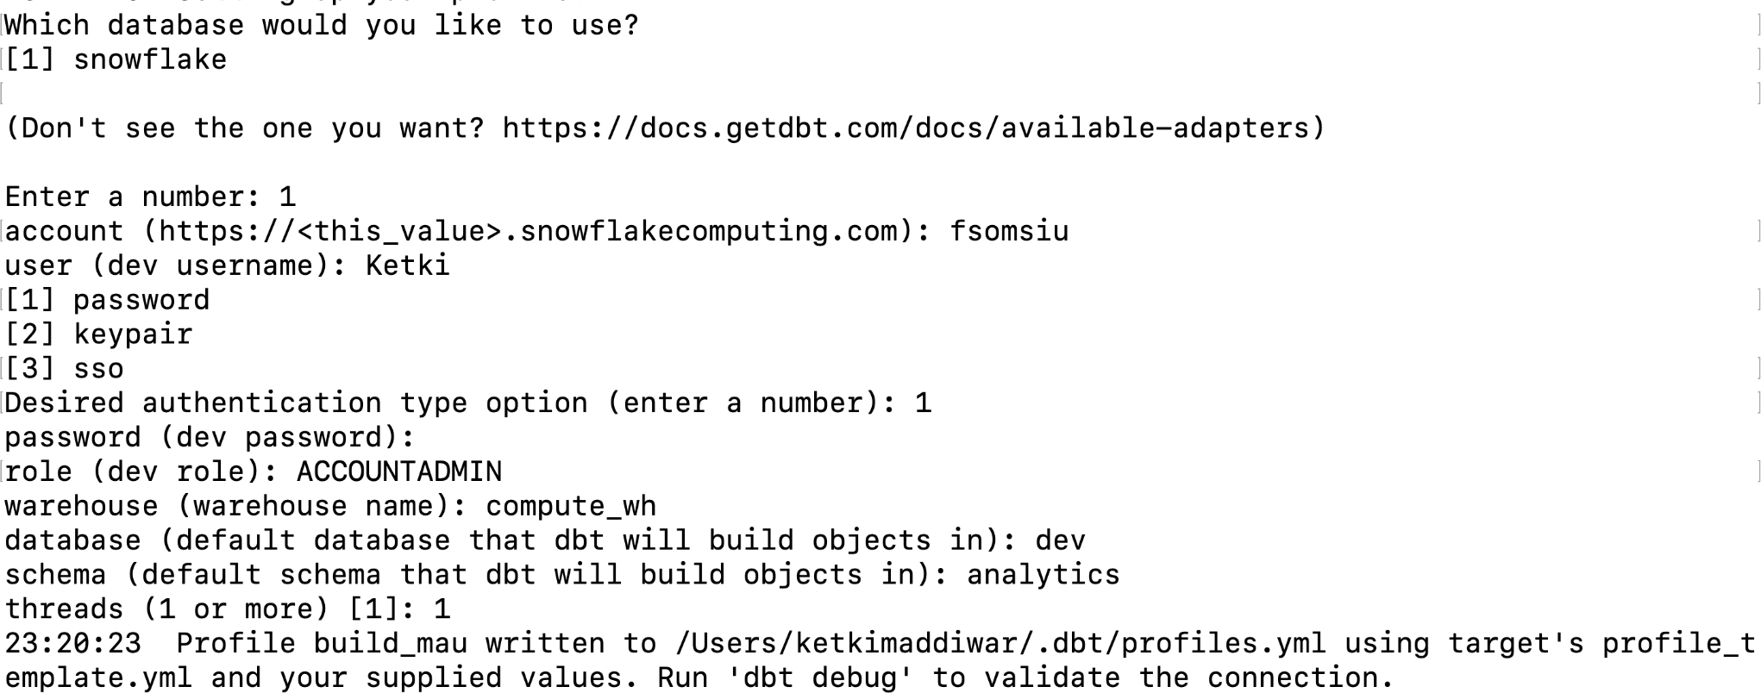

1. Setup Input models

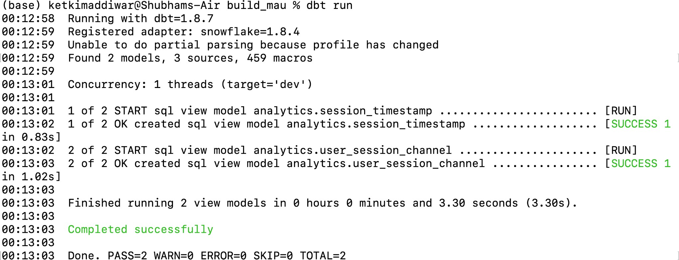

1. Set up Output models

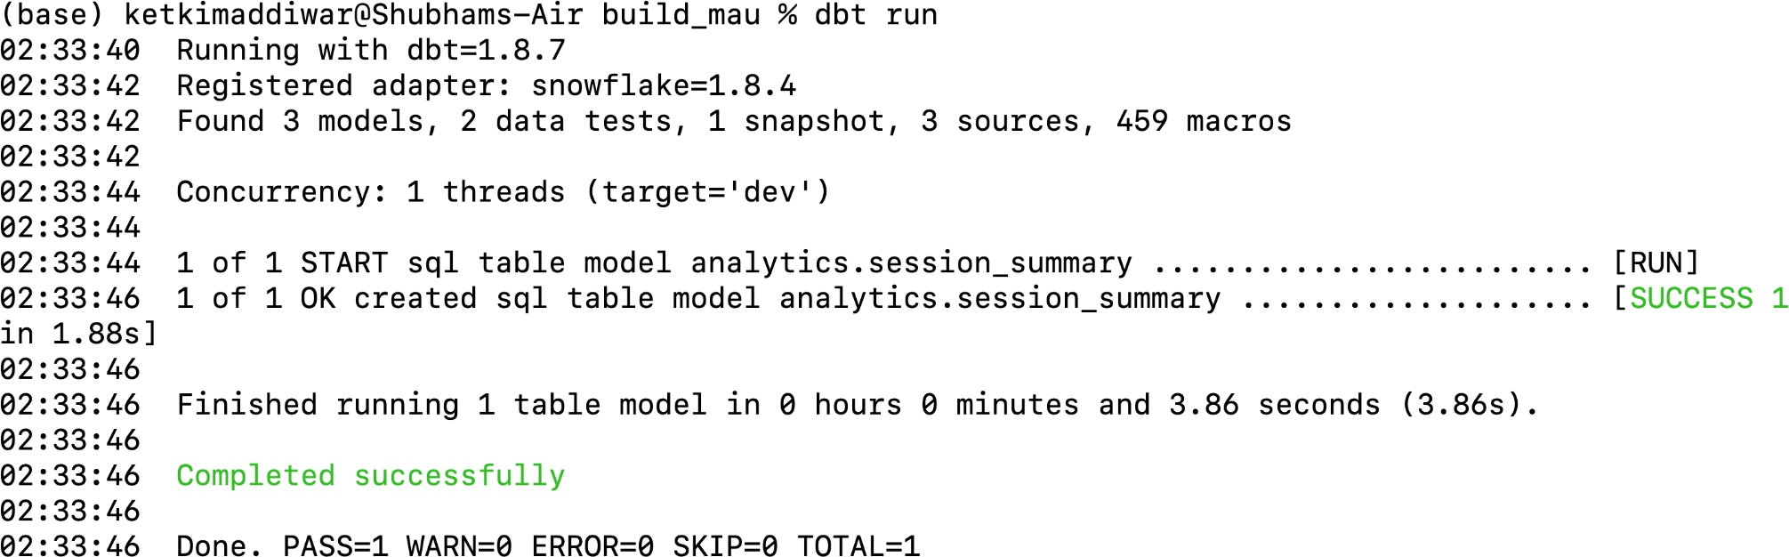

1. Add Snapshot to the output table (session_summary)

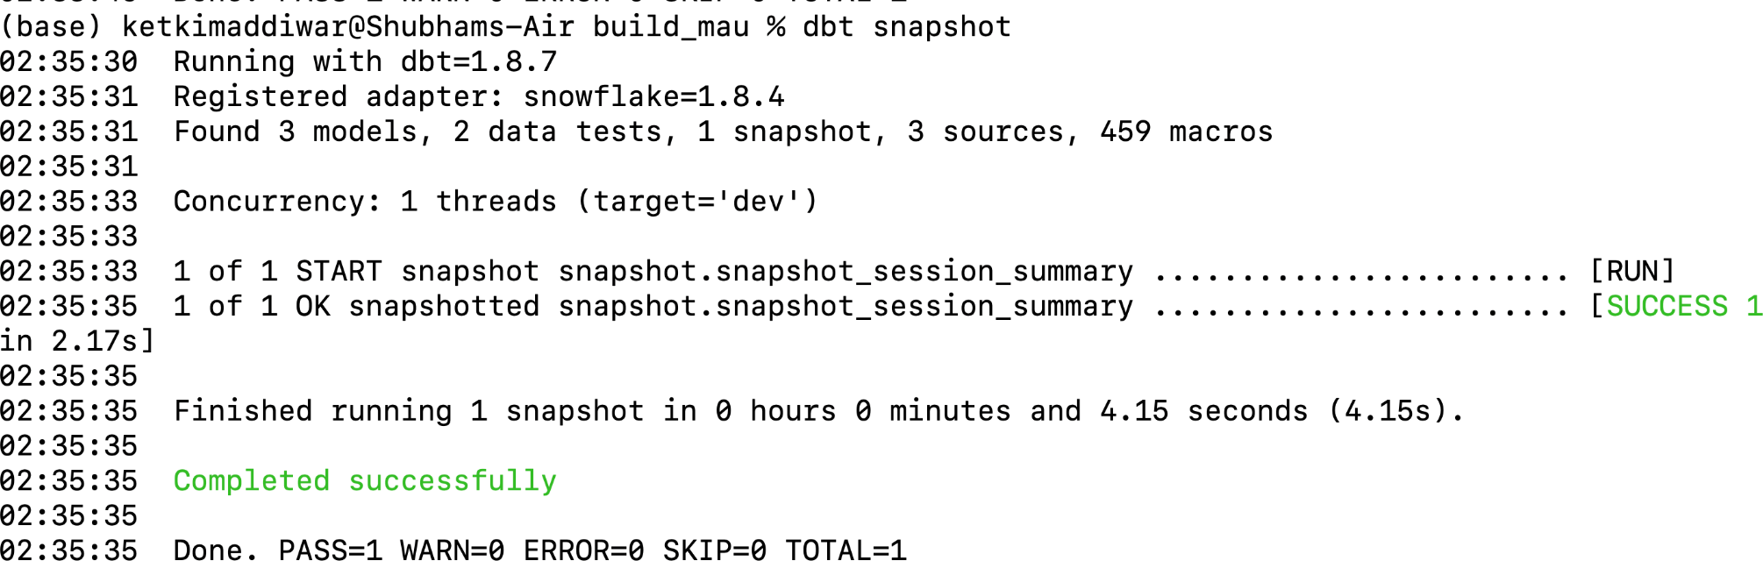

1. Add at least 2 tests to sessionId field of session_summary (2pt)

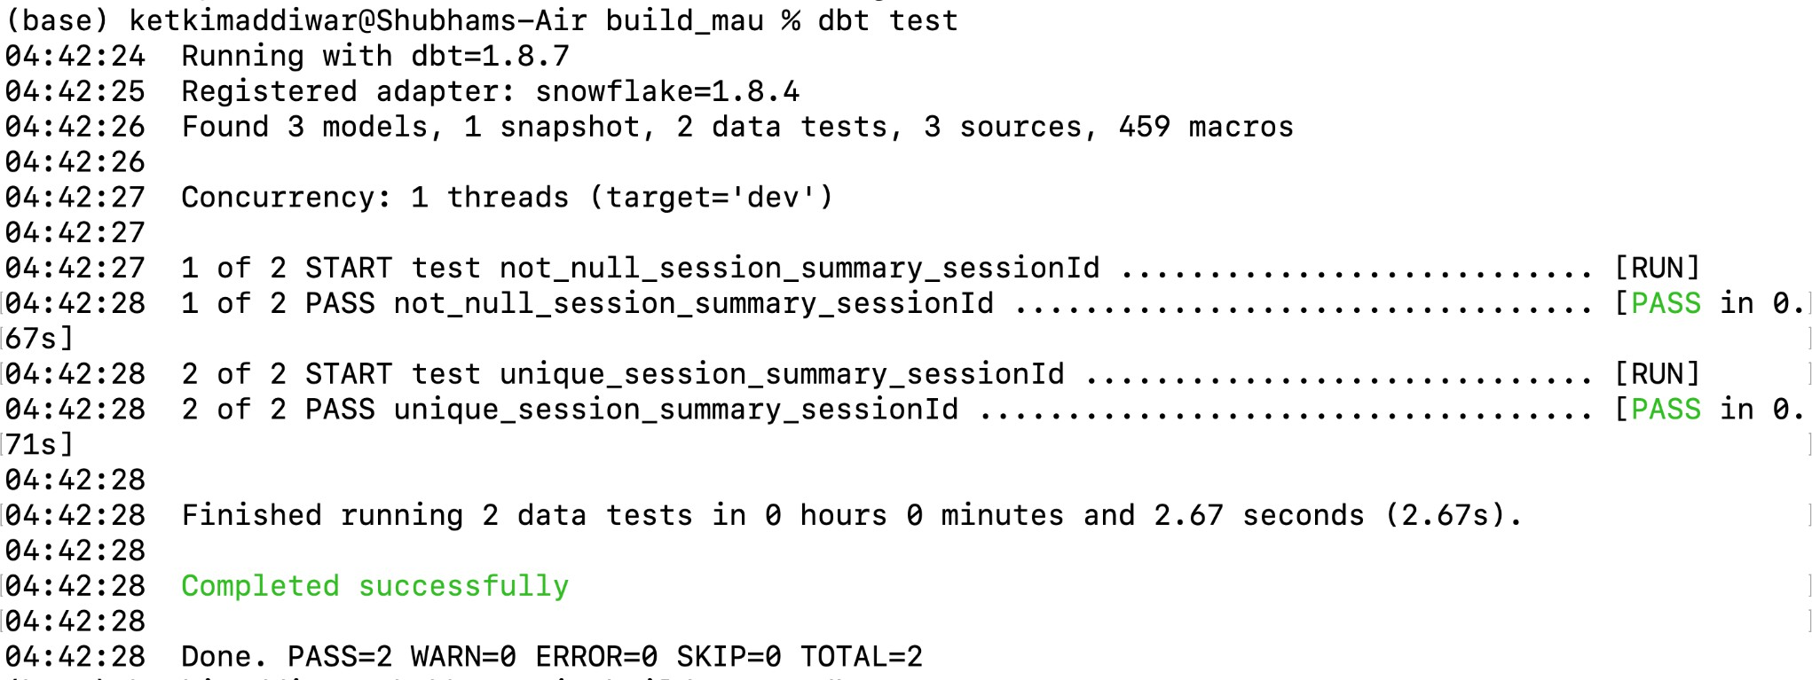

Git Link:

<https://github.com/ketkimaddiwar/Data-226-Homeworks/tree/main/HW-8/build_mau>