AES Encryption and Decryption

To encrypt create a new text file and click encrypt → click symmetric(modern) → aes → enter key
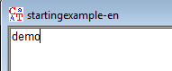
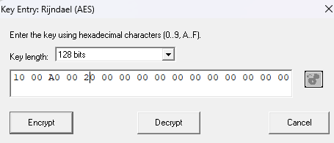
To decrypt click the encrypted file and click decrypt → aes → enter key → get plain text
https://codebeautify.org/char-to-ascii
https://cryptii.com/pipes/vigenere-cipher
https://thepythoncode.com/article/implementing-the-vigenere-cipher-in-python

https://one.one.one.one/ cloudflare warp
https://demo.geniuslynx.in/cc/lc-dc.html

https://www.geeksforgeeks.org/computer-networks/differential-and-linear-cryptanalysis/

File encrypt decrypt attack analysis using cryptool
Go to CrypTool → Analysis → Attack on the Hash Value of the Digital Signature..
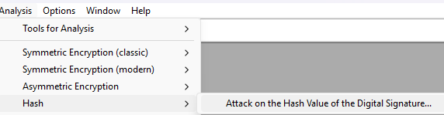
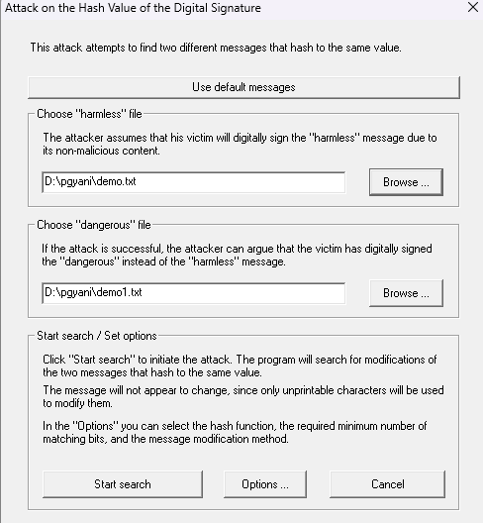
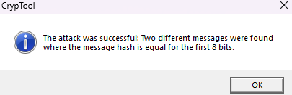
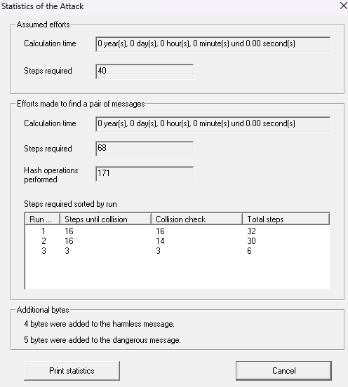
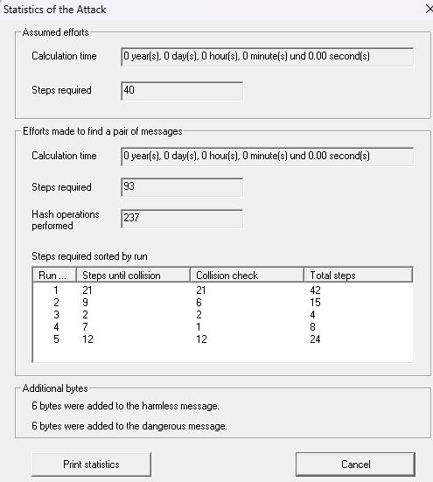
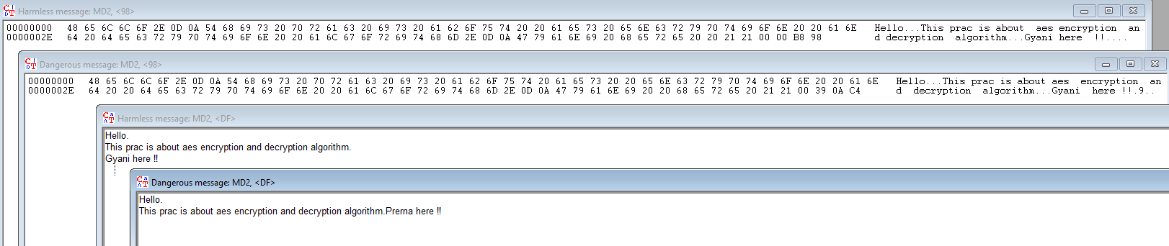
Name: Prerna Deepak Gyanchandani Roll No.: 25KSMSCCS06 Date: 5/2/26

Cryptography and Cryptanalysis

Practical 1

Aim: Program to implement password salting and hashing to create secure passwords.

Code:
#simple password salting and hashing -> encrypt
import bcrypt
#print("Version bcrypt: ",bcrypt.__version__)

print("Prerna Gyanchandani")
pwd = input('Enter password: ')
byte_pwd = pwd.encode('utf-8') #encoding into bytes
salt = bcrypt.gensalt()
hashed = bcrypt.hashpw(byte_pwd, salt)
print('Hashed passsword: ', hashed)

#Verify password
check_pwd = input('Re-enter password to verify:')
if bcrypt.checkpw(check_pwd.encode('utf-8'),hashed):
print('Password is correct!')
else:
print('Password is incorrect!')
Output:
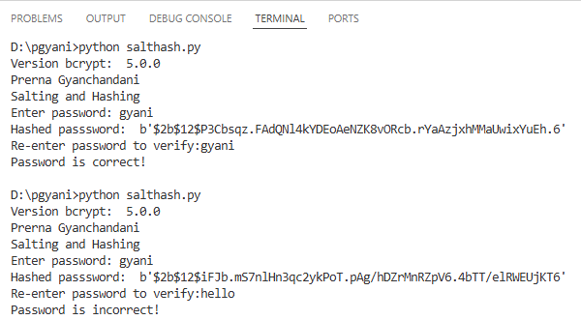
Name: Prerna Deepak Gyanchandani Roll No.: 25KSMSCCS06 Date: 5/2/26

Cryptography and Cryptanalysis

Practical 2

Aim: Program to implement various classical ciphers-Substitution Cipher, Vigenère Cipher, and Affine cipher.
Code:
# Substitution (Caesar) Cipher
def caesar_encrypt_simple(text, key):
result = ""
for c in text:
if c.islower():
shifted = ord(c) - ord('a')
shifted = shifted + key
shifted = shifted % 26
new_char = chr(shifted + ord('a'))
result = result + new_char
elif c.isupper():
shifted = ord(c) - ord('A')
shifted = shifted + key
shifted = shifted % 26
new_char = chr(shifted + ord('A'))
result = result + new_char
else:
result = result + c
return result

def caesar_encrypt(text, key):
return ''.join(
chr((ord(c) - ord('a') + key) % 26 + ord('a')) if c.islower() else
chr((ord(c) - ord('A') + key) % 26 + ord('A')) if c.isupper() else c
for c in text)
def caesar_decrypt(cipher, key):
return caesar_encrypt(cipher, -key)

# Vigenère Cipher
def vigenere_encrypt(text, key):
key = key.lower()
letters = [c for c in text if c.isalpha()]
shifts = [ord(key[i % len(key)]) - ord('a') for i in range(len(letters))]
it = iter(shifts)
return ''.join(
chr((ord(c) - ord('a') + next(it)) % 26 + ord('a')) if c.islower() else
chr((ord(c) - ord('A') + next(it)) % 26 + ord('A')) if c.isupper() else c
for c in text)
def vigenere_decrypt(cipher, key):
key = key.lower()
letters = [c for c in cipher if c.isalpha()]
shifts = [ord(key[i % len(key)]) - ord('a') for i in range(len(letters))]
it = iter(shifts)
return ''.join(
chr((ord(c) - ord('a') - next(it)) % 26 + ord('a')) if c.islower() else
chr((ord(c) - ord('A') - next(it)) % 26 + ord('A')) if c.isupper() else c
for c in cipher)

# Affine Cipher
def affine_encrypt(text, a, b):
return ''.join(
chr((a * (ord(c) - ord('a') ) + b) % 26 + ord('a')) if c.islower() else
chr((a * (ord(c) - ord('A') ) + b) % 26 + ord('A')) if c.isupper() else c
for c in text)
def modinv(a, m):
for x in range(1, m):
if (a * x) % m == 1:
return x
raise ValueError('No modular inverse')
def affine_decrypt(cipher, a, b):
a_inv = modinv(a, 26)
return ''.join(
chr((a_inv * ((ord(c) - ord('a') - b)) % 26) + ord('a')) if c.islower() else
chr((a_inv * ((ord(c) - ord('A') - b)) % 26) + ord('A')) if c.isupper() else c
for c in cipher)
if __name__ == "__main__":
text = input('Text: ')
print('\nSubstitution (Caesar) Cipher:')
k = int(input('Key: '))
enc = caesar_encrypt(text, k)
print('Encrypted:', enc)
print('Decrypted:', caesar_decrypt(enc, k))
print('\nVigenère Cipher:')
while True:
key = input('Key (letters only): ')
if key.isalpha():
break
print('Error: Key must contain only letters.')
enc = vigenere_encrypt(text, key)
print('Encrypted:', enc)
print('Decrypted:', vigenere_decrypt(enc, key))
print('\nAffine Cipher:')
a = int(input('number value for Key a: '))
b = int(input('number value for Key b: '))
enc = affine_encrypt(text, a, b)
print('Encrypted:', enc)
print('Decrypted:', affine_decrypt(enc, a, b))

Output:
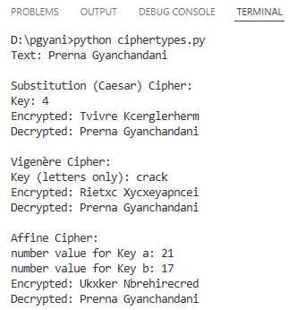
Name: Prerna Deepak Gyanchandani Roll No.: 25KSMSCCS06 Date: 7/2/26

Cryptography and Cryptanalysis

Practical 3

Aim: Program to demonstrate cryptanalysis (e.g., breaking Caesar or Vigenère Cipher).
Code:
def break_caesar(cipher):
for key in range(26):
plain = ""
for c in cipher:
if c.isalpha():
shift = ord('a') if c.islower() else ord('A')
plain += chr((ord(c) - shift - key) % 26 + shift)
else:
plain += c
print(f"Key {key}: {plain}")
cipher_text = input("Enter the Caesar cipher text: ")
break_caesar(cipher_text)
Output:
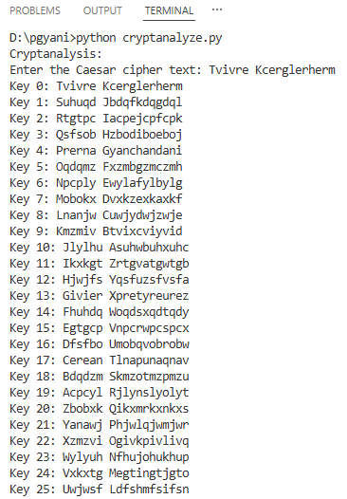
Name: Prerna Deepak Gyanchandani Roll No.: 25KSMSCCS06 Date: 14/2/26

Cryptography and Cryptanalysis

Practical 4

Aim: Program to implement AES algorithm for file encryption and decryption.
Code:
#pip install pycryptodome
#padding when there is 16bit and to store is only 6bits then to fill remaining space is filled by #different bits is padding & emptying it is unpadding.
from Crypto.Cipher import AES
from Crypto.Random import get_random_bytes
from Crypto.Util.Padding import pad, unpad
def encrypt_file(input_file, output_file, key):
with open(input_file, 'rb') as f:
data = f.read()
cipher = AES.new(key, AES.MODE_CBC)
encrypted = cipher.encrypt(pad(data, AES.block_size))
with open(output_file, 'wb') as f:
f.write(cipher.iv + encrypted)
def decrypt_file(input_file, output_file, key):
with open(input_file, 'rb') as f:
iv = f.read(16)
encrypted = f.read()
cipher = AES.new(key, AES.MODE_CBC, iv)
decrypted = unpad(cipher.decrypt(encrypted), AES.block_size)
with open(output_file, 'wb') as f:
f.write(decrypted)
def main():
# Generate a random 16-byte (128-bit) AES key
key = get_random_bytes(16)
input_file = input("Enter the path of the input file to encrypt/decrypt: ").strip()
encrypt_file(input_file, 'encrypt.txt', key)
print(f"File encrypted at: ")
print(encrypt_file)
decrypt_file('encrypt.txt', 'decrypt.txt', key)
print(f"File decrypted ")
print("Prerna Gyanchandani Rno 6")
if __name__ == "__main__":
main()
Output:
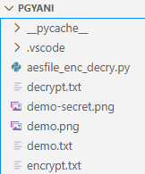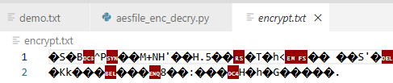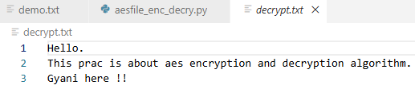
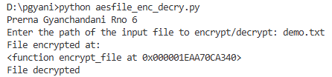

Name: Prerna Deepak Gyanchandani Roll No.: 25KSMSCCS06 Date: 17/2/26

Cryptography and Cryptanalysis

Practical 5

Aim: Program to implement various block cipher modes.
Code:
#pip install pycryptodome
from Crypto.Cipher import AES
from Crypto.Random import get_random_bytes
from Crypto.Util.Padding import pad, unpad
from Crypto.Util import Counter
print("Prerna Gyanchandani Rno 6")
data = b"Hello Block Cipher Modes!"
key = get_random_bytes(16)
print("Plaintext:", data)
# -------- ECB --------
cipher = AES.new(key, AES.MODE_ECB)
ct = cipher.encrypt(pad(data, AES.block_size))
#print("ecb encrypt: ",ct)
pt = unpad(cipher.decrypt(ct), AES.block_size)
print("ECB:", pt)
# -------- CBC --------
cipher = AES.new(key, AES.MODE_CBC)
ct = cipher.encrypt(pad(data, AES.block_size))
#print("cbc encrypt: ",ct)
cipher_dec = AES.new(key, AES.MODE_CBC, iv=cipher.iv)
pt = unpad(cipher_dec.decrypt(ct), AES.block_size)
print("CBC:", pt)
# -------- CFB --------
cipher = AES.new(key, AES.MODE_CFB)
ct = cipher.encrypt(data)
#print("cfb encrypt: ",ct)
cipher_dec = AES.new(key, AES.MODE_CFB, iv=cipher.iv)
pt = cipher_dec.decrypt(ct)
print("CFB:", pt)
# -------- OFB --------
cipher = AES.new(key, AES.MODE_OFB)
ct = cipher.encrypt(data)
#print("ofb encrypt:",ct)
cipher_dec = AES.new(key, AES.MODE_OFB, iv=cipher.iv)
pt = cipher_dec.decrypt(ct)
print("OFB:", pt)
# -------- CTR --------
ctr = Counter.new(128)
cipher = AES.new(key, AES.MODE_CTR, counter=ctr)
ct = cipher.encrypt(data)
#print("ctr encrypt: ",ct)
ctr = Counter.new(128)
cipher_dec = AES.new(key, AES.MODE_CTR, counter=ctr)
pt = cipher_dec.decrypt(ct)
print("CTR:", pt)
Output:
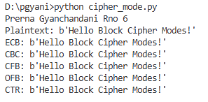
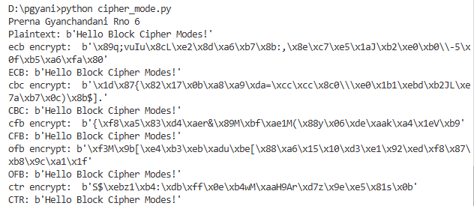

Name: Prerna Deepak Gyanchandani Roll No.: 25KSMSCCS06 Date: 7/2/26

Cryptography and Cryptanalysis

Practical 6

Aim: Program to implement Steganography for hiding messages inside the image file.
From Windows cmd.exec on place where image and zip
Cmd: copy /b demo.png + demo.zip output.jpg
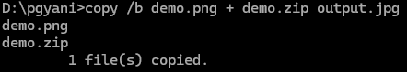
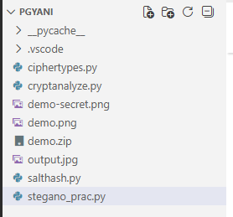Take any image
Package Installation Cmd: pip install stegano pillow
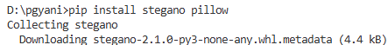
Code:
from stegano import lsb
from PIL import Image
import os
def hide_message(image_path, message, output_path=None):
base, ext = os.path.splitext(image_path)
# Convert to PNG if JPG (stegano requires lossless format)
if ext.lower() in ['.jpg', '.jpeg']:
png_path = base + '.png'
Image.open(image_path).save(png_path)
image_path = png_path
# Set output path
if output_path is None:
output_path = base + '-secret.png'
steg = lsb.hide(image_path, message)
steg.save(output_path)
print(f'Message hidden in: {output_path}')
return output_path
def reveal_message(image_path):
"""Reveal a hidden message from an image"""
msg = lsb.reveal(image_path)
return msg
if __name__ == "__main__":
input_image = input('Enter image path (JPG/PNG): ')
message = input('Enter secret message: ')
output = hide_message(input_image, message)
revealed = reveal_message(output)
print('Hidden message:', revealed)
Output:
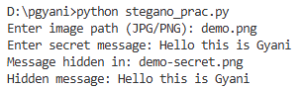
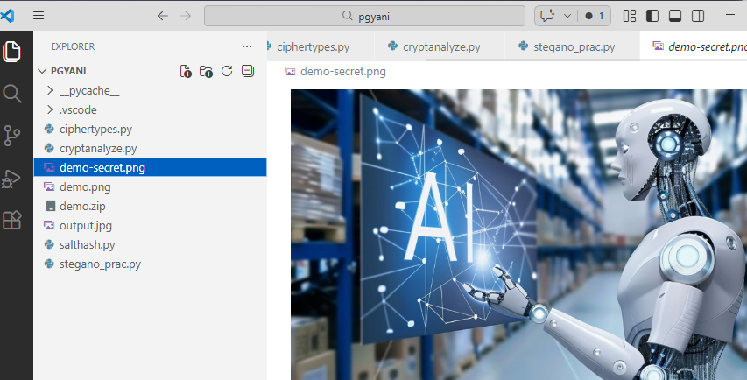
Name: Prerna Deepak Gyanchandani Roll No.: 25KSMSCCS06 Date: 14/2/26

Cryptography and Cryptanalysis

Practical 7

Aim: Program to implement HMAC for signing messages.
Code:
import hmac
import hashlib
import secrets
# Initial sent message
sent_msg = input('Enter message: ')
key = secrets.token_bytes(32)
s_md_l = hmac.new(key=key, msg=sent_msg.encode(), digestmod=hashlib.sha256)
init_msg_digest = s_md_l.hexdigest()
#Received message
received = sent_msg
r_md_l = hmac.new(key=key, msg=received.encode(), digestmod=hashlib.sha256)
recv_msg_digest = r_md_l.hexdigest()
#Comparing sent and received msg
print('----Before Tampering-----')
print('Original Message:', sent_msg)
print('Original Digest:', init_msg_digest)
print('Received Message:', received)
print('Received Digest:', recv_msg_digest)
print('Is the message received without any tampering:', 'Yes' if hmac.compare_digest(init_msg_digest, recv_msg_digest) else 'No')
# Tampered message
tampered_msg = sent_msg[1:] if len(sent_msg) > 0 else sent_msg # Avoid error if empty
md_2 = hmac.new(key=key, msg=tampered_msg.encode(), digestmod=hashlib.sha256)
tampered_msg_digest = md_2.hexdigest()
# Comparing after tampering
print('----After Tampering-----')
print('Tampered Message:', tampered_msg)
print('Tampered Digest:', tampered_msg_digest)
print('Is the message received without any tampering:', 'Yes' if hmac.compare_digest(init_msg_digest, tampered_msg_digest) else 'No')
#mac - to get msg authentication code - it maintains integrity, msg digest - unique id of text, skips 1 character
Output:
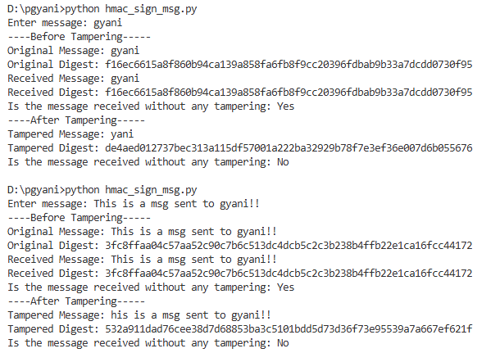

Name: Prerna Deepak Gyanchandani Roll No.: 25KSMSCCS06 Date: 17/2/26

Cryptography and Cryptanalysis

Practical 8

Aim: Program to implement Sending Secure Messages Over IP Networks.
Code:
⇒ server.py
import socket
from Crypto.Cipher import AES
from Crypto.Util.Padding import unpad
# shared secret key (16 bytes)
key = b'1234567890abcdef'
s = socket.socket()
s.bind(("0.0.0.0", 5000))
s.listen(1)
conn, addr = s.accept()
print("Connected:", addr)
iv = conn.recv(16)
ciphertext = conn.recv(1024)
print("\n--- Server ---")
print("IV received (hex):", iv.hex())
print("Ciphertext received (hex):", ciphertext.hex())
cipher = AES.new(key, AES.MODE_CBC, iv)
plaintext = unpad(cipher.decrypt(ciphertext), 16)
print("Decrypted message:", plaintext.decode())
conn.close()
⇒ client.py
import socket
from Crypto.Cipher import AES
from Crypto.Util.Padding import pad
from Crypto.Random import get_random_bytes
# shared secret key (16 bytes)
key = b'1234567890abcdef'
msg = input("Enter message: ").encode()
print("\n--- Client ---")
print("Original message:", msg.decode())
cipher = AES.new(key, AES.MODE_CBC)
ciphertext = cipher.encrypt(pad(msg, 16))
print("IV (hex):", cipher.iv.hex())
print("Encrypted ciphertext (hex):", ciphertext.hex())
s = socket.socket()
s.connect(("127.0.0.1", 5000))
s.send(cipher.iv)
s.send(ciphertext)
s.close()
print("Message sent to server.")

Output:
Run server.py in one terminal (cmd):
Then run client.py in another terminal (cmd) and enter a message:
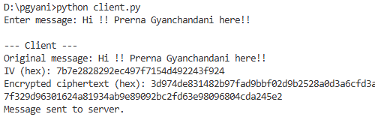
Check the message on server received from client:
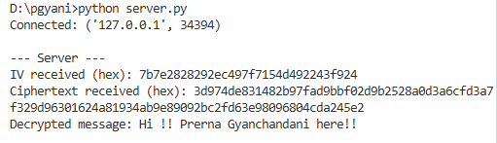

Name: Prerna Deepak Gyanchandani Roll No.: 25KSMSCCS06 Date: 17/2/26

Cryptography and Cryptanalysis

Practical 9

Aim: Program to implement RSA encryption/decryption
Code:
#pip install pycryptodome
# Key generation
p = 11
q = 13
# modulus
n = p * q
phi = (p-1)*(q-1)
# public exponent (coprime with phi)
e = 7
# find d such that (d*e) % phi = 1
for d in range(1, phi):
if (d * e) % phi == 1:
break
print("Public key (e, n):", (e, n))
print("Private key (d, n):", (d, n))
# message (number < n)
#msg = 9
#print("Original:", msg)
# message (number < n)
print("Prerna Gyanchandani Rno 6")
msg = int(input(f"Enter a number to encrypt (less than {n}): "))
print("Original:", msg)
# Encryption: c = m^e mod n
cipher = pow(msg, e, n)
print("Encrypted:", cipher)
# Decryption: m = c^d mod n
plain = pow(cipher, d, n)
print("Decrypted:", plain)

Output:
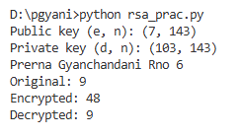
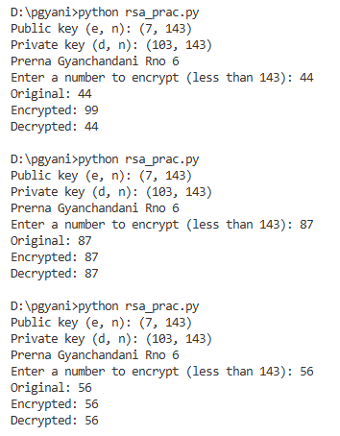

RSA ADDITIONAL WITH STRING DATA (PRACTICE ONLY VERSION) - not include for exam
Code:
p = 11
q = 13
n = p * q
phi = (p-1)*(q-1)
e = 7
for d in range(1, phi):
if (d * e) % phi == 1:
break
print("Public key (e, n):", (e, n))
print("Private key (d, n):", (d, n))
msg = input("Enter a message to encrypt: ")
print("Original:", msg)
cipher = [pow(ord(ch), e, n) for ch in msg]
print("Encrypted:", cipher)
plain = ''.join(chr(pow(c, d, n)) for c in cipher)
print("Decrypted:", plain)
Output:
