# Project Title:- Simulation of a computer Network using Bus and Star topology

# Project Description :-

### Design a Bus topology with Star topology as a backbone and star topology as the terminal of bus topology. Consider 192.168.16.0/24 as the first address of the network, and allocate

### 64 addresses to 2 star terminal

### 32 addresses to 2 star terminal

### iii) 16 addresses to 4 star terminal

Whole Network 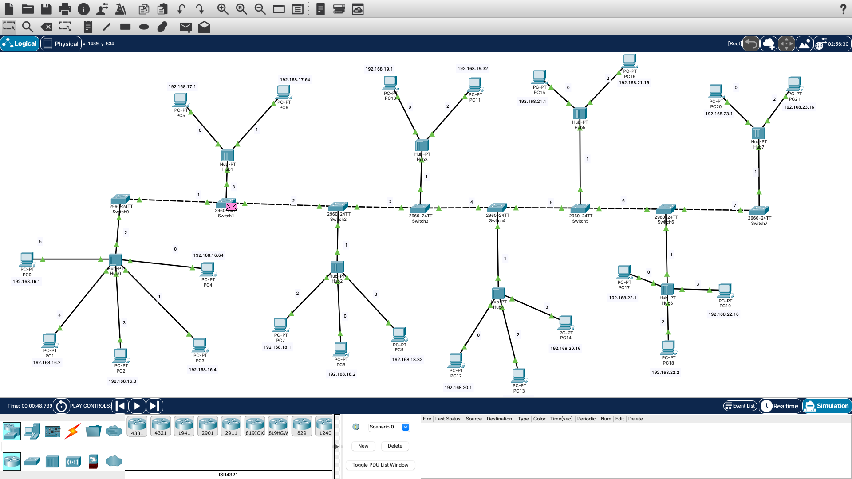

PDU List

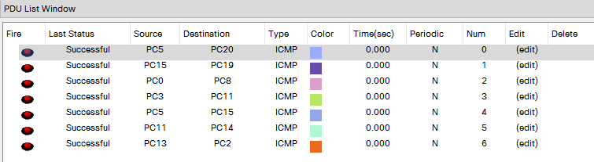

IP Addresses :-

1. **64 addresses to 2 star terminal**

**Switch 0 -**

PC0=192.168.16.1

PC1=192.168.16.2

PC2=192.168.16.3

PC3=192.168.16.4

PC4=192.168.16.64

Default gateway= 192.168.16.255

**Switch 1 –**

**PC5-** 192.168.17.1

**PC6-** 192.168.17.64

Default gateway= 192.168.17.255

1. **32 addresses to 2 star terminal**

**Switch 2 -**

**PC7-** 192.168.18.1

**PC8-** 192.168.18.2

**PC9-** 192.168.18.32

Default gateway= 192.168.18.255

**Switch 3 -**

**PC10-** 192.168.19.1

**PC11-** 192.168.19.32

Default gateway= 192.168.19.255

1. **16 addresses to 4 star terminal**

**Switch 4 -**

**PC12-** 192.168.20.1

**PC13-** 192.168.20.2

**PC14-** 192.168.20.16

Default gateway= 192.168.20.255

**Switch 5 -**

**PC15-** 192.168.21.1

**PC16-** 192.168.21.16

Default gateway= 192.168.21.255

**Switch 6 –**

PC17- 192.168.22.1

PC18- 192.168.22.2

PC19- 192.168.22.16

Default gateway= 192.168.22.255

**Switch 7 –**

PC20- 192.168.23.1

PC21- 192.168.23.16

Default gateway= 192.168.23.255

|  |  |
| --- | --- |
|  |  |