|  |  |
| --- | --- |
| **Name – Prerna Sunil Jadhav** | **SAP ID - 60004220127** |

**Experiment No - 01**

**AIM: TO IMPLEMENT JAVA PROGRAM STRUCTURES & SIMPLE PROGRAMS**

**THEORY:**

* Java is a programming language and a platform. Java is a high level, robust, object-oriented, and secure programming language.
* main() method is essential for all Java programs because the execution of all Java programs starts from the main() method. In other words, it is an entry point of the class.
* 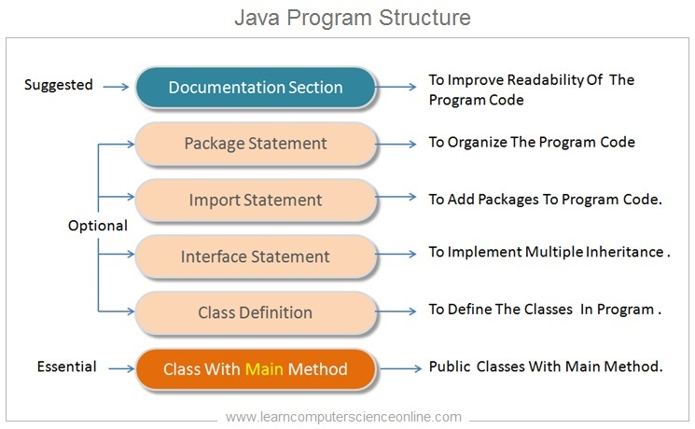A typical structure of a Java program contains the following elements:

**PROGRAM 1**: Write a Program to display “Hello” Message on screen.

**CODE:**

**THEORY:**

In Java, System.out.println() is used to print a statement which has been passed in its argument. There are 2 printing statements in Java, the first being System.out.print() which prints the argument passed through it

on the same line and the second being System.out.println() which is similar to System.out.print() method except that it moves the cursor to the next line after printing the result.

**OUTPUT:**



**PROGRAM 1**: Write a Java program that reads a positive integer from command line and count the number of digits the number (less than ten billion) has.

**CODE:**

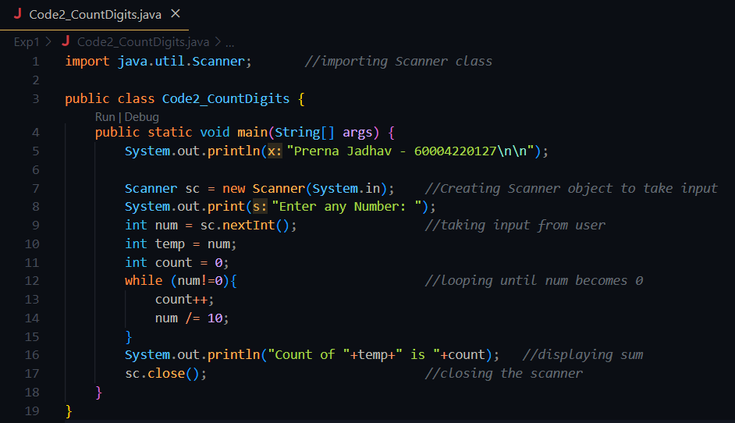

**THEORY:**

The while loop in Java is a control flow statement that allows code to be executed repeatedly based on a given boolean condition. The loop goes on until the boolean condition turns false. When the number of iterations in not known to the user, they can use the while loop

**OUTPUT:**



**CONCLUSION:**

This Experiment covered a lot of territory relating to the fundamentals of the Java programming language.

It started by learning about the structure of Java program code then learned about the different data types used in Java. From there it was learnt how Java evaluates expressions. Finally, we also coded a program about the different operators used to carry out operations such as assignment, addition, subtraction, modulus, division etc.