|  |  |
| --- | --- |
| **Name – Prerna Sunil Jadhav** | **SAP ID - 60004220127** |

**Experiment No – 10**

**AIM: To implement Package (CO2)**

**THEORY:**

Package in Java is a mechanism to encapsulate a group of classes, sub packages and interfaces. To create package in Java: - First create a directory within the name of the package. - Create a java file in the newly created directory. - In this java file you must specify the package name with the help of package keyword. - Save this file with same name of public class Note: only one class in a program can declare as public.

**CODE (i): WAP to create a user defined package & import the package in another program.**

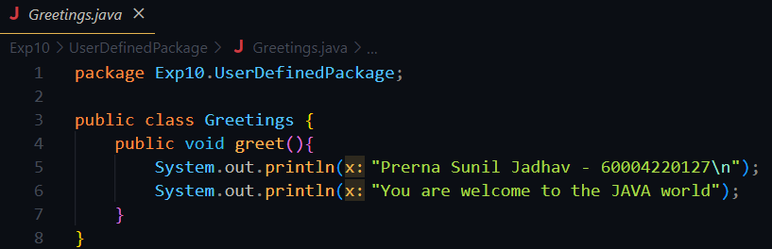

**Output:**

**Conclusion:**

**Thus we implemented Package**