|  |  |
| --- | --- |
| **Name – Prerna Sunil Jadhav** | **SAP ID - 60004220127** |

**Experiment No – 11**

**AIM: To implement exceptions in Java (CO5)**

**THEORY:**

In Java, an exception is an event that disrupts the normal flow of the program. It is an object which is thrown at runtime. The core advantage of exception handling is to maintain the normal flow of the application. An exception normally disrupts the normal flow of the application; that is why we need to handle exceptions. The java.lang. Throwable class is the root class of Java Exception hierarchy inherited by two subclasses: Exception and Error. Java Exception Handling in which we are using a try-catch statement to handle the exception.

**CODE (i): Write a Java Program to input the data through command Line and Find out total valid and in-valid integers. (Hint: use exception handling)**

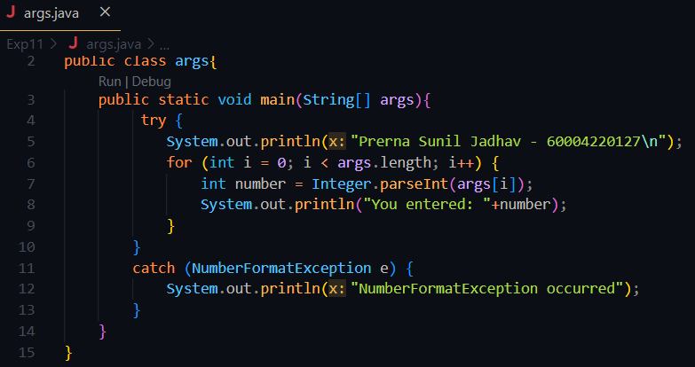

**Output:**

**Theory:**

In Java, we can create our own exceptions that are derived classes of the Exception class. Steps to create custom Exception Handling : Create a new class whose name should end with an Exception like MarksOutOfBoundsException .This is a convention to differentiate an exception class from regular ones. Make the class extends one of the exceptions which are subtypes of the java.lang.Exception class. Generally, a custom exception class always extends directly from the Exception class. Create a constructor with a String parameter which is the detailed message of the exception. In this constructor, simply call the super constructor and pass the message

**CODE (ii): Write a Java Program to calculate the Result. Result should consist of name, seatno, date, center number and marks of semester three exam. Create a User Defined Exception class MarksOutOfBoundsException, If Entered marks of any subject is greater than 100 or less than 0, and then program should create a user defined Exception of type MarksOutOfBoundsException and must have a provision to handle it.**

**OUTPUT:**

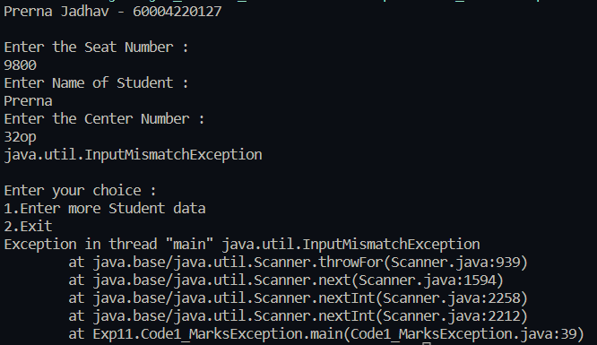

**CONCLUSION: Hereby, implemented exceptions in Java.**