|  |  |
| --- | --- |
| **Name – Prerna Sunil Jadhav** | **SAP ID - 60004220127** |

**Experiment No – 12**

**AIM: To implement Multithreading**

**THEORY:**

Multi-threading enables you to write in a way where multiple activities can proceed concurrently in the same program. By definition, multitasking is when multiple processes share common processing resources such as a CPU. Multi-threading extends the idea of multitasking into applications where you can subdivide specific operations within a single application into individual threads. Each of the threads can run in parallel. The OS divides processing time not only among different applications, but also among each thread within an application.

**CODE (i): WAP to print Table of Five, Seven and Thirteen using Multithreading (Use Thread class for the implementation). Also print the total time taken by each thread for the execution.**

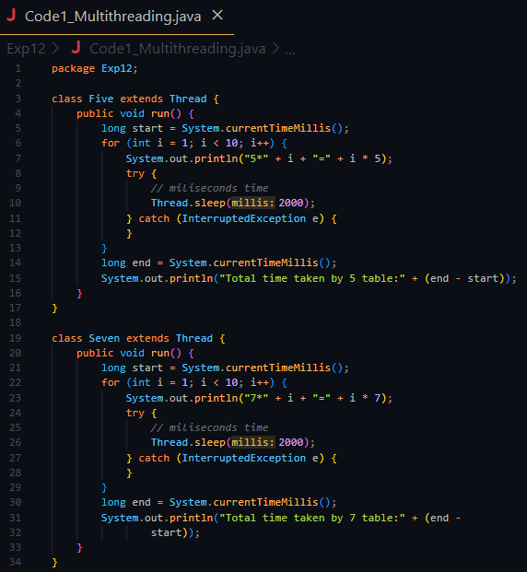

**Output:**

**CONCLUSION: Hereby, implemented multithreading in Java.**

**AIM:** **Write java program to implement the concept of Thread Synchronization**

**THEORY:**

When we start two or more threads within a program, there may be a situation when multiple threads try to access the same resource and finally, they can produce unforeseen result due to concurrency issues. The function Thread.sleep() is used so that it sleeps a thread for the specified amount of time. Till the time another thread is running. The function isAlive() is used so that it tests if the thread is alive.(It returns a boolean value).

**CODE:** **Write java program to implement the concept of Thread Synchronization**

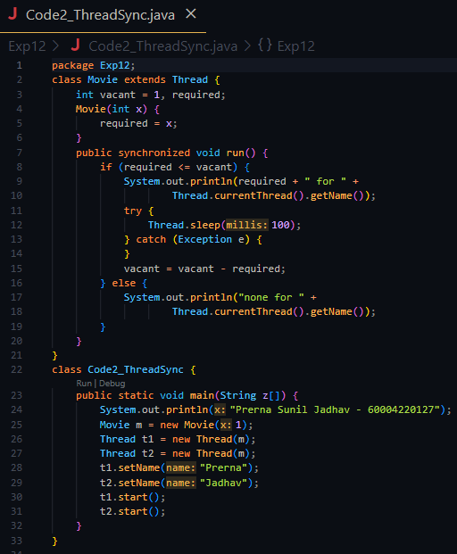

**OUTPUT:**



**CONCLUSION: Thus, we implemented programs on Multithreading.**