|  |  |
| --- | --- |
| **Name – Prerna Sunil Jadhav** | **SAP ID - 60004220127** |

**Experiment No – 13**

**AIM: To implement Applets (CO6)**

**THEORY:**

The javax.swing.JFrame class is a type of container which inherits the java.awt.Frame class. JFrame works like the main window where components like labels, buttons, textfields are added to create a GUI. Unlike Frame, JFrame has the option to hide or close the window with the help of setDefaultCloseOperation(int) method. Here, I have created a house using VSCode IDE .

**CODE (i): Write a java program to draw the house on an applet**

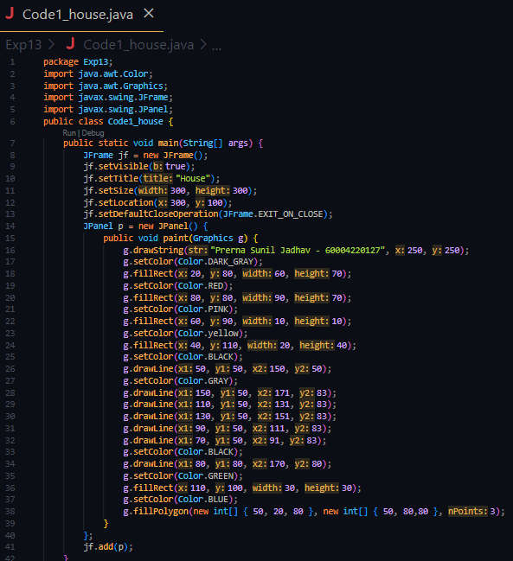

**Output:**

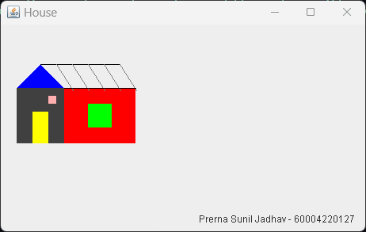

**THEORY:**

The following program implements the use of abstract class where we declare all the functions and define and Applets are embeddable Java applications that are expected to start and stop themselves on command, possibly many times in their lifetime. A Java-enabled web browser normally starts an applet when the applet is displayed and stops it when the user moves to another page or (in theory) when the user scrolls the applet out of view. To conform to this API, we would like an applet to cease its nonessential activity when it is stopped and resume it when started again. An important compromise was made early in the design of Swing relating to speed, GUI consistency, and thread safety. To provide maximum performance and simplicity in the common case, Swing does not explicitly synchronize access to most Swing component methods. This means that most Swing components are, technically, not threadsafe for multithreaded applications.

**Code (ii): Write java program to create an advertisement banner on an applet using multithreading**

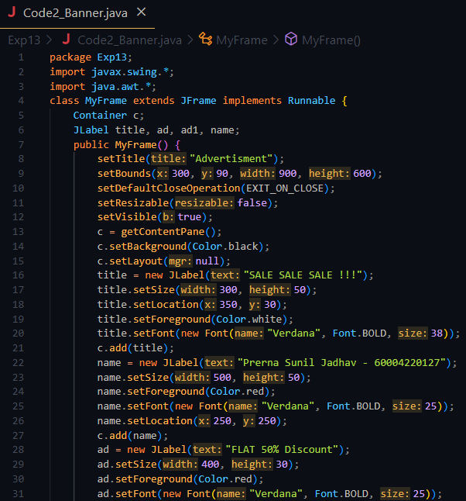



**OUTPUT:**

**CONCLUSION: Thus, we implemented programs on applets.**