|  |  |
| --- | --- |
| **Name – Prerna Sunil Jadhav** | **SAP ID - 60004220127** |

**Experiment No – 14**

**AIM: Designing Graphical User Interfaces in Java using AWT and Event handling (CO6)**

**THEORY:**

Java AWT (Abstract Window Toolkit) is an API to develop Graphical User Interface (GUI) or windows-based applications in Java. Java AWT components are platform-dependent i.e. components are displayed according to the view of operating system. AWT is heavy weight i.e. its components are using the resources of underlying operating system (OS). The java.awt package provides classes for AWT API such as TextField, Label, TextArea, RadioButton, CheckBox, Choice, List etc. The AWT tutorial will help the user to understand Java GUI programming in simple and easy steps.

**Code (i): Write java program to create a registration form using AWT..**

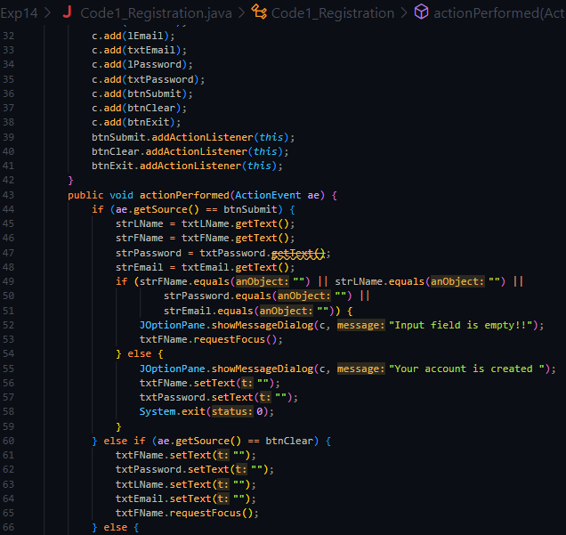

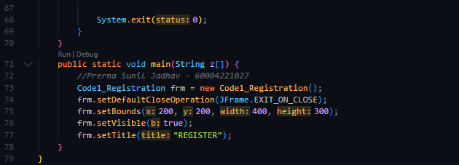

**OUTPUT:**

**THEORY:**

In this program we have created a login form where used gets logged in if he enters the correct username and password. After OK button is pressed the username and password is checked, if it matches the actual credentials then used successfully logs in or else it’s an unsuccessful login.

Components Used:

• JFrame

• JTextField

• JPasswordField

• JButton

**Code (ii): On Applet: Take a Login and Password from the user and display it on the third Text Field which appears only on clicking OK button and clear both the Text Fields on clicking RESET button**

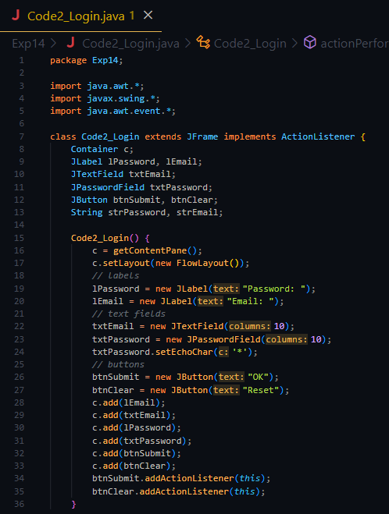

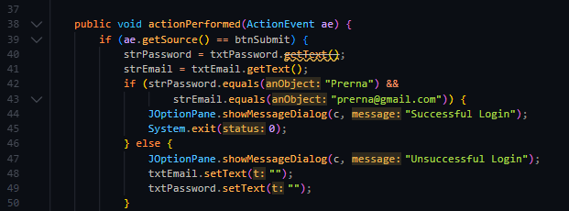

**OUTPUT:**

**CONCLUSION:** Thus, we implemented Graphical User Interfaces in Java using AWT and Event handling