|  |  |
| --- | --- |
| **Name – Prerna Sunil Jadhav** | **SAP ID - 60004220127** |

**Experiment No - 03**

**AIM: TO IMPLEMENT ARRAYS**

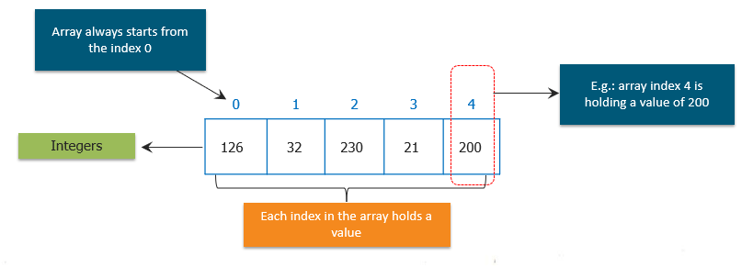**THEORY:**

An array is a collection of similar types of data.

For example, if we want to store the names of 100 people then we can create an array of the string type that can store 100 names.

String[] array = new String[100];

Here, the above array cannot store more than 100 names. The number of values in a Java array is always fixed.

In Java, here is how we can declare an array.

dataType[] arrayName;

datatype - it can be primitive data types like int, char, double, byte, etc. or Java objects

arrayName - it is an identifier

For example,

double[] data;

Here, data is an array that can hold values of type double.

A multidimensional array is an array of arrays. Each element of a multidimensional array is an array itself.

int[][] a = new int[3][4];

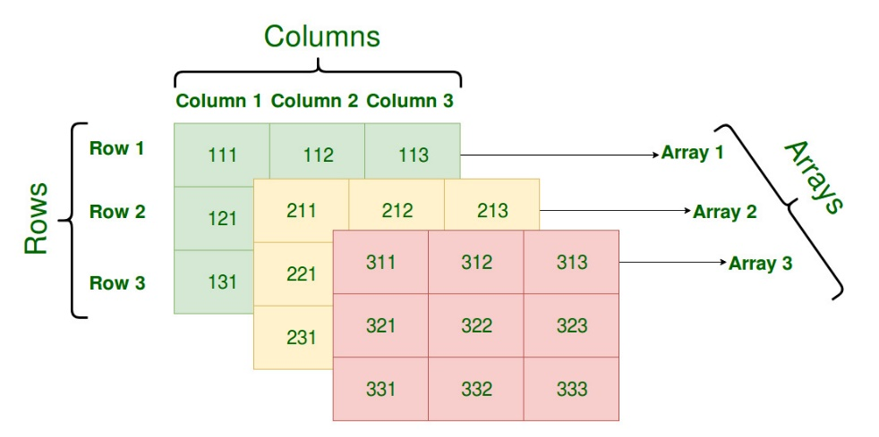**PROGRAM 1:** Write A Program to find whether the entered 4 digit number is vampire or not. Combination of digits from this number forms 2 digit number. When they are multiplied by each other we get the original number. (1260=21*60, 1395=15*93, 1530=30*51)

**CODE:**

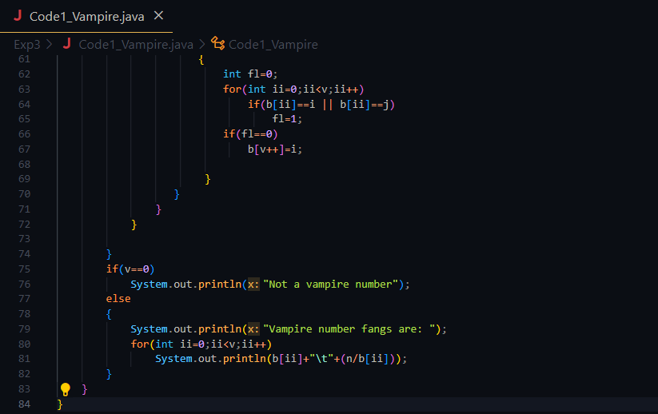

OUTPUT:

**PROGRAM 2:** WAP to display the following using irregular arrays

2 3

4 5 6

**CODE:**

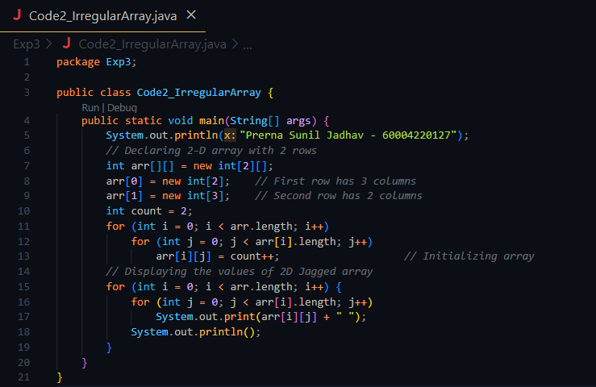

**OUTPUT:**

**PROGRAM3:** WAP that queries a user for no. of rows & columns representing students & their marks. Reads data row by row & displays the data in the tabular form along with the row & columns & grand total.

**CODE:**

**OUTPUT:**

**CONCLUSION:**

* 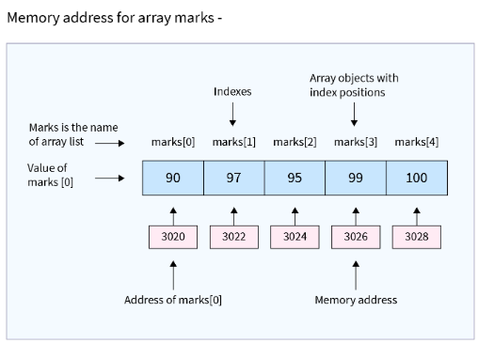Array indices always start from 0. That is, the first element of an array is at index 0.
* If the size of an array is n, then the last element of the array will be at index n-1.
* Array in Java is a non-primitive data type used to store multiple values of the same data type.
* Elements of the array can be accessed by the index ranging from 0 to array length - 1.
* We can use for loop and for-each loop for looping through all the array elements.
* There are two arrays in Java: Single and Multi-dimensional, where single has one dimension, and multi includes 2D, 3D, and nD dimensions.
* Likewise primitive data types, we can also implement an array of objects in Java.