|  |  |
| --- | --- |
| **Name – Prerna Sunil Jadhav** | **SAP ID - 60004220127** |

**Experiment No - 04**

**AIM: TO IMPLEMENT VECTORS**

**THEORY:**

* Vector is a data structure that is used to store a collection of elements. Elements can be of all primitive types like int, float, Object etc. Vectors are dynamic in nature and accordingly grow or shrink as per the requirement.
* Vector class is found in the java.util package.
* 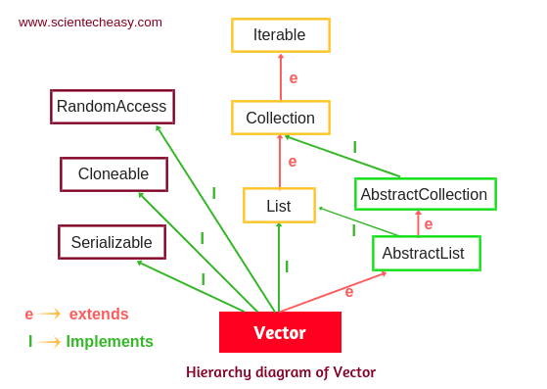Vector class is a child class of the AbstractList class and implements the List interface. Therefore we can use all the methods of the List interface.
* Vectors are known to give ConcurrentModificationException when accessed concurrently at the time of modification.
* When a Vector is created, it has a certain capacity to store elements that can be defined initially. This capacity is dynamic in nature and can be increased or decreased.
* By definition, Vectors are synchronized, which implies that at a time, only one thread is able to access the code while other threads have to wait. Due to this, Vectors are slower in performance as they acquire a lock on a thread.
* Declaration of Vector in Java

Syntax:

**public class Vector<E> extends AbstractList<E> implements List<E>, RandomAccess, Cloneable, Serializable**

Here, E denotes the Element Type

Vector Class extends AbstractList and implements multiple interfaces like Serializable, Cloneable, Iterable<E>, Collection<E>, List<E>, RandomAccess interfaces.

**PROGRAM 1:** Write A Program that accepts a shopping list of items and performs the following operations: Add an item at a specified location, delete an item in the list, and print the contents of the vector

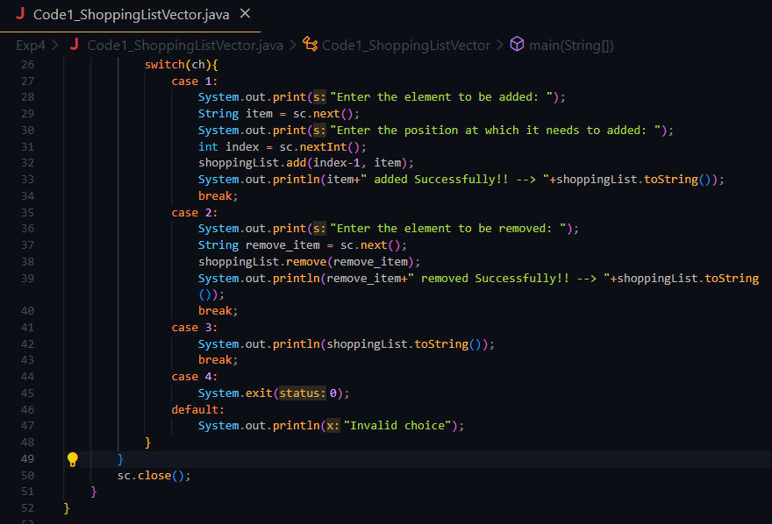**CODE:**

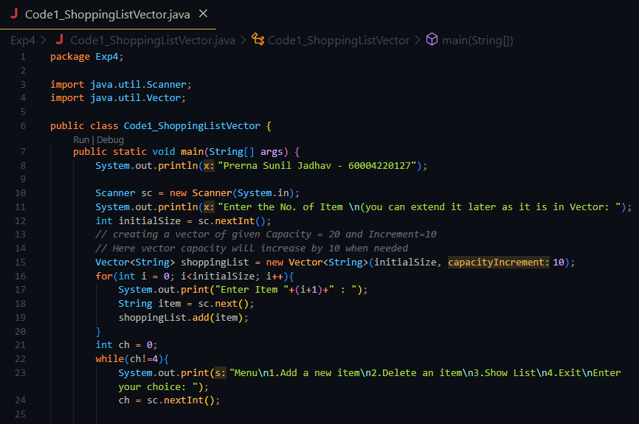



**OUTPUT:**

**PROGRAM2:** Write a java program to find frequency of an element in the given Vector array.

**CODE:**

**OUTPUT:**

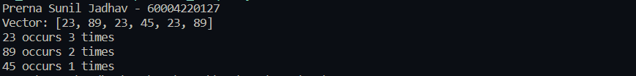

**CONCLUSION:**

* The usage of vectors in java is mainly in cases when we want the processes in a synchronized manner since ArrayList and Vector both possess the property of dynamic sizes, but ArrayList is avoided when working with multiple threads.
* Vector class in Java throws ConcurrentModificationException, IllegalArgumentException and NullPointerException exceptions.
* Vectors in Java can be initialized using four types of constructors.
* Various methods are provided in the Vector class for handling the vector operations.
* We can use vectors to implement Tree Data structure or anywhere we are unsure about the size.