|  |  |
| --- | --- |
| **Name – Prerna Sunil Jadhav** | **SAP ID - 60004220127** |

**Experiment No - 05**

**AIM: TO IMPLEMENT STRINGS**

**THEORY:**

* Strings are an integral part of programming.
* In Java, We have a String class for creating and manipulating strings.
* Also, there is an interface called CharSequence used for representing a character sequence.
* The String class is one of the classes which implement this interface.
* Hence, string is basically an object that represents a sequence of char values..
* Diagram, timeline

  Description automatically generatedFor example, the word "sufiyan" is an array of characters 's', 'u', 'f', 'i', 'y', 'a', 'n. Here "sufiyan" is nothing but a sequence of characters i.e. a string.
* We have different String methods such as concat(), length(), compareTo(), equals(), etc. to handle various string operations.
* There can be two ways(or methods) of doing this:
  + Using char[] array in Java

**public class Main {**

**public static void main(String args[]) {**

**char[] ch = { 's', 'u', 'f', 'i', 'y', 'a', 'n' };**

**System.out.println(ch); *// sufiyan***

**}**

**}**

* Output:

**sufiyan**

* Using String class in Java

***// student name***

**public class Main {**

**public static void main(String args[]) {**

**String stdName = "sufiyan";**

**System.out.println(stdName); *// sufiyan***

**}**

**}**

* Output:

**sufiyan**

**PROGRAM 1:** Write A Program to check if 2 strings are Meta strings or not. Meta strings are the strings which can be made equal by exactly one swap in any of the strings. Equal string are not considered here as Meta strings.

Example: str1 = "geeks”, str2 = "keegs"

By just swapping 'k' and 'g' in any of string, both will become same.

Example: str1 = "Converse", str2 = "Conserve"

By just swapping 'v' and’s’ in any of string, both will become same.

**CODE:**

**OUTPUT:**



**PROGRAM2:** Write a java program to count number of alphabets, digits, special symbols, blank spaces, and words from the given sentence. Also count number of vowels and consonants**.**

**CODE:**

**OUTPUT:**

**CONCLUSION:**

* In Java, Strings are the Objects which are internally a sequence of characters. In simple words, Strings are the collection/combination of characters.
* Newly created strings are stored in a special area in the heap called String pool or String Constant Pool.
* Strings can be created using the string literals as well as using the new keyword as strings are objects in Java.
* 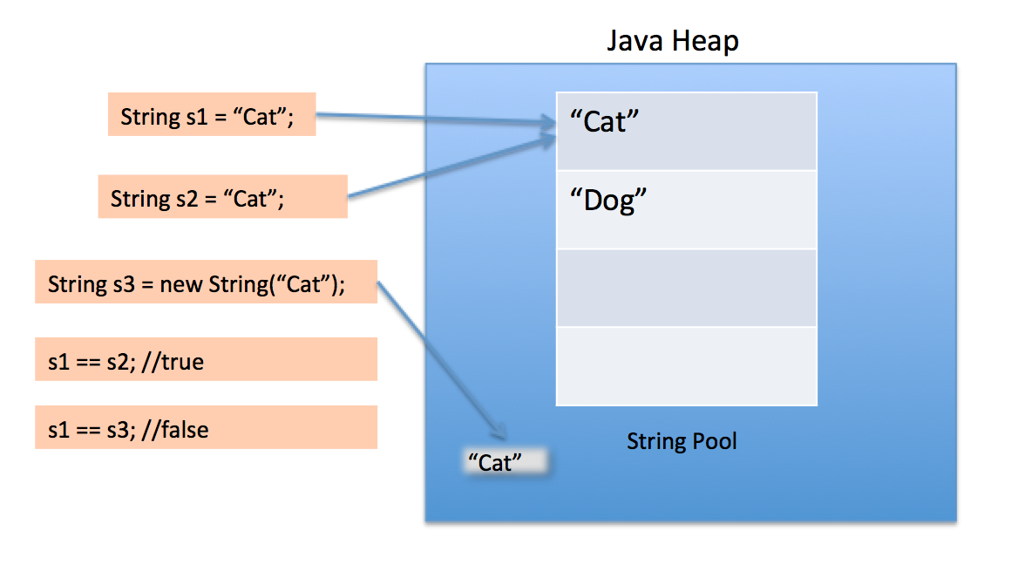Strings created using the new keyword are allocated memory in the heap memory outside the string constant pool.
* There are different methods of Strings in Java that can be used to make it easy to work with string in Java.
* Strings can be concatenated using the two ways: the + operator and the concat() method of string in Java.
* Strings can be formatted using the format() method.
* We can use the escape character(\) to escape some characters in String and go through all of the string text.
* Strings in Java are immutable which simply means that the string value can not be changed once it gets initialized(or created) .