|  |  |
| --- | --- |
| **Name – Prerna Sunil Jadhav** | **SAP ID - 60004220127** |

**Experiment No – 06(A)**

**AIM: To implement Functions, recursive functions and overloading (CO1)**

**THEORY:**

* Functions/ Methods
  + Java Method is a collection of statements that perform some specific task and return the result to the caller.
  + A Java method can perform some specific task without returning anything.
  + Methods in Java allow us to reuse the code without retyping the code.
  + In Java, every method must be part of some class that is different from languages like C, C++, and Python.

1. A method is like function i.e. used to expose behavior of an object.

2. it is a set of codes that perform a particular task.

* Recursion
  + Recursion is the technique of making a function call itself. This technique provides a way to break complicated problems down into simple problems which are easier to solve.
  + Just as loops can run into the problem of infinite looping, recursive functions can run into the problem of infinite recursion. Infinite recursion is when the function never stops calling itself. Every recursive function should have a halting condition, which is the condition where the function stops calling itself.
* Method Overloading
  + If a class has multiple methods having same name but different in parameters, it is known as Method Overloading.
  + If we have to perform only one operation, having same name of the methods increases the readability of the program.

**PROGRAM 1:** Write A Program to check if 2 strings are Meta strings or not. Meta strings are the strings which can be made equal by exactly one swap in any of the strings. Equal string are not considered here as Meta strings.

Example: str1 = "geeks”, str2 = "keegs"

By just swapping 'k' and 'g' in any of string, both will become same.

Example: str1 = "Converse", str2 = "Conserve"

By just swapping 'v' and’s’ in any of string, both will become same.

**CODE (i): WAP to display area of square and rectangle using the concept of overloaded functions**

**OUTPUT:**

**(ii) Write menu driven program to implement recursive functions for following tasks**

**CODE (ii)(a):** To find GCD and LCM

**OUTPUT:**

**CODE (ii)(b):** To find

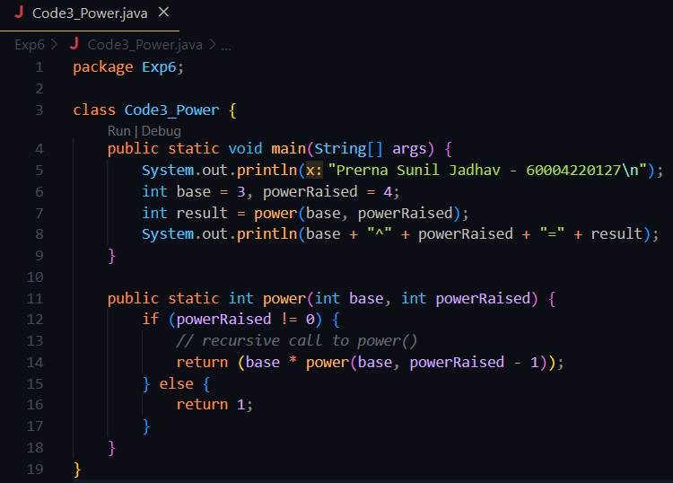

**OUTPUT:**

**CODE (ii)(c):** To print n Fibonacci numbers

**OUTPUT:**

**CODE (ii)(d):** To find reverse of number

**OUTPUT:**

**CODE (ii)(e):** To 1+2+3+4+…….+ (n-1)+n

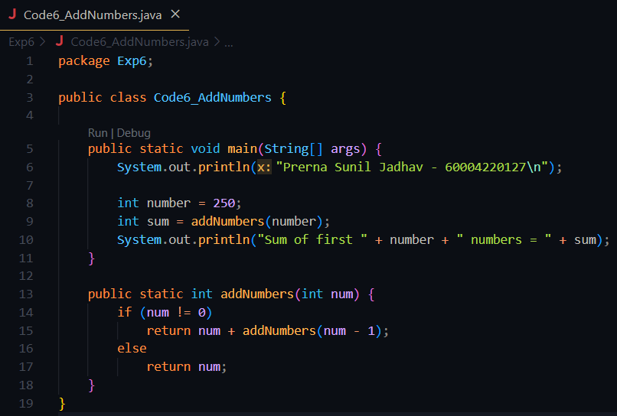

**OUTPUT:**

**CODE (ii)(f):** Calculate sum of digits of a number

**OUTPUT:**

**CONCLUSION:**

* Method overloading refers to the creation of more than one methods with the same name in the same class. Method overloading is a way that demonstrates polymorphism(or more accurately static polymorphism) in Java.
* Recursion is the process in which a function calls itself and the method that calls itself is known as a recursive function. This means that the method call statement is present in the body of the method itself.