|  |  |
| --- | --- |
| **Name – Prerna Sunil Jadhav** | **SAP ID - 60004220127** |

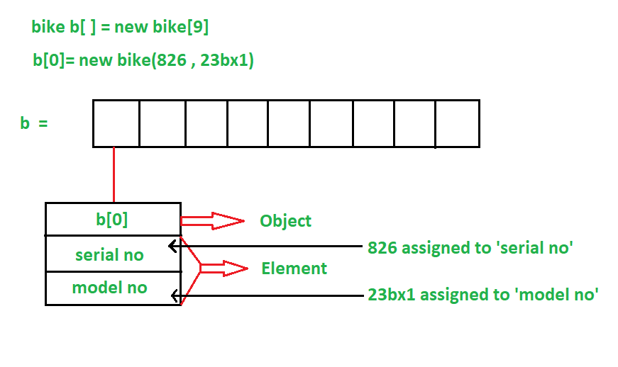**Experiment No – 06(B)**

**AIM: To implement Array of Objects (CO2)**

**THEORY:**

* The array of Objects the name itself suggests that it stores an array of objects.
* Unlike the traditional array stores values like String, integer, Boolean, etc an Array of Objects stores objects that mean objects are stored as elements of an array.
* Note that when we say Array of Objects it is not the object itself that is stored in the array but the reference of the object.

**CODE (i): WOOP to arrange the names of students in descending order of their total marks, input data consists of students details such as names, ID.no, marks of maths, physics, chemistry. (Use array of objects)**

**OUTPUT:**

**CONCLUSION:**

* An object represents a single record in memory, and thus for multiple records, an array of objects must be created.
* It must be noted that the arrays can hold only references to the objects, and not the objects themselves.