|  |  |
| --- | --- |
| **Name – Prerna Sunil Jadhav** | **SAP ID - 60004220127** |

**Experiment No – 08**

**AIM: To implement Abstract classes (CO4)**

**THEORY:**

In this below given program we have implemented concepts like data encapsulation , constructor overloading. Encapsulation in Java is a mechanism of wrapping the data (variables) and code acting on the data (methods) together as a single unit. In encapsulation, the variables of a class will be hidden from other classes and can be accessed only through the methods of their current class. Abstract class called Shape has three subclasses say Triangle, Rectangle, Circle. Method area() in the abstract class and override this area() in these three subclasses to calculate for specific object i.e., Area() of Triangle subclass should calculate area of triangle etc. Same for Rectangle and Circle. An abstract class is like a blueprint/format about the minimum required functions. A method which is declared as abstract and does not have implementation is known as an abstract method.

**CODE (i): Write a abstract class program to calculate area of circle, rectangle and triangle**

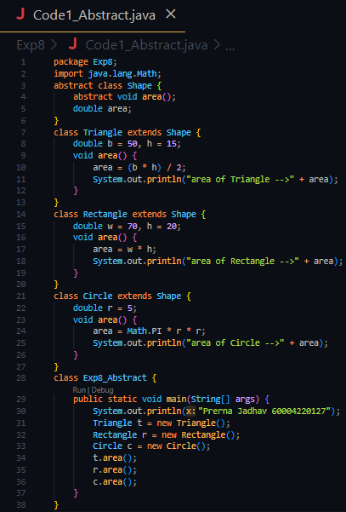

**OUTPUT:**

**CONCLUSION: Thus, we implemented Abstract classes.**