|  |  |
| --- | --- |
| **Name – Prerna Sunil Jadhav** | **SAP ID - 60004220127** |

**Experiment No – 09**

**AIM: To implement Inheritance, interfaces and method Overriding**

**THEORY:**

In this program we created, and interface named sports which consists of score function and created 3 classes namely student, text by extending the student class and Result by extending student class and implementing the interface sports. Lastly, we created class multiple and executed all the functions. Inheritance in Java is a mechanism in which one object acquires all the properties and behaviors of a parent object. It is an important part of OOPs (Object Oriented programming system). An interface is a reference type, similar to a class. That can contain only constants, method signatures, default methods, static methods, and nested types.

**CODE (i): WAP to implement three classes namely Student, Test and Result. Student class has member as roll no, Test class has members as sem1_marks and sem2_marks and Result class has member as total. Create an interface named sports that has a member score (). Derive Test class from Student and Result class has multiple inheritances from Test and Sports. Total is formula based on sem1_marks, sem2_mark and score.**

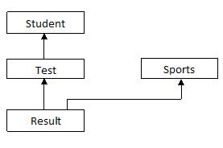

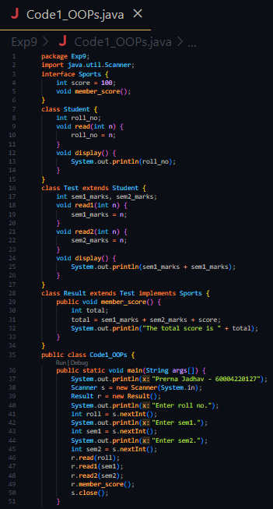

**Output:**

**Conclusion:**

**Thus we implemented Inheritance, interfaces and method Overriding**