SMART CRADLE

##### A SUMMER TRAINING PROJECT REPORT

###### **Submitted by**

###### [TRIPTI SAINI, PRERNA SINGH, DILSHEEN KAUR(Group7)]

Under the guidance of

Dr. SRN Reddy, Associate Professor, IGDTUW

***in partial fulfillment for the award of the certificate***

***in***

**“Build Your Smart Device”**

**Organizing by CSE Dept, Indira Gandhi Delhi Technical University For Women, Delhi in collaboration**

(From 5-06-2017 to 14-07-2017)

**CERTIFICATE**

This is to certify that Summer Training Project Report entitled “**SMART CRADLE**” submitted by Dilsheen Kaur, Prerna Singh, Tripti Saini ( group 7) is an authentic work carried out by [Him/ her] at Indira Gandhi Delhi Technical University for Women, Delhi under my guidance during STP8 in 2017. The matter embodied in this project work has not been submitted earlier for the award of any degree or diploma to the best of my knowledge and belief.

Date: Signature of the Guide

**Dr. S.R.N Reddy/[]**

**Associate Professor, ……**

**Kashmeri Gate, Delhi, 110006**

Signature of the Student

**ACKNOWLEDGEMENT**

I take this opportunity to express a deep sense of gratitude towards Indira Gandhi Delhi Technical University For Women for organizing the Summer Training Program. I am highly indebted to **Dr. S.R.N Reddy** for their guidance and constant supervision as well as for providing necessary information regarding the project & also for their support in completing the project.

I would like to express my gratitude towards my parents & member of IGDTUW for their kind co-operation and encouragement which help me in completion of this project.

I would like to express my special gratitude and thanks to industry persons for giving me such attention and time.

My thanks and appreciations also go to my colleague in developing the project and people who have willingly helped me out with their abilities.

**DILSHEEN KAUR, TRIPTI SAINI,PRERNA SINGH**

**Group 7**

Indira Gandhi Delhi Technical University For Women

**ABSTRACT**

Child growth and development is a continuous process that needs utmost monitoring. Growth can be retrogressive or progressive. In the modern world, infants (within age limit 24 months) face under- nourishment or poor nutrition which escapes in the regular examination by medical practitioners. This hinders the normal growth curve thus making the child prone to diseases. WHO provides certain parameters to determine a child’s growth rate (length- weight, weight- age, length-age) which helps them to record and draw a growth chart. This database is the key base to provide diagnosis and prognosis for any medical condition the child is suffering from. The other reason behind the substandard growth rate is inefficient track of vaccines given to the child.

Our project aims at providing world with a method to identify the poor or anomalous growth rate of child by WHO standards and rectifying it by providing certain instructions and suggestions. The ideology behind the project is to provide a healthy and well monitored childhood

**CONTENTS**

|  |  |  |  |  |
| --- | --- | --- | --- | --- |
| **Certificate** | | | **i** | |
| **Acknowledgement** | | | **ii** | |
| **Abstract** | | | **iii** | |
| **Chapter 1:** | | **Introduction to Project** | **1** |
| **Chapter 2:** | | **Literature Review** | **9** |
| **Chapter 3** | | **Selection of Technology and Components** | **26** |
| **Chapter 4** | | **Design of the System** | **41** |
| **Chapter 5** | | **Implementation** | **49** |
| **Chapter 6** | | **Testing and Maintenance** | **62** |
| **Chapter 7** | | **Conclusion and Future work** | **68** |
|  |
|  |
|  |

**CHAPTER 1**

**Introduction**

Monitoring system for children is not a new invention or system. There had been basic monitoring systems for children which aimed at keeping an eye out for their activities but none taking in the growth as a primary concern. Infant’ s growth is often ignored in the busy schedule of parents. A kid’s mind is capable of growing to its maximum capacity in the initial years. If the infant is ignored in terms of nourishment or vaccine, severe consequences could hinder his/her growth in the subsequent years. The nutrition to kid is only helpful if he/she is provided with right quality and quantity. Often parents ignore the attributes such as height and weight in the primary years of a child. What they fail to understand is that this can pose a great difference to the growth chart of their ward. WHO has provided charts based on surveys and research which takes age, weight and height as attributes. These standard charts give a reference for others to follow up their child’s growth.

Responses were received from 178 (88%) countries, 154 of which included growth charts (n = 806). Two thirds of the charts covered preschool age. All countries used weight-for-age, over half relying on this index alone. The reference most commonly used (68%) was the National Center for Health Statistics/World Health Organization population, with regional variations, where most European countries used local standards. Sixty-three percent of charts classified child growth on percentiles, whereas about one fifth used z scores. Problems reported were both conceptual (eg, interpreting growth trajectories) and practical (eg, lack of equipment).

Growth monitoring is widely accepted and strongly supported by health professionals, and is a standard component of community paediatric services throughout the world. We sought to evaluate research evidence of its impact. This requires definition, consideration of the setting, and discussion of the intended effects of this activity. In this review, we define growth monitoring as the regular recording of a child's weight, coupled with some specified remedial actions if the weight is abnormal in some way. Although the causes of growth faltering and the responses to it may be region specific, the process is the same, and we consider here growth monitoring in both the deprived and richer populations of the world.

What our project aims for is providing the child a healthy and disease free conditions to grow up in. There are several ways to govern a child’s growth but every single system is supervised or undertaken by a doctor or a medical practitioner, our project eliminates the continuous visits to clinic. One can easily monitor their kid’s growing curve using our system. There are several other method to gain the health status of the infant but our project is user friendly and cost efficient.

To describe child growth monitoring practices worldwide in preparation for the construction and application of a new international growth reference. A questionnaire was sent to Ministries of Health in 202 countries requesting information on growth charts used in national programs, reference populations, classification systems, problems encountered, and actions taken against growth faltering. Countries also provided hard copies of charts in current use. This information was entered and analyzed in Microsoft Access. Responses were received from 178 (88%) countries, 154 of which included growth charts (n=806). Two thirds of the charts covered preschool age. All countries used weight-for-age, over half relying on this index alone. The reference most commonly used (68%) was the National Center for Health Statistics/World Health Organization population, with regional variations, where most European countries used local standards. Sixty-three percent of charts classified child growth on percentiles, whereas about one fifth used z scores. Problems reported were both conceptual (eg, interpreting growth trajectories) and practical (eg, lack of equipment). The survey demonstrates that growth charts are used universally in pediatric care.

Growth charts demonstrate the growth of a reference population and are used for assessment of individuals and groups of children.

Serial measurements of the child's growth are plotted on the growth chart to identify and assess patterns of growth. Single or 'one-off' measurements for individual children are usually less meaningful.

Growth monitoring is especially important during infancy for:

* detection of growth faltering or excessive growth
* assessment of the impact of illness and response to treatment
* screening for high risk individuals.

For populations, single measures can be used for monitoring and surveillance of under or over nutrition, international comparison and evaluating effectiveness of nutrition programs.

Unusual or concerning patterns of weight gain and growth sometimes go unrecognised for various reasons:

* Measurements taken incorrectly, plotted on a growth chart inaccurately, or not plotted at all, may lead to erroneous interpretation of growth patterns and missed or unnecessary referrals.
* Growth assessment is not effective in improving child health unless what is revealed by the growth monitoring is discussed with the family. Information about adequate or inadequate changes in growth is used to reinforce or motivate positive nutritional and healthy lifestyle practices with the family.

**CHAPTER 2**

**Literature Review**

The present case scenario of the baby care products is that either they are too expensive to be bought or harmful for the baby. Even though there are several products in the market which aim at keeping the child safety as the core aim of the project but they do not aim at proving the infant with a better and healthy environment.

Our project aims at providing both of the characteristics.

The projects undertaken by the multinational companies aims at making a high end product which is way too expensive to be available to the local population. The cost and quality doesn’t exist in the present products.

The project which we have undertaken doesn’t cause any harm to the baby thus the baby is protected from the harmful radiations other project has.

Growth monitoring consists of routine measurements to detect abnormal growth, combined with some action when this is detected. As primary care workers worldwide invest time in this activity, we sought evidence of its benefits and harms. The review objectives are to evaluate the effects of routine growth monitoring on: 1. The child, in relation to preventing death, illness or malnutrition; and referrals for medical care, medical specialist assessment or professional social support follow-up. 2. The mother, in relation to nutritional knowledge, anxiety or reassurance about the child's health, and satisfaction with services.

The project we have undertaken is different from the other services available cause our project takes in the reference as WHO standard chart.

Growth Monitoring forms the basis of comprehensive child health care. It includes the regular measurement of weight (and sometimes length) of the child. Weighing starts at birth and continues until the child is five years old. Ideally the child weight must be taken once a month until the age of two years and then thrice a month until the child is five years old.

The weight is also checked against the growth chart to see if the weight falls within the acceptable range for the child's age. If the child is underweight, food supplements are available at clinics or the child is referred to secondary or tertiary level hospitals.

Healthy growth is a key way of monitoring health in infants, children and adolescents. Regular growth monitoring using standardized, evidence-based tools and practices helps to ensure accurate and timely identification of growth concerns. This allows for early intervention and support for families.

| **Age group** | **Chart type** | **Girls** | **Boys** | **Centiles** |
| --- | --- | --- | --- | --- |
| 0 - 24 months | WHO (2006) | Head circumference Weight for age Length for age | Head circumference Weight for age Length for age | 5th - 98thpercentiles |
| 2 - 18 years | CDC (2000) | Weight for age Height (stature) for age BMI for age | Weight for age Height (stature) for age BMI for age | 5th - 98thpercentiles |

**CHAPTER 3**

**Selection Of Technology and Components**

Our project uses 8051 microcontroller as it’s technology. 8051 board is relatively cheap as compared to other available options. Ever single parent would be able to afford this system due to its low price range and monitor his/her kid’s growth. 8051 board is easy to interface with other sensor. Using embedded C as the developing language for the project provided us as developer a comfort zone to work in.

Using Nuvoton to load and run the programs onto the 8051 board eliminates use of external programmer. Nuvoton has a loaded hex file which it transfers to the board when one uploads the chip with the new program.

MIT App inventor is the technology used to create the application for our project. MIT App inventor is a user friendly software. It provides the developer with easy drag and drop method to come up with a smooth running application. This software doesn’t need an extensive knowledge of JAVA CORE to code in android. It is a fast and efficient way to come up with an application.

Components used in the project involves :

* Ultrasonic sensor
* Sound senor
* Light Detecting Resistor
* Load sensor
* Load Cell
* Light emitting diode
* Bluetooth module
* LCD

Another software or technology used in our project is SPP Manager which is used to receive the transmission from other Bluetooth modules. Bluetooth SPP manager is easily connectable and efficient.

**Processor**

While the microcontroller is a central part of any embedded system design, little consideration has gone into choice of device in the past. There are a wide range of microcontrollers currently on the market – all of them offer broadly similar features. These processors can be picked up for implementation based upon the individual requirements of the application. It is well-known that varying architectural, technological and implementation aspects of embedded microprocessors can produce widely differing performance and power specifications. There is an exhaustive list of processors used in embedded systems. Hardware characteristics of a few selected processors are given in this section.

The most commonly used set of microcontrollers belong to 8051 Family. 8051 Microcontrollers continue to remain a preferred choice for a vast community of hobbyists and professionals. Through 8051, the world became witness to the most revolutionary set of microcontrollers. Intel fabricated the original 8051 which is known as MCS-51. It operates on a voltage range of 2.7-5.5V.

The AVR is a modified Harvard architecture  8-bit  RISC  single chip  microcontroller which was developed by Atmel in 1996. The AVR was one of the first microcontroller families to use on-chip flash memory for program storage, as opposed to one-time programmable ROM, EPROM, or EEPROM used by other microcontrollers at the time. AVRs are generally classified into following broad groups: tinyAVR, megaAVR, XMEGA, Application specific AVR and FPSLIC (AVR with FPGA) and 32-bit AVR. The difference between these devices lies in the available features.

The tinyAVR μC are usually devices with lower pin-count or reduced feature set compared to the megaAVR's. All AVR devices have the same instruction set and memory organization, so migrating from one device to another AVR is easy. Some AVR's contain SRAM, EEPROM, External SRAM interface, Analog to Digital Converters, Hardware Multiplier, UART, USART and the list goes on. So for your project you should select an AVR that only includes the features that you need if you are on a strict budget.

**Ultrasonic sensor**

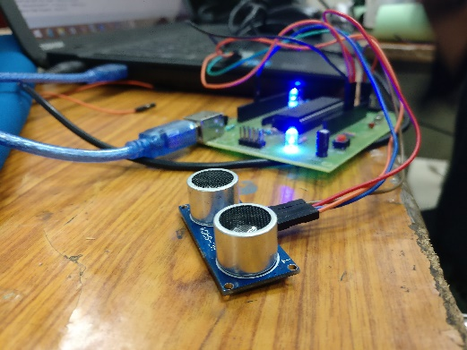

An Ultrasonic sensor is a device that can measure the distance to an object by using sound waves. It measures distance by sending out a sound wave at a specific frequency and listening for that sound wave to bounce back. By recording the elapsed time between the sound wave being generated and the sound wave bouncing back, it is possible to calculate the distance between the sonar sensor and the object.

Generally, the distance can be measured using pulse echo and phase measurement method. Here, the distance can be measured using pulse echo method. The ultrasonic module transmits a signal to the object, then receives echo signal from the object and produces output signal whose time period is proportional to the distance of the object.  The mechanism of the ultra sonic sensor is similar to the RADAR (Radio detection and ranging).

When HIGH pulse of 10us is applied to the TRIG pin, the ultrasonic module transmits 8 consecutive pulses of 40 KHz. after transmitting 8th pulse the ECHO pin of the sensor becomes HIGH. When the module receives reflected signal from the object, the ECHO pin becomes LOW. The time taken by the signal to leave and return to the sensor is used to find out the range of the object.

Distance in centimeters = (Time/58)

Object distance in inches = (time/148)

Distance can also be calculated using speed of the ultrasonic wave 340m/s

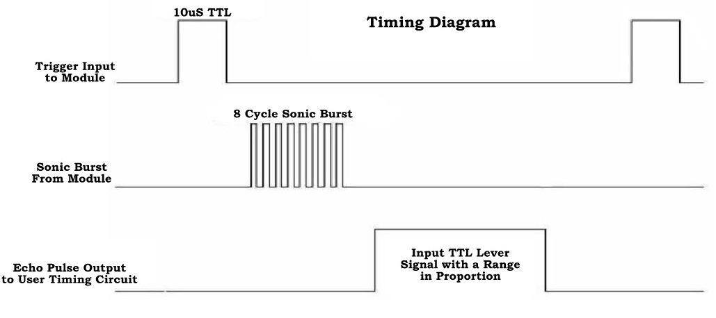

**Bluetooth Module**

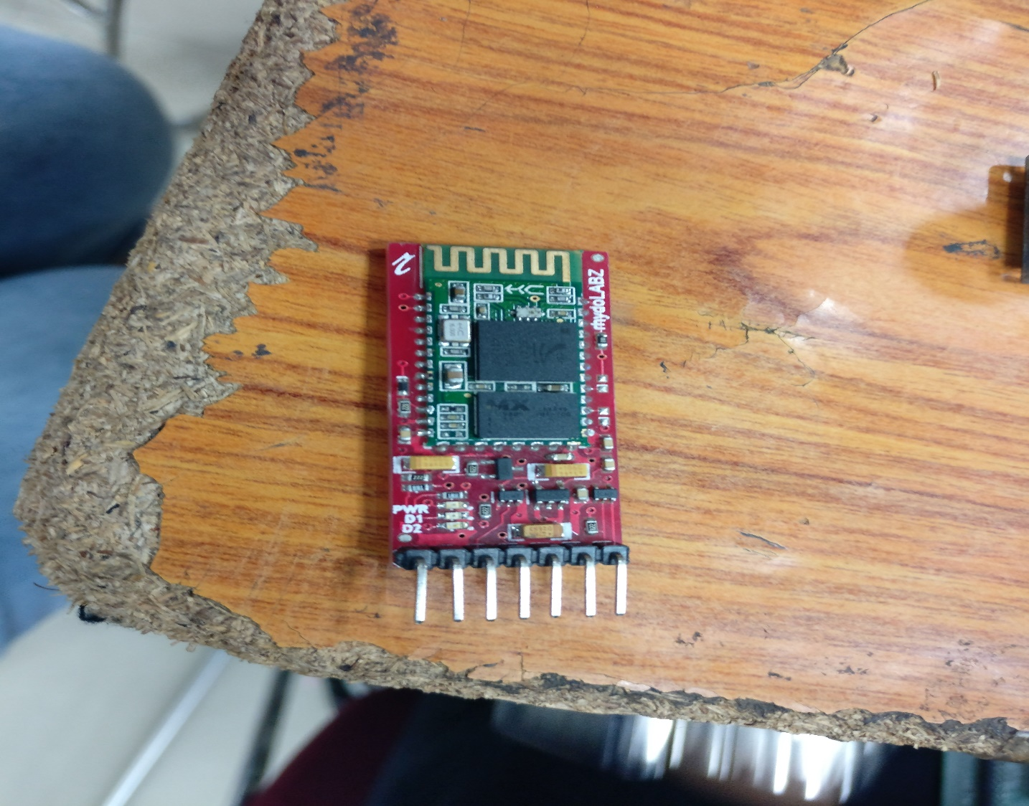

It is also a popular mechanism for short distance point to point or point to multi-point communication. Bluetooth has been designed to enable cordless connectivity between a multitude of devices and user terminals. Bluetooth is being used to connect: keyboards with computers, hands-free ear-pieces to phones, laptops to printers and to the internet. Another important usage for Bluetooth is to connect wireless user terminals, like phones or PDAs (Personal Digital Assistants) to different information servers. Naturally, some of these information servers could be embedded, hence allowing the user to access information e.g., to access calendar information from the home computer. The features of Bluetooth include low cost, low power and small size. Also the robustness for the interferences has made Bluetooth as a highly versatile and attractive technology among other short range wireless technologies. Operating over unlicensed, globally available frequency of 2.4GHz, it can link digital devices within a range of 10m to 100m at the speed of up to 3Mbps depending on the Bluetooth device class.

Bluetooth devices are classified as

* Class I- Range up to 100 m
* Class II- Range 10-20 m
* Class III- Range up to 1 m

Although Bluetooth overcomes a few drawbacks of GSM networks such as usage cost, it also has some limitations. These limitations are:

* Limited range (up to few meters)
* No real time monitoring
* Access delay and Interference

We are using both the technologies interchangeably to overcome a few imitations of each other such as network usage cost and mobility.

**Sound sensor**

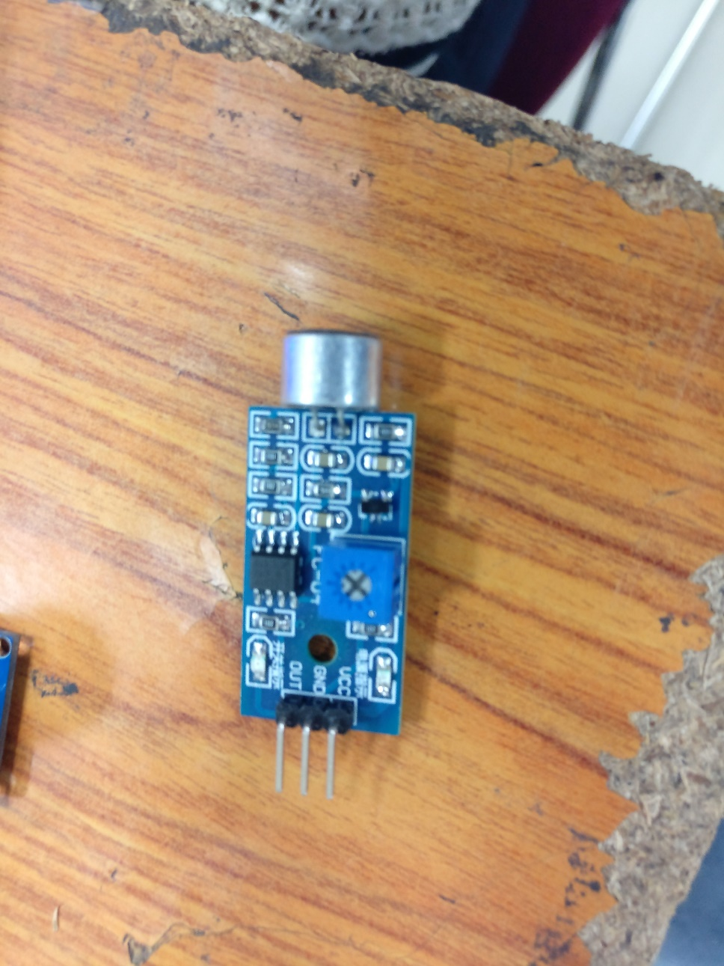

The Sound Detector is a small and very easy to use audio sensing board with three different outputs. The Sound Detector not only provides an audio output, but also a binary indication of the presence of sound, and an analog representation of its amplitude. The 3 outputs are simultaneous and independent, so you can use as many or as few as you want at once.

The envelope output allows you to easily read amplitude of sound by simply measuring the analog voltage. Gain can be adjusted with a through-hole resistor, to change the threshold of the binary (gate) output pin as well. Check the hookup guide below for more information about setting gain.

Each of the three output signals is present on the .1" header at the edge of the board. They are active simultaneously. If you aren’t using one in your particular application, simply leave that pin disconnected.

**Load Sensor and Load Cell**

Strain-gauge load cells convert the load acting on them into electrical signals. The measuring is done with very small resistor patterns called strain gauges - effectively small, flexible circuit boards. The gauges are bonded onto a beam or structural member that deforms when weight is applied, in turn deforming the strain-gauge. As the strain gauge is deformed, it’s electrical resistance changes in proportion to the load.

The changes to the circuit caused by force is much smaller than the changes caused by variation in temperature. Higher quality load cells cancel out the effects of temperature using two techniques. By matching the expansion rate of the strain gauge to the expansion rate of the metal it’s mounted on, undue strain on the gauges can be avoided as the load cell warms up and cools down. The most important method of temperature compensation involves using multiple strain gauges, which all respond to the change in temperature with the same change in resistance. Some load cell designs use gauges which are never subjected to any force, but only serve to counterbalance the temperature effects on the gauges that measuring force. Most designs use 4 strain gauges, some in compression, some under tension, which maximizes the sensitivity of the load cell, and automatically cancels the effect of temperature.

You can use this simple formula to convert the measured mv/V output from the load cell to the measured force:

Expected Force/Weight = K * (Measured mV/V - Offset)

Where K is gain value that will change depending on what unit of force or weight you want to measure. Since the offset varies between individual load cells, it’s necessary to measure it for each sensor. Record the output of the load cell at rest on a flat surface with no force on it. The mv/V output measured by the PhidgetBridge is the offset.

Once you’ve found the offset, measure something with a known weight and solve the equation for K. You can also calibrate the load cell at multiple known weights and use these points to model a linear function.

**CHAPTER 4**

**Design of the System**

This chapter describes the design approach and conceptual design of a low cost and low power remote monitoring and control system. The system’s low cost needs are catered by employing a Bluetooth module when operating in a limited perimeter with the controlled devices and its need for mobility are met by remotely controlling the same devices via SMS by interfacing a GSM module.

**4.1 Introduction to System Design**

The embedded systems consist of many modules, which are comprised of software components, hardware components and interfaces. All these modules can be independently modeled as complex systems. In order to achieve a correct implementation of a project all of the independent designs must work in synergy. Therefore, application of system design principles to the design of embedded system can dramatically streamline the design work and avoid future problems involved with integrating the modules to constitute a larger system. The embedded system is a system in which the processing unit is actually embedded between its peripherals and the system is designed to perform some predefined tasks. Being dedicated to certain tasks, the embedded system provides a very efficient solution compared to their general purpose counterparts. When designing complex systems, it is beneficial to approach the design via an architecture, which is structured as an integration of sub-systems. In this approach the designers identify the system requirements for subsystems, which are based on overall system requirements. The subsystems are designed independently and then interfaced to achieve the completed system architecture. This approach simplifies the procedures related to testing, debugging and integration of the subsystems, which are required to ensure proper design and working of the whole system and also divides the functionality to verify the working of the subsystems independently.

**4.2 Design Methodology**

A good design methodology can help the system design process in many ways. It can help to verify the system for functionality and for errors and helps realize a solution, which achieves all the goals of the system including manufacturing cost, performance and power consumption. Figure 4.1 shows the major steps in system design process of a project.

**Requirements**

**Specifications**

**Architecture**

**Hardware Design**

**System Integration**

**Software Design**

**System Test**

**Figure 4.1 System Design Process**

There are two approaches to the system design process. One is top-down design and other is bottom-up design. In top-down approach the design procedures are initiated from requirements for system integration. This approach involves arriving at the right solution after considering all the possible alternatives. The alternative is the bottom-up in which we start from the components to build a system i.e. the reverse of the top-down approach. The bottom-up design is needed because one does not know how the later stages of the project will turn out to be. In this remote monitoring and control system with automatic light controller we have considered a top-down design approach. The detailed description of the steps is given in the following sections.

**4.3 Requirements and Specifications**

The requirements are objective descriptions of the system, which includes functional as well as nonfunctional requirements. The requirements are the customer’s expectations about what the system has to achieve. The requirements put monetary and timing constraints on the design, which will have to be considered along with the technical specifications. The designers need to incorporate these requirements and realize a system, which can perform the expected tasks. The system specifications are more focused on system implementation. They offer the designer a role map for the design of the system. The specifications have to be written carefully to ensure that they meet requirements. The system design has to fulfill the system requirements. The planning stage is the most important stage in the design cycle since it considers all the available resources and their efficiencies.

**Architecture of the system**

The system architecture can be served in two parts- Hardware architecture and Software architecture.

* **Hardware Architecture**

Hardware of the system comprises of some main units-

* Microcontroller which is the heart of the system
* Ultrasonic sensor
* Bluetooth module
* Light detecting Resistor
* Power supply unit
* 16x2 LCD display
* Load cell and sensor
* **Software Architecture**

The 8051 board communicated with the ultrasonic sensor to give the height and transmits it to the SPP manager and similarly Load sensor takes in the weight of the baby and gives the output to the mobile via Bluetooth module. The information is then further forwarded to gain the growth chart.

In the baby crying system, once sound is detected the information is transmitted to parent’s phone informing of the current status of the baby. The LDR used then detects the light and switches on and off according to the conditions.

**CHAPTER 5**

**Implementation**

The working code of the project :

//final2.c

#include<reg51.h>

sbit led=P3^7;

sbit ldr=P0^6;

sbit soundsensor=P0^7;

unsigned int i;

sbit led1=P3^4;

char choice;

sbit trig=P3^3;

char str[5];

int j;

char ht;

void calc_height(){

unsigned int target_range=0,timer_val;

P3|=0x04; //P3.2 as INPUT

TMOD=0x0l;

TH0=0xFF;TL0=0xF5;

trig=1;

TR0=1;

while(!TF0);

TR0=0;

TF0=0;

TMOD=0x09; //timer0 in 16 bit mode with gate enable

TH0=0x00; TL0=0x00;

TR0=1; //timer0 run enabled

trig=0;

while(!INT0);

while (INT0);

TR0=0;

timer_val=TH0<<8|TL0;

if(timer_val<35000)

target_range=timer_val*0.01860775;

else

target_range=0; // indicates that there is no obstacle in front of the sensor

for(i=0;i<5;i++)

{

str[i]=target_range%10;

target_range= target_range/10;

}

TMOD=0x20;

TH1=0XFD;

SCON=0X50;

TR1=1;

for(j=4;j>=0;j--)

{

SBUF=str[j]+0x30;

while(TI==0);

TI=0;

}

for(j=0;j<28000;j++);

}

void main(void)

{ while(1)

{ here:

TMOD=0X20;

SCON=0X50;

TH1=0xfd;

TR1=1;

while(!RI);

choice=SBUF;

RI=0;

if(choice=='A')

{

calc_height();

}

if(choice=='B')

{ while(1)

{

if(soundsensor==1)

{ if(ldr)

led=1;

else

led=0;

TMOD=0x20;

TH1=0xFD;

SCON=0x50;

TR1=1;

SBUF='3';

while(TI==0);

TI=0;

for(i=0;i<28000;i++);

}

if(RI)

{ choice=SBUF;

RI=0;

if(choice=='C')

goto here;

}

}

}

}

}

The snapshot of the working app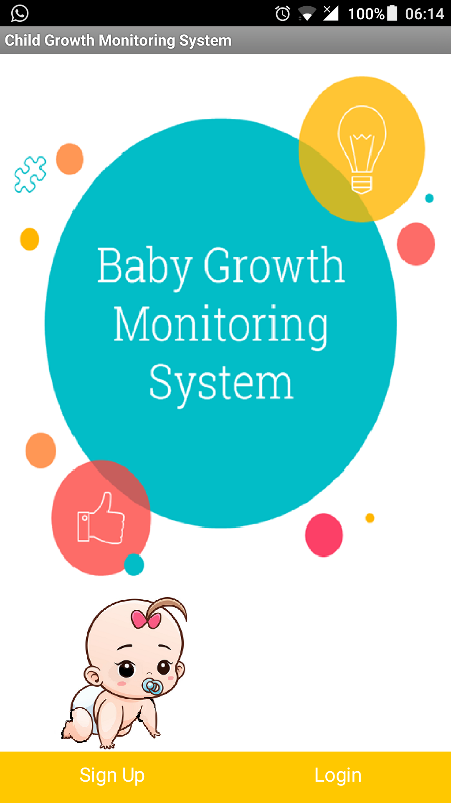**CHAPTER 6**

**Testing and Maintenance**

**CHAPTER 7**

**Conclusion and Future Work**

Our project is capable of handling the current health status of a child. The child can have healthy prospects if kept under the work of smart cradle. The height and weight of kid is easily monitored by our project and gives one a good chance at maintaining a healthy outlook of the infant. The cost efficient as a characteristic of the project can help thousands of kids which cant keep a healthy profile. The project is not harmful to baby at any point thus proving to be the harmless designed product.

The project in current status is in the primary stage of production. We can include many other option of babycam or monthly reminders about pediatrician visits.

The smart cradle is not only a world changing product today but definitely hold great promises for tomorrow.

**Note from prerna**

1. **Jo bhi sub points likhe hai na like 1.1 and 1.2 etc mene voh follow nahi kiye but jo bhi sub points mein tha I have covered maximum part. So padhne ke baad use na erase kar diyo matlab subpoints nahi hone chaiye**
2. **Mene components ke bare mein short mein likha hai**
3. **Code abhi implementation mein hai**
4. **Testing blank hai**
5. **Implentation mein pseudocode and flowchart aaega.**
6. **Sab changes karne ke baad page number dekh lena index mein**
7. **Chapter 2 and 7 mein khuch add kar sakati hai toh good**