Assignment

Ques1.

INPUT/ OUTPUT UNIT

OPERATIONAL MEMORY

CENTRAL

PROCESSING

CONTROL UNIT

ARITHMMETICAL – LOGICAL UNIT(ALU)

UNIT

The different components of the given computer

* The **control unit** fetches machine language instructions from the operational memory, decodes them and generates control signals for the three remaining blocks of the computer. The control unit sends data to the arithmetical-logical unit or input/output unit when it has decoded an instruction, which directly contains data (immediate argument). The control unit contains **address registers**, which are used to store memory addresses during program execution. The control unit sends data to the operational memory when it performs instructions concerned with the control in a program or when an interrupt is serviced in which case the program execution context has to be stored in the stack together with the return address to the interrupted program. The control unit can contain, nowadays commonly existing, **cache memory**, in which current instructions of the performed program are stored.
* The **operational memory** (**main memory**) is the memory, which stores currently executed programs with their data. The operational memory can supply data (or be the source of data) for the three remaining blocks of a computer.
* The **arithmetical/logical unit - ALU** receives from the control unitdecoded instruction for execution. The arithmetical-logical units contain executive (functional) used for implementation of arithmetical and logical instructions of the computer. These units contain **general purpose registers**, which are used to store data necessary for execution of arithmetical and logical operations. These units commonly use a **data cache**, which belongs to this block the arithmetical-logical units perform (in smaller computers) arithmetical operations concerned with addressing next instructions to be executed.
* The **input/output units** implement co-operation of the computer with so called **external** or **peripheral devices**. These devices enable inputting and outputting information (data, programs, directives) to and out a computer.
* Peripheral devices are a keyboard, a mouse. a joy-stick, a monitor, display devices (video cameras, TV sets, CD and DVD readers), different sound devices (loudspeakers, sound recorders), data transmitting devices (modems, network switches), etc. To peripheral devices belong all types of **secondary store (memory)** or **peripheral memory (store)** of a computer, such as magnetic memory on hard and floppy discs, magnetic tape memory, optical memory on compact disks (CD), DVD disk memory, and similar.

The control unit, arithmetical-logical units and the set of computer registers compose the **processor** of a computer, which can be also named the **central processing unit, central processor -** in short **CPU**

Ques 2.

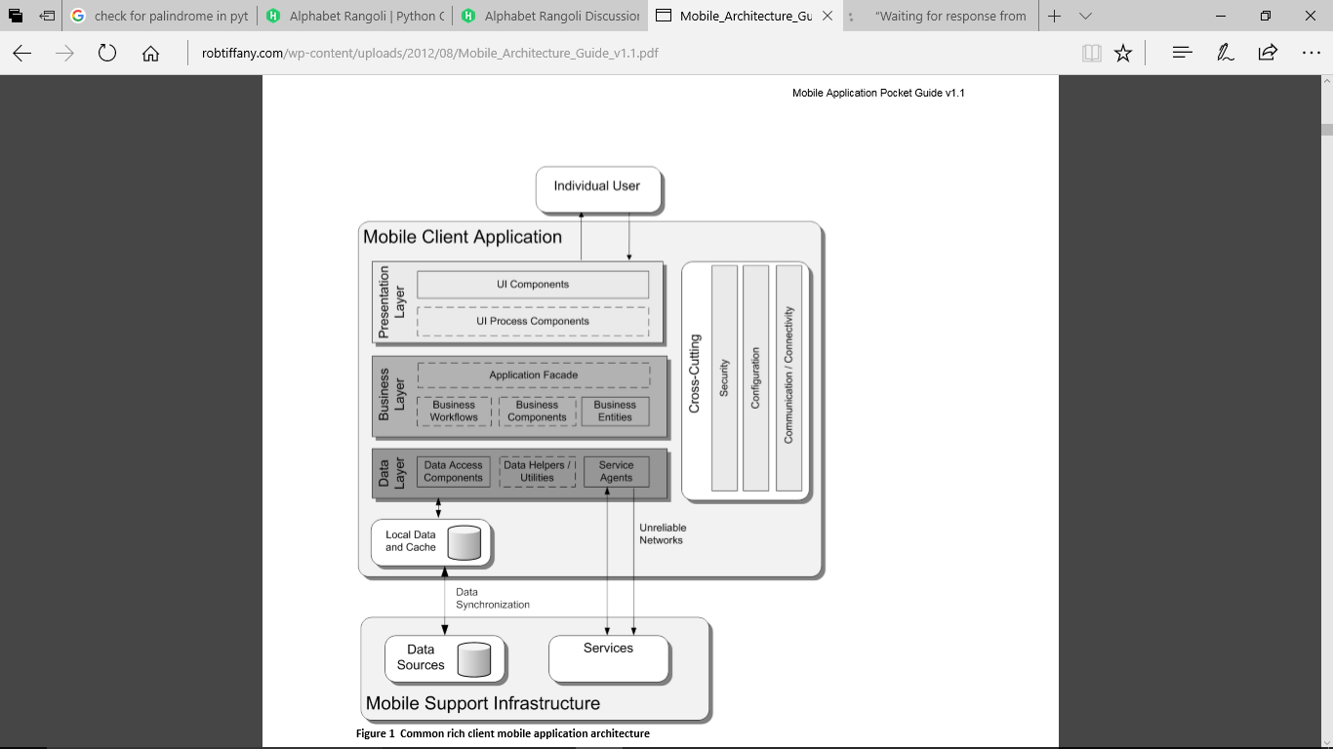

Model no: ONE PLUS 3T

SPEED: 6 GB

No of cores: 1.6 HZ quad core

SOC: Qualcomm Snapdragon 821

Memory and its size: 64 GB

OS: Android 6.0.1

Application language: java, android

Input and output peripherals: Touch screen, on screen keyboard, speakers, microphone, headphones, USB, in front and rear camera, flash, USB port

Communication periphrals: Wi-Fi, Bluetooth, NFC, Infrared, GSM, flash memory, scanner

Sensors: compass/ magnetometer, proximity, accelerometer, ambient light sensor, gyroscope