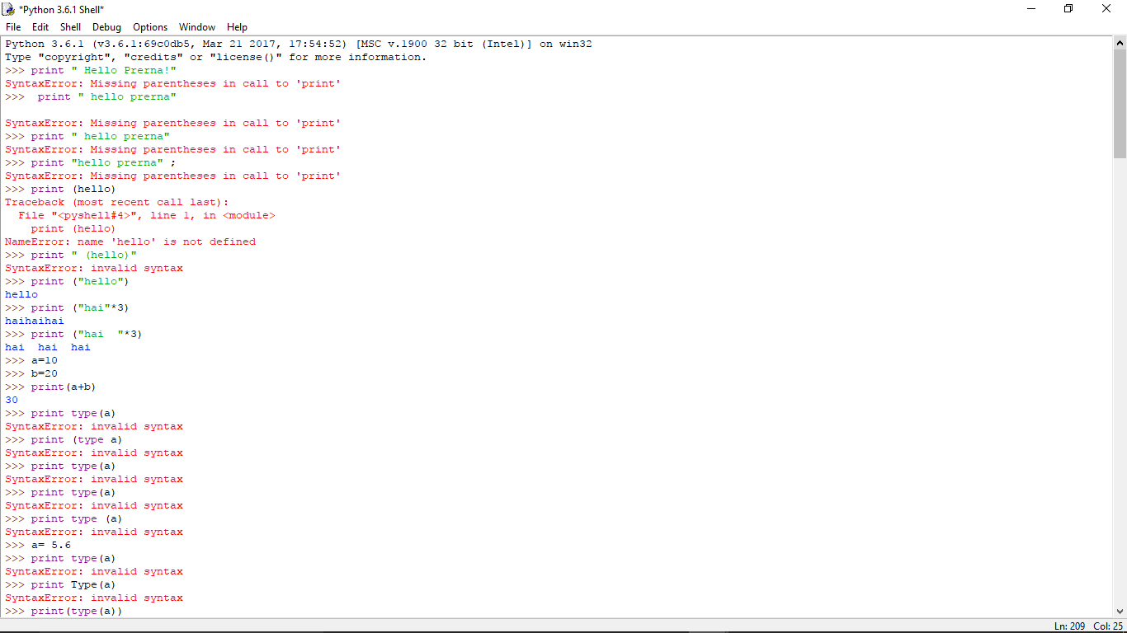

Mysmarthphonekit.Myeducation.net