Phase 2 Output Results
Project: Road Damage Detection / Road Accident Risk Implementation
1. Notebook Execution Summary
The notebook was executed successfully after attaching the Kaggle competition dataset. The model was trained, validation predictions were generated, and a submission file was saved to the Kaggle working directory.
2. Printed Output from Notebook
Output Item | Value
Validation RMSE | 0.05940224618610835
Submission Status | Submission saved successfully
Output File | /kaggle/working/submission.csv
Prediction Target | accident_risk

3. Sample Submission Output
id | accident_risk
517754 | 0.334567
517755 | 0.119000
517756 | 0.161015
517757 | 0.329500
517758 | 0.404300

4. Output Screenshot
Figure 1 shows the executed Kaggle notebook output, including the validation RMSE and generated submission preview.
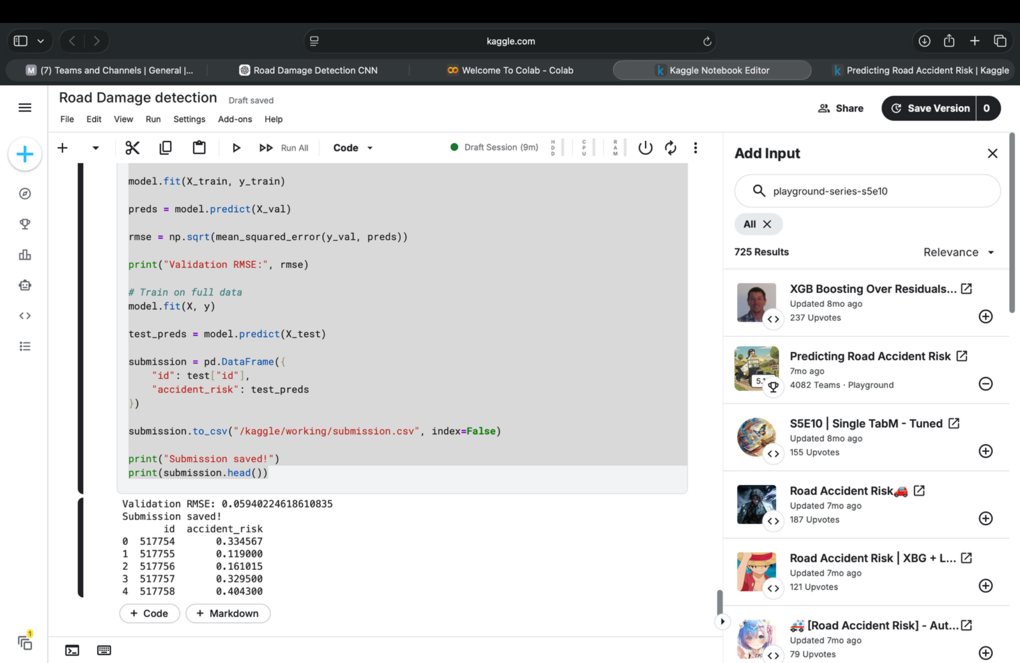
Figure 1. Kaggle notebook output showing validation RMSE and saved submission file.
5. Generated Output Files
- /kaggle/working/submission.csv
- /kaggle/working/model_comparison.csv
- /kaggle/working/actual_vs_predicted.png
- /kaggle/working/error_distribution.png
Conclusion
The implementation generated a working prediction pipeline and submission file. The reported validation RMSE was 0.05940224618610835, and sample predictions were produced for the test dataset.

