ER Model to Tables

Refer to the given ER Diagram (School Management System).

**Entities:**

**Student (RollNo, Name, Email, phone_no, Gender, Age)**

**Course (CourseID, Title, Credits)**

**Teacher (TeacherID, Name,phone_no , Subject)**

**Enrollment (RollNo, CourseID)**

Relationships:

**Student ENROLLS in Course  
Teacher TEACHES Course**

**Answer: -**

**Link: -**[E - R Model3.drawio.svg](E%20-%20%20R%20Model3.drawio.svg)

[E-R Diagram3.drawio.svg](E%20-%20R%20Diagram3.drawio.svg)

1: Draw the ER diagram in your notebook (or use online tool): -

Convert ER model into SQL tables with proper constraints: -

-Primary Key (PK)

-NOT NULL, UNIQUE, DEFAULT constraints

-Appropriate Data Types

**Answer: -**

Student

|  |  |  |
| --- | --- | --- |
| Rollno | int | Primary Key |
| Name | Varchar(50) | Not Null |
| Email | Varchar(50) | Unique |
| Phone_no | int | Not Null |
| Gender | Varchar(50) | ENUM('Male', 'Female', 'Other') |
| Age | int | Not Null |

Course

|  |  |  |
| --- | --- | --- |
| CourseID, | int | Primary Key |
| Title | Varchar(50) | Not NULL |
| Credits | Varchar(50) | Not NULL |

Teacher

|  |  |  |
| --- | --- | --- |
| Teacher_id | int | Primary Key |
| Name | Varchar(50) | Not NULL |
| Phone_no | int | Unquie |
| Subject | Varchar(50) | Not NULL |

Enrollment

|  |  |  |
| --- | --- | --- |
| Rollno | int |  |
| Course_id | int |  |

2: Create and Insert Data

1. **Create all 4 tables (Student, Course, Teacher, Enrollment).**
2. **Insert:  
   At least 5 Students  
   At least 2 Teachers**
3. **Insert at least one student with NULL Age (test NULL handling).**
4. **Try inserting duplicate RollNo and Email → note the error message.**

**Answer: -**

**Student**

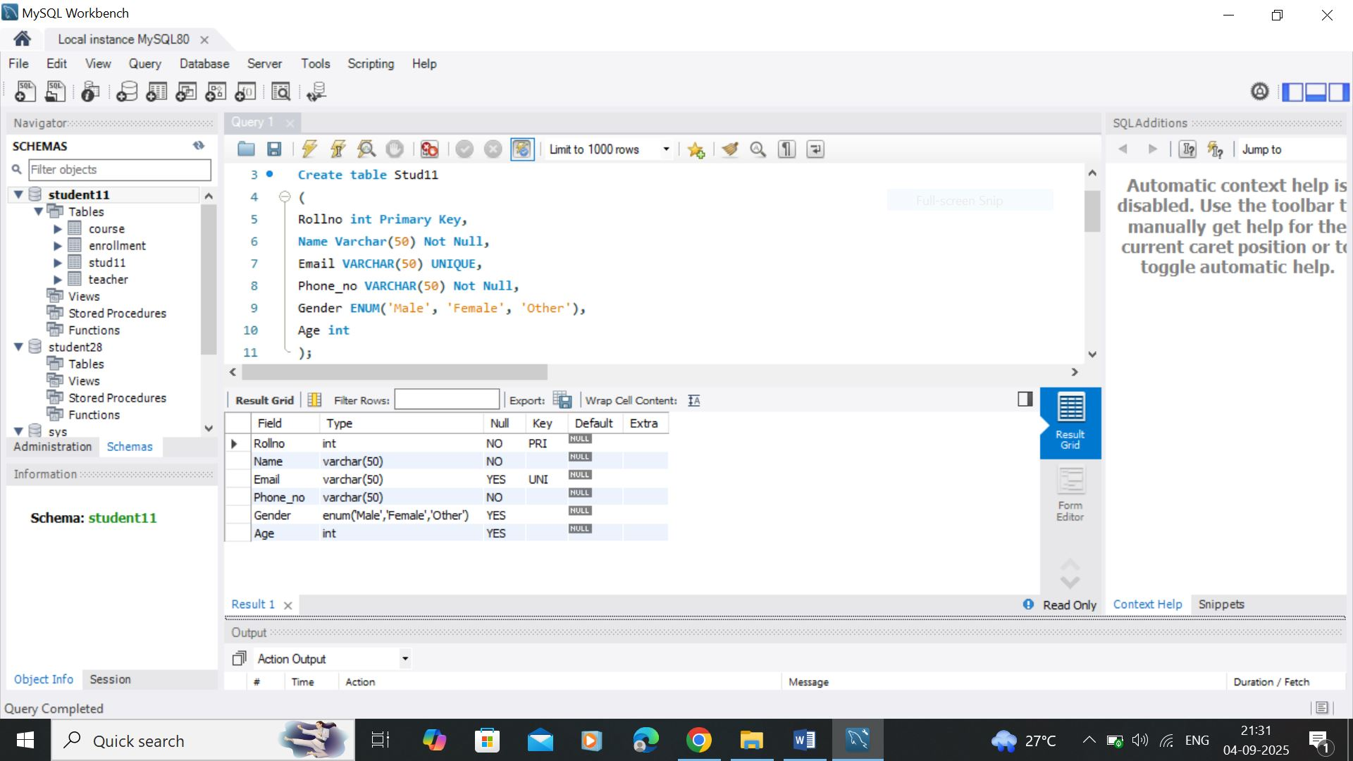

**Course**

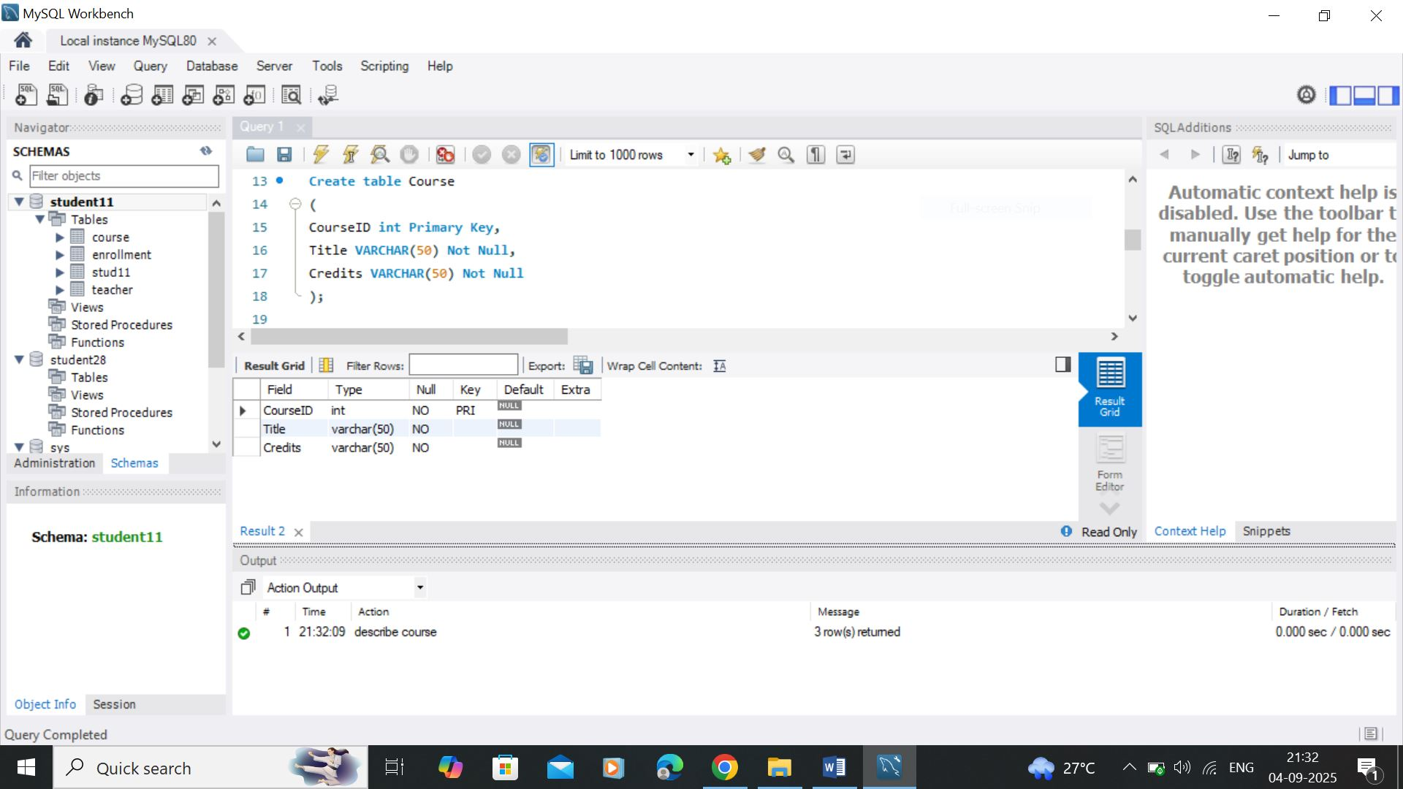

**Teacher**

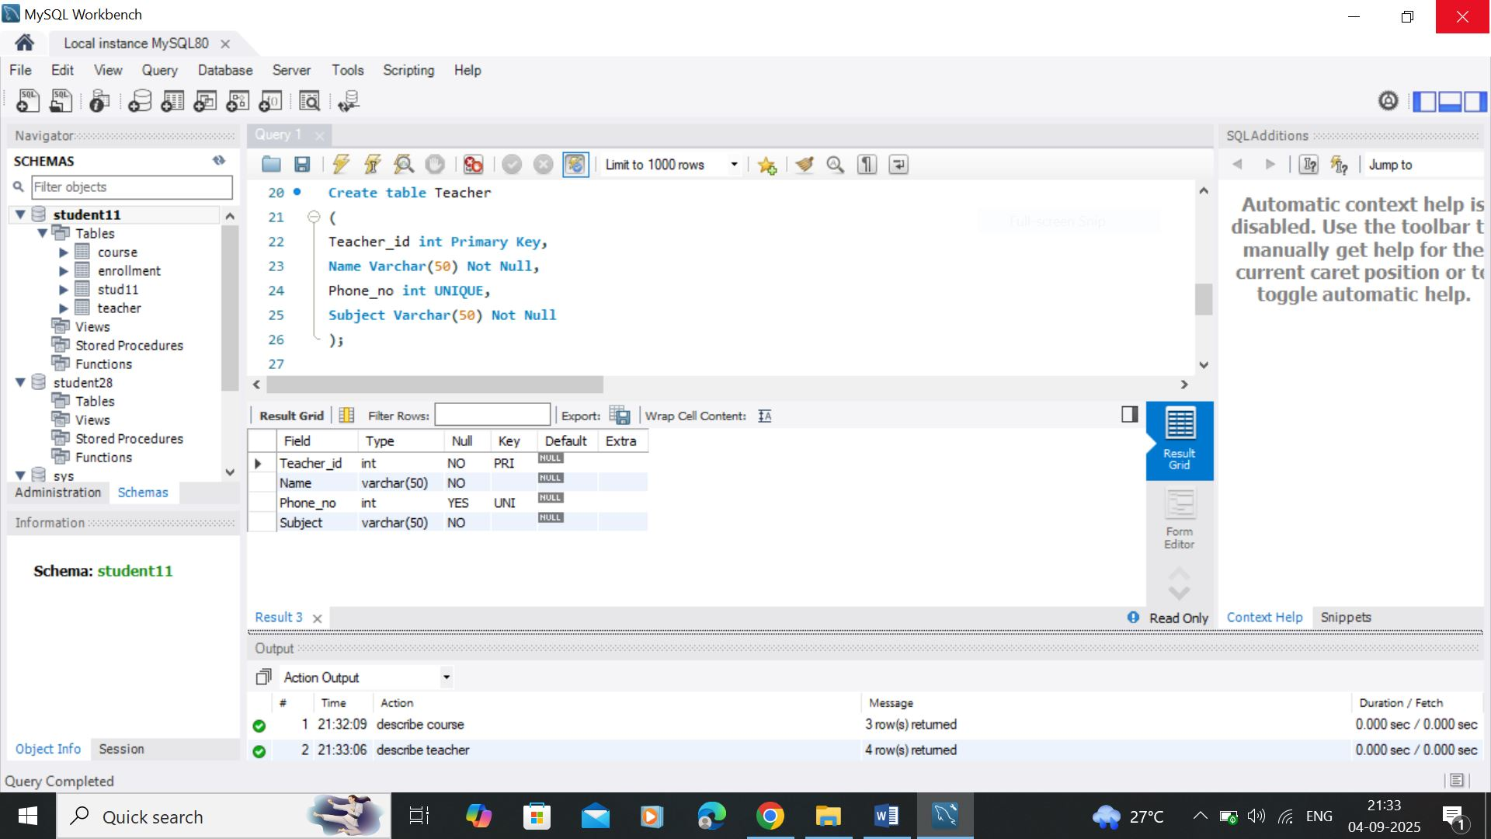

**Enrollment**

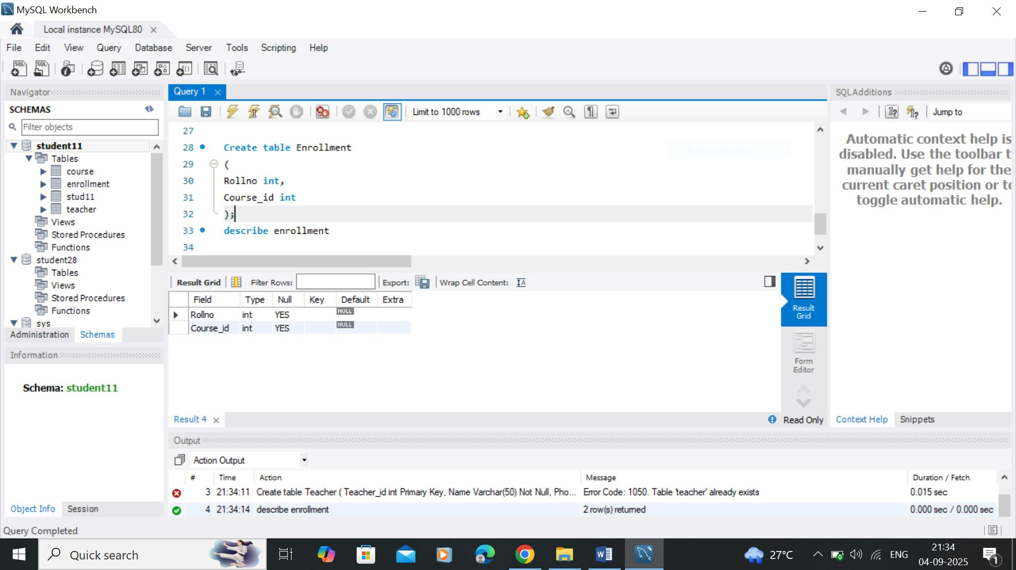

3: Select Queries (DQL)

- Show all students (SELECT *).

Answer: -

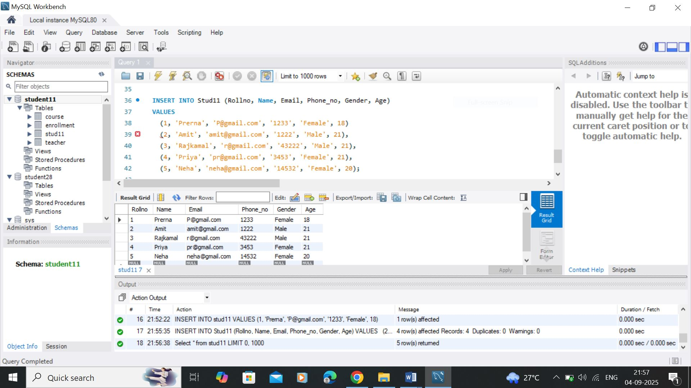

- Show only Names and Emails.

Answer: -

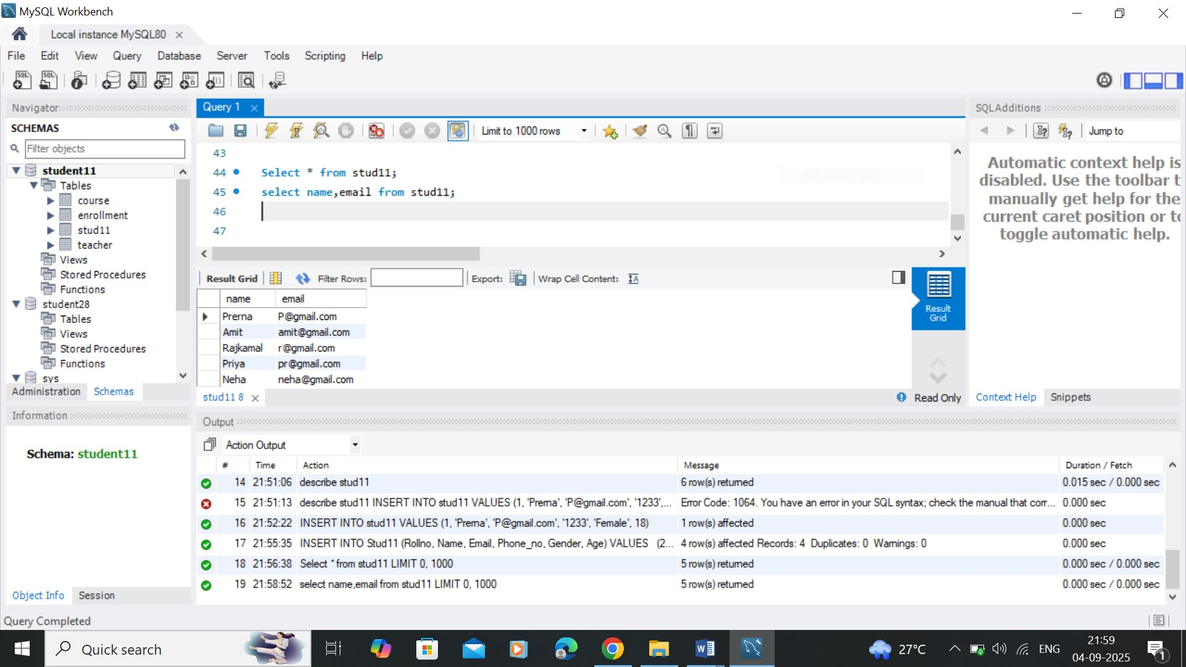

- Use aliasing: Show Name as StudentName and Email as ContactEmail.

- Show Enrollment details (RollNo, CourseID).