**Q- Create a new database called ExamDB using the CLI.**

**Answer: -**

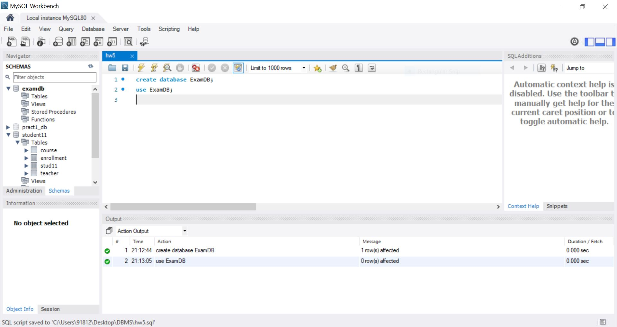

**Q- In ExamDB, create a table Student with the following structure:  
● StudentID (Primary Key)  
● Name (Not Null)  
● Email (Unique)  
● Gender (ENUM: ‘Male’, ‘Female’, ‘Other’, default = ‘Other’)  
● DOB (Date)**

**Answer: -**

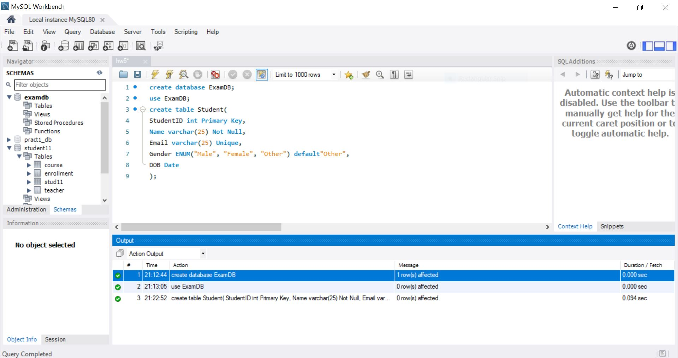

**Q- Insert at least 3 records into the Student table.  
◦ Gender for one student to test the default value.**

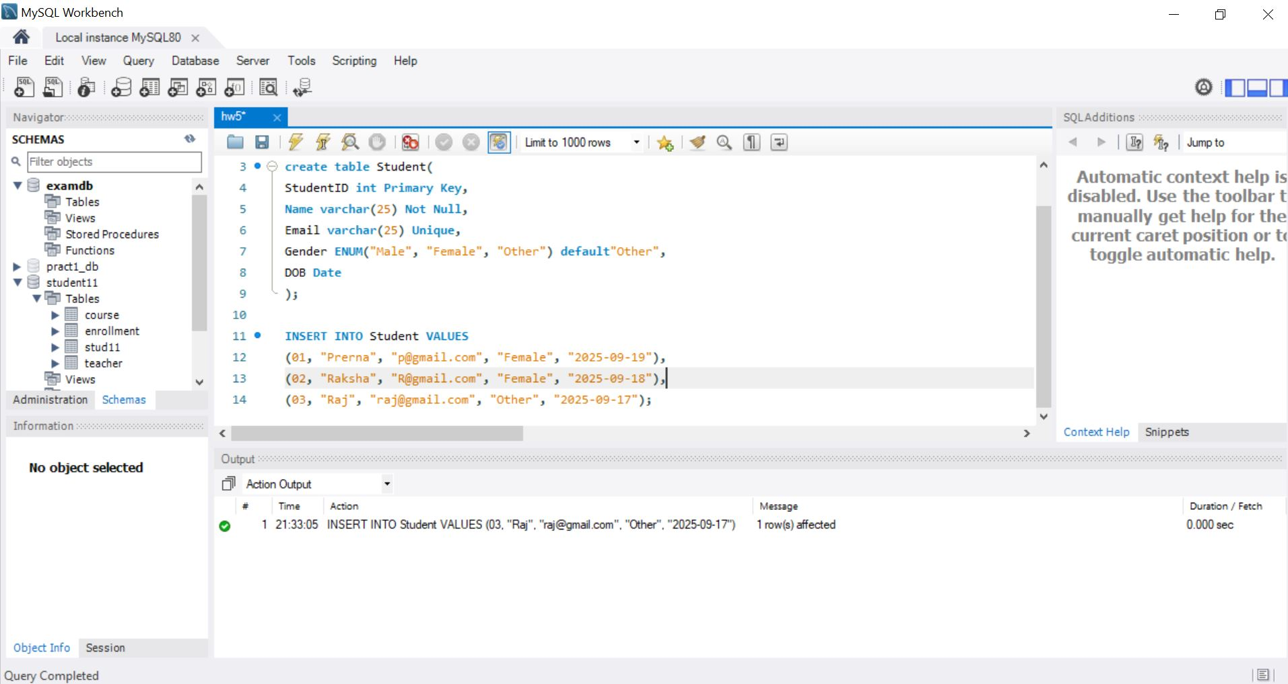

**Q- Try inserting a record into Student with a duplicate Email and note the error.**

**Answer: -**

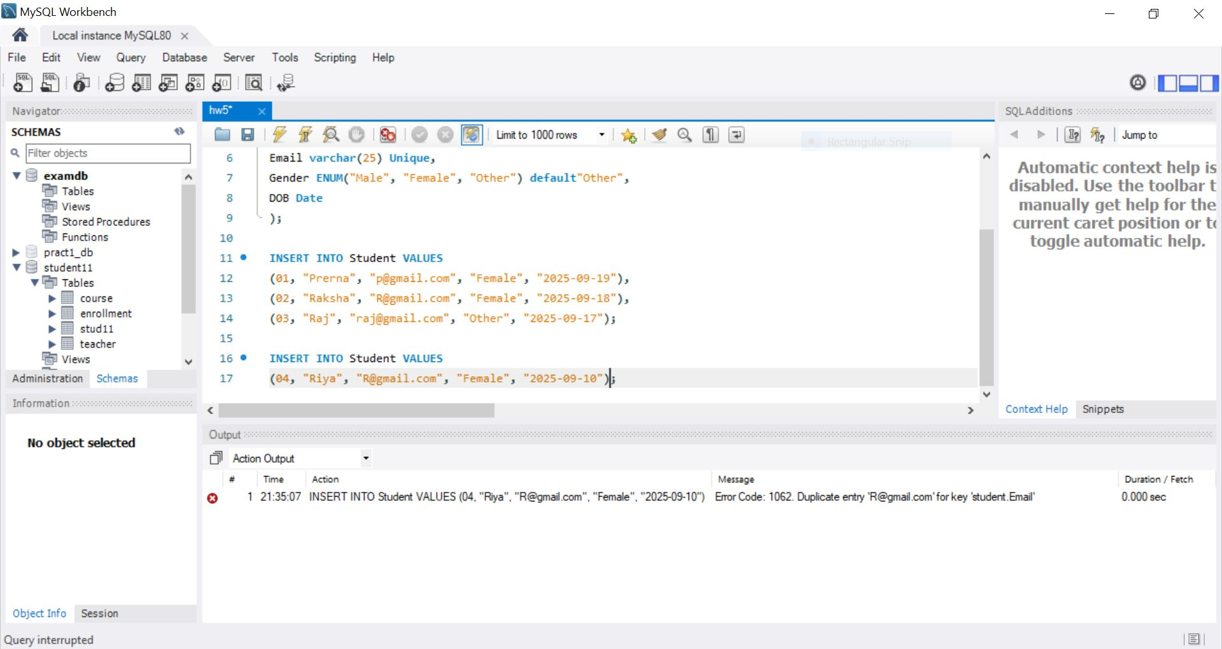

**Q- Create a table Course with the following columns:  
- CourseID (Primary Key), Title, Duration.  
-Insert at least 3 records into Course.**

**Answer: -**

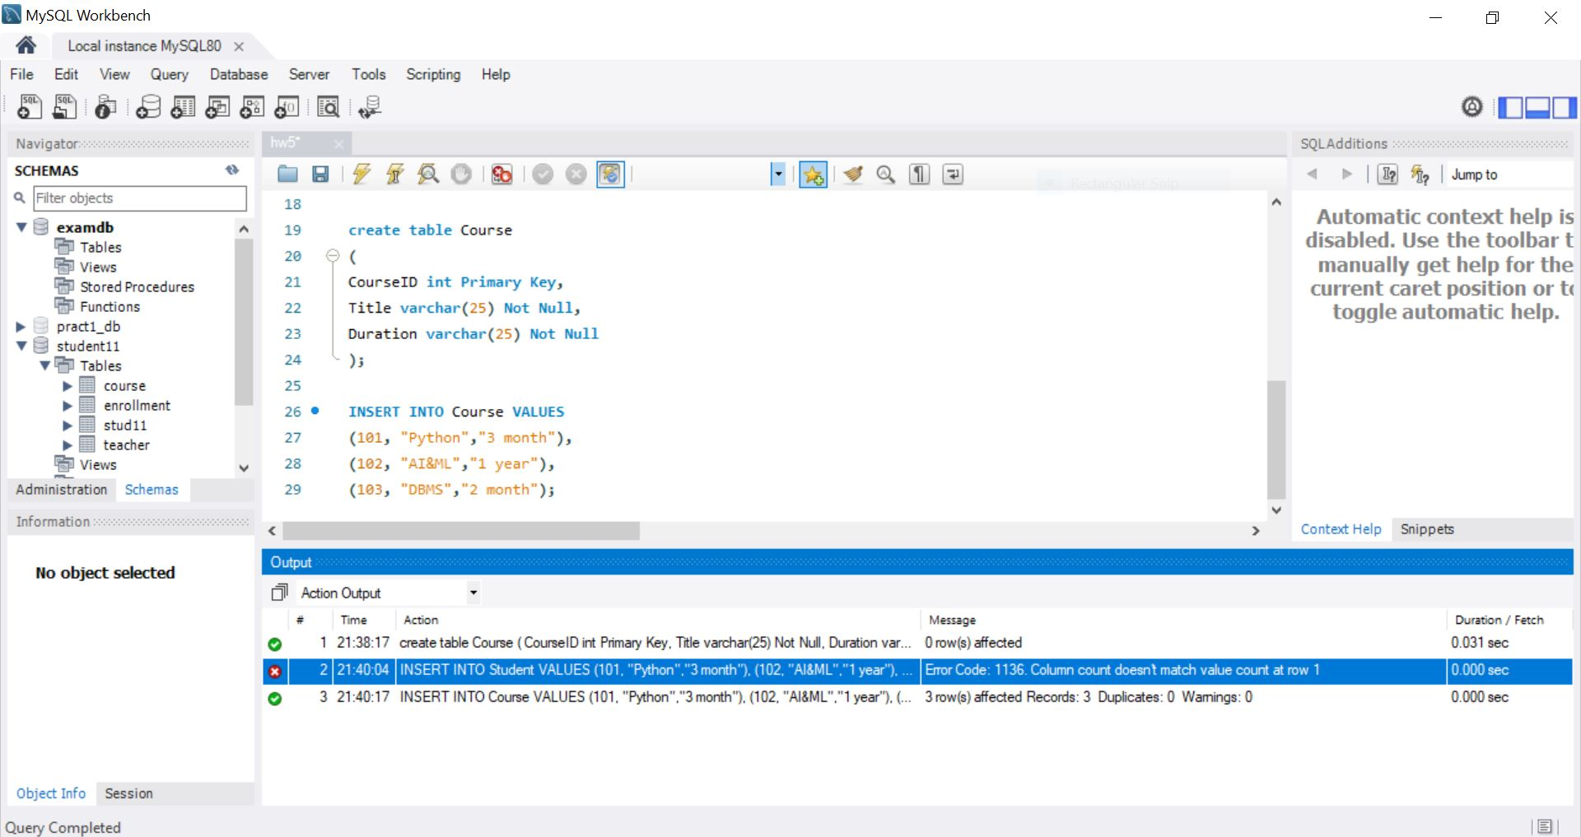

**Q- Create a table Enrollment with the following columns:  
- EnrollmentID (Primary Key), StudentID , CourseID , EnrollDate (Default current date/time).  
-Insert at least 2 records.**

**Answer:-**