Part 1:

1. Threshold input voltage range: (-7.5) – (7.5)V.
2. and 3)

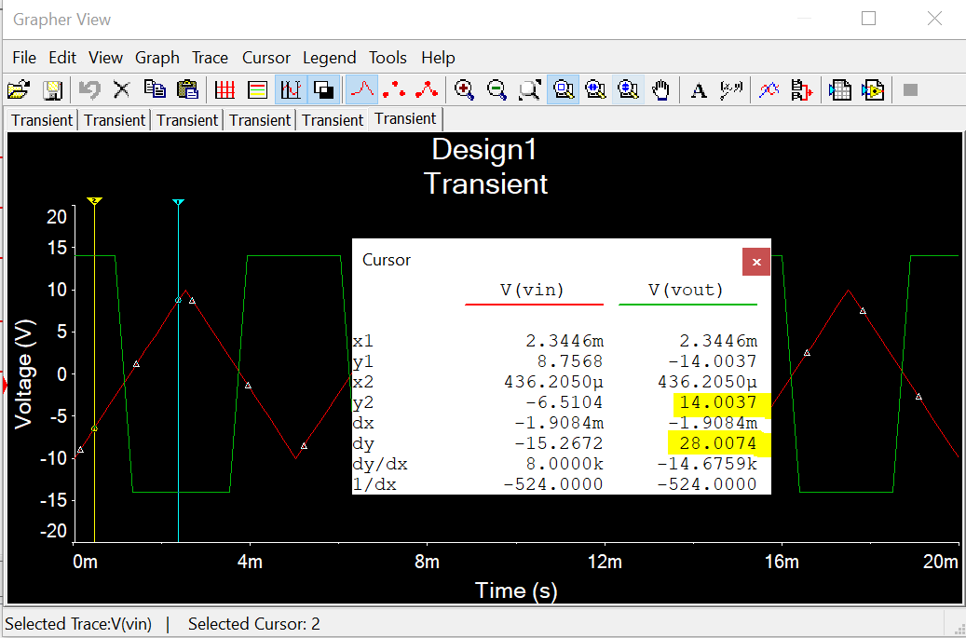

Part 2:

1. Oscillation frequency: T = 2.1544ms and therefore, *f* = 1/T = 0.46 kHz
2. Relationship between capacitor value and oscillation frequency: The higher the capacitor value, the lower the oscillation frequency. They are inversely proportional.

