**Part1:**

1. Vctrl = 1V

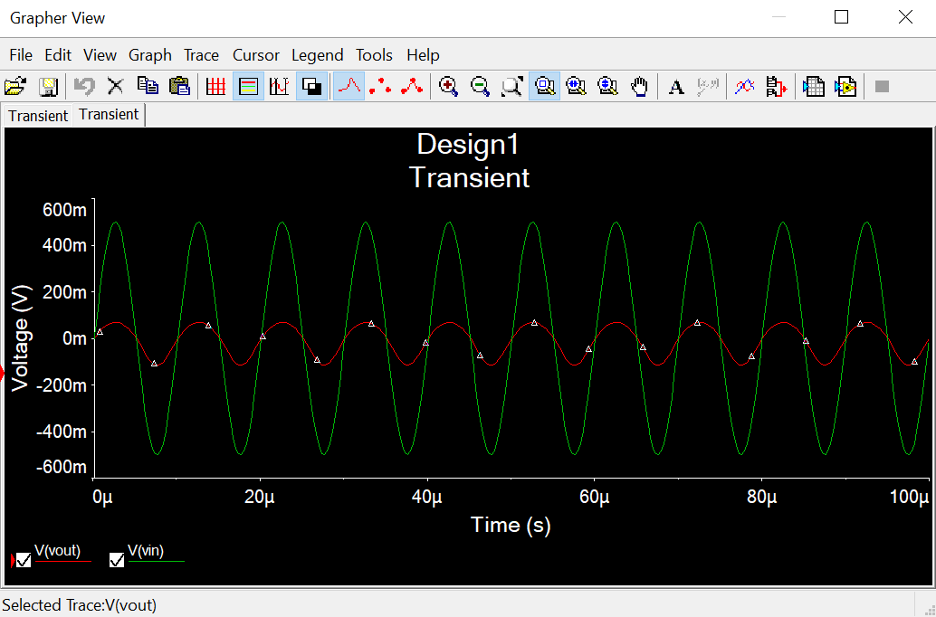

1. Vctrl = 2.5

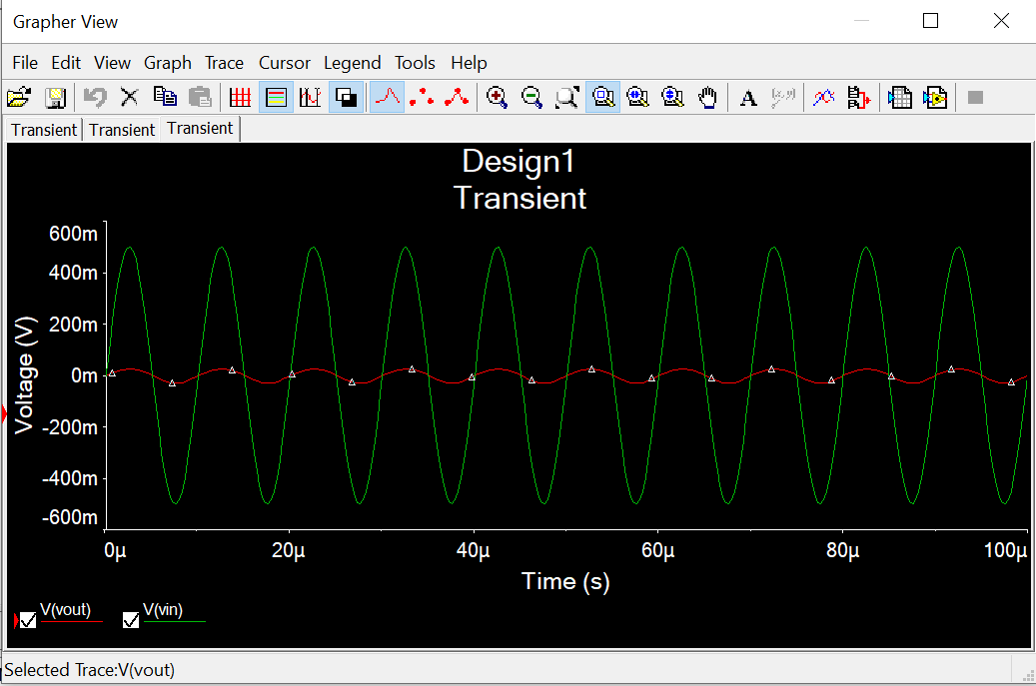

**Part2:**

ID = (2.5-1.4)/100k = 11 microA

Rd = 2.273 kohm

Vout = 21.7 mV

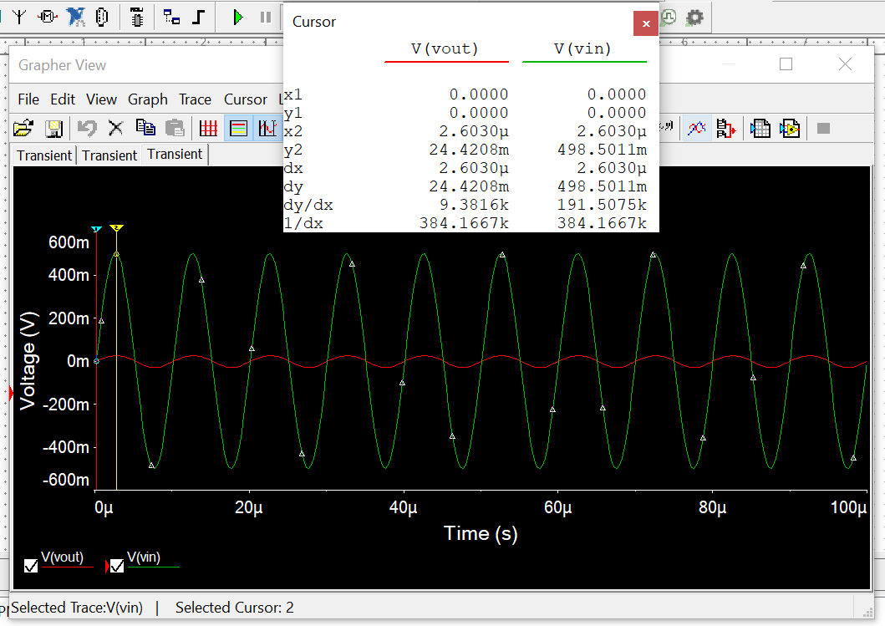

Vout p-p from simulation = 24.4mV. Hence, you get similar results.

**Part3:**

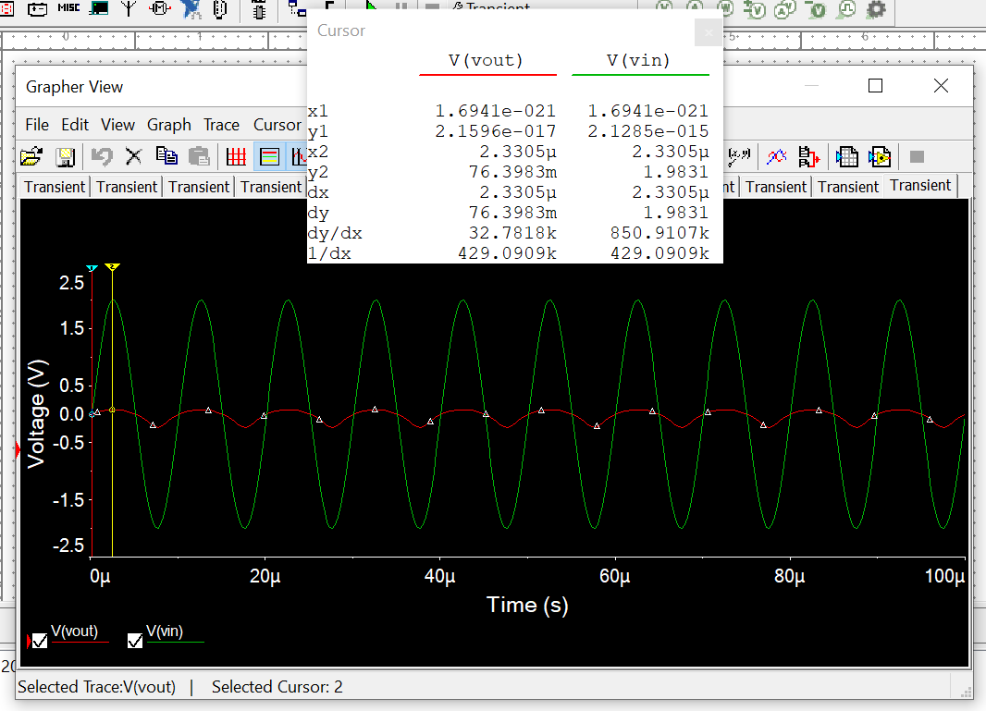

Vout = 76.4 mV

Vin = 1.9831 V