Part 1:

1. Threshold input voltage range: 4 – 6V

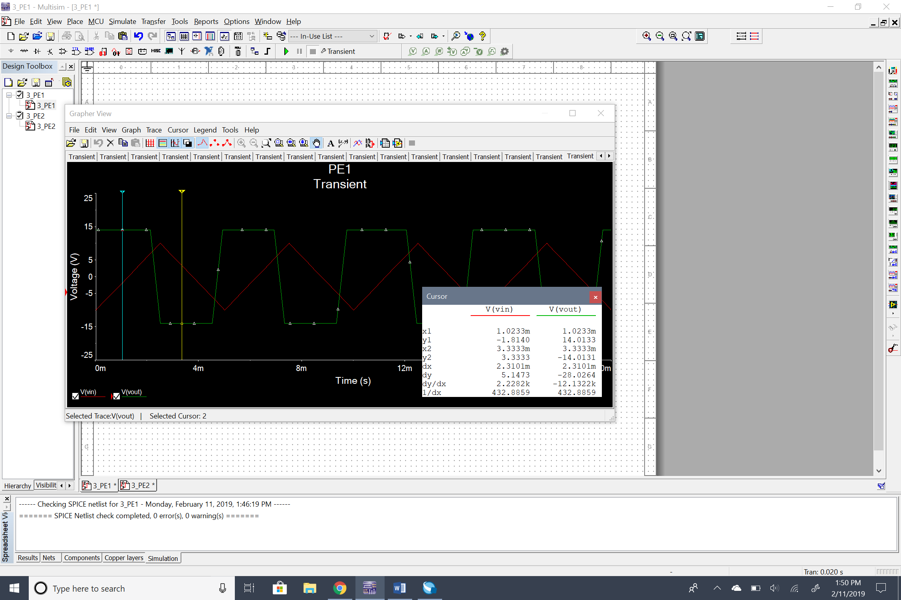2) and 3)

Part 2:

1. Oscillation frequency:

T = 2.1544ms and therefore, *f* = 1/T = 0.46 kHz

1. Relationship between capacitor value and oscillation frequency:

The higher the capacitor value, the lower the oscillation frequency and vice-versa.

1. 