**EXPERIMENT 1**

**Aim:** To prepare a detailed problem definition statement for selected case study and identify suitable process model for the same with justification.

**Problem definition**

An online portal to get certified birth and death certificates of an individual. It involves verification of the documents by the respective authorities that include hospitals, the government and other offices thereby maintaining the authenticity of the documents. It also maintains a certified record of nominees of each individual. The use of the portal will help minimize the procedure that involves visiting offices and manual registration of any individual in case of a birth or death.The purpose of this project is to digitalize and provide easy access to authorities especially in cases of dispute. It makes the process of verification efficient and requires minimal time.

**Functionalities**

1. The user can upload scanned documents of the birth certificate.
2. Initially, when the user uploads a document, it is marked as ‘verification pending’.
3. Added proof of the heirs of the individual can also be uploaded in addition to the document.
4. In case of a death, any authorized family member of the user can submit the proof including certified documents from the hospital.
5. The centralized portal for the hospital will ensure validity of the documents uploaded by the user. Once the hospital verifies the document, it marks it as verified or forged.
6. In case of any discrepancies, the hospital has the authority to mark the document as forged.
7. The government can access all of the information and see whether any document is verified or not.
8. The government can use these documents as proof for any further investigation or requirements.
9. Family hierarchy can be accessed by the user as well as by the hospital and any concerned authorities.

**Process model employed**

The model employed for this problem is the Rapid Application Development (RAD) model which distributes the analysis, design, build and test phases into a series of short iterative development cycles.

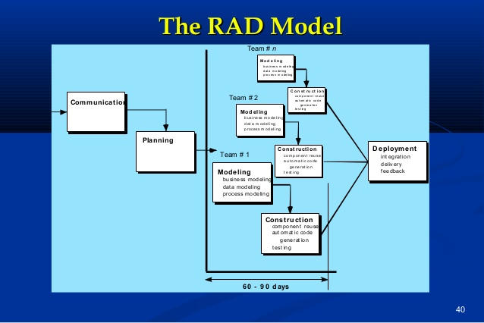

**Why it is used:**

The primary purpose of the project is to create a portal for uploading and verification of documents. The modelling of the project does not involve any unknown changes to occur during the construction phase of the model. In case of any update, it can only occur once the project has been deployed and made available to the users. Hence, the RAD model is an ideal and efficient model which caters to the needs of this project.

In addition to this, once a change is asked for, the model will require to implement the planning phase again in order to construct a blueprint with the added features. The modelling and construction phase can be segregated among the teams that handle the different aspects of the portal i.e. hospital logins, government servers and the user logins.

Therefore we can easily implement the construction as separate modules and the RAD model therefore ensures efficient implementation.