**Experiment No: 10**

**Aim:** To develop test cases for selected case study using white box testing.

**Theory:**

White box testing is a testing technique which evaluates the code and the internal structure of a program.

**White Box Testing is coverage of the specification in the code:**

**1. Code coverage**

**2. Segment coverage:**Ensure that each code statement is executed once.

**3. Branch Coverage or Node Testing:**Coverage of each code branch in from all possible was.

**4. Compound Condition Coverage:**For multiple conditions test each condition with multiple paths and combination of the different path to reach that condition.

**5. Basis Path Testing:**Each independent path in the code is taken for testing.

**6. Data Flow Testing (DFT):**In this approach you track the specific variables through each possible calculation, thus defining the set of intermediate paths through the code.DFT tends to reflect dependencies but it is mainly through sequences of data manipulation. In short, each data variable is tracked and its use is verified. This approach tends to uncover bugs like variables used but not initialize, or declared but not used, and so on.

**7. Path Testing:**Path testing is where all possible paths through the code are defined and covered. It’s a time-consuming task.

**8. Loop Testing:**These strategies relate to testing single loops, concatenated loops, and nested loops. Independent and dependent code loops and values are tested by this approach.

Steps to Perform WBT

**Step #1** – Understand the functionality of an application through its source code. Which means that a tester must be well versed with the programming language and the other tools as well techniques used to develop the software.

**Step #2**– Create the tests and execute them.

When we discuss the concept of testing, “[coverage](https://www.softwaretestinghelp.com/test-coverage/)” is considered to be the most important factor. Here I will explain how to have maximum coverage from the context of White box testing.

**Main White Box Testing Techniques:**

1. Statement Coverage
2. Branch Coverage
3. Path Coverage

### **White Box Testing Example**

***Consider the below simple pseudocode:***

INPUT A & B

C = A + B

IF C>100

PRINT “ITS DONE”

For ***Statement Coverage*** – we would only need one test case to check all the lines of the code.

**That means:**

If I consider *TestCase_01 to be (A=40 and B=70),* then all the lines of code will be executed.

**Now the question arises:**

1. Is that sufficient?
2. What if I consider my Test case as A=33 and B=45?

Because Statement coverage will only cover the true side, for the pseudo code, only one test case would NOT be sufficient to test it. As a tester, we have to consider the negative cases as well.

Hence for maximum coverage, we need to consider **“*Branch Coverage*”**, which will evaluate the “FALSE” conditions.

In the real world, you may add appropriate statements when the condition fails.

***So now the pseudocode becomes:***

INPUT A & B

C = A + B

IF C>100

PRINT “ITS DONE”

ELSE

PRINT “ITS PENDING”

Since Statement coverage is not sufficient to test the entire pseudo code, we would require Branch coverage to ensure maximum coverage**.**

So, for Branch coverage, we would require two test cases to complete the testing of this pseudo code.

**TestCase_01**: A=33, B=45

**TestCase_02**: A=25, B=30

With this, we can see that each and every line of the code is executed at least once.

White Box Testing for User Email Validation

Code:

<html>

<head>

<title>Login</title>

</head>

<body>

<h1>Validate Email</h1>

<form onsubmit="checkEmail();" method="post">

<p>Username: <input type="text" id="username"></p>

<p>Password: <input type="text" id="password"></p>

<p>Email: <input type="text" id="email"></p>

<p><input type="submit" name="submit" value="Login"></p>

</form>

<script type="text/javascript">

function checkEmail(){

var e = document.getElementById('email').value;

var reg = /^\w+([\.-]?\w+)*@\w+([\.-]?\w+)*(\.\w{2,3})+$/

if(document.getElementById('username') == 'root'){

if(document.getElementById('password') == 'pass@123'){

if(reg.test(e))

return true;

return false;

}

return false;

}

return false;

}

</script>

</body>

</html>

Flowchart:

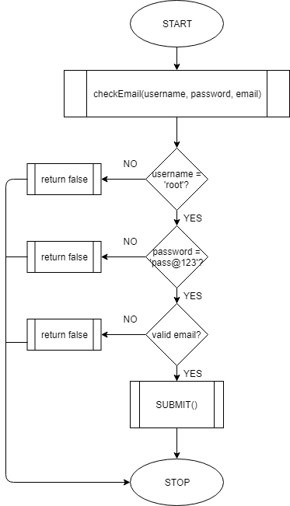

**Conclusion:** Thus, we successfully performed white box testing and developed test case for the selected case study.