**EXPERIMENT-3**

**Aim:** To prepare schedule for the project using project management tool (MS-Project)

**Theory:**

MS Project, the project management software program by Microsoft, is a very handy tool for project managers that helps them develop a schedule, assign resources to tasks, track the progress, manage the budget, and analyze workloads for an ongoing project. This tutorial discusses the various features of the software program with examples for easy understanding.

**Task List:**

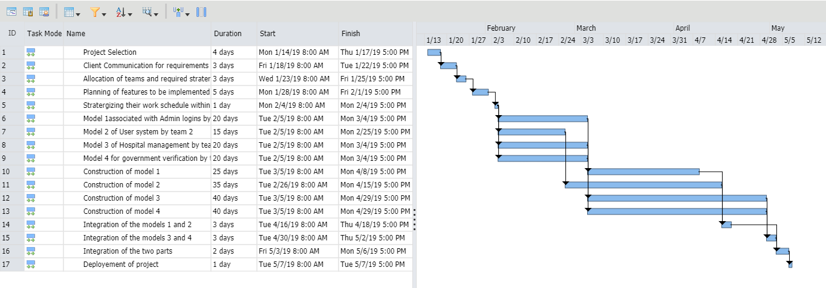

**Entire Schedule:**



**Conclusion:** Thus, using the MS project planner we have implemented the schedule of our project along with the deadlines and merging of various modules. It helps with keeping the track of our project as a whole and to deliver according to user expectations.