**Experiment No: 05**

**Aim:** To identify scenarios & develop UML Use case and Class Diagram for the selected case study.

**Theory:**

Use Case Diagram:

## **Purpose of Use Case Diagram**

Use case diagrams are typically develop in early stage of development and people often apply use case modeling for the following purposes:

* Specify the context of a system
* Capture the requirements of a system
* Validate a systems architecture
* Drive implementation and generate test cases
* Developed by analysts together with domain experts

## **Use Case Diagram at a Glance**

A standard form of use case diagram is defined in the Unified Modeling Language as shown in the Use Case Diagram example below:

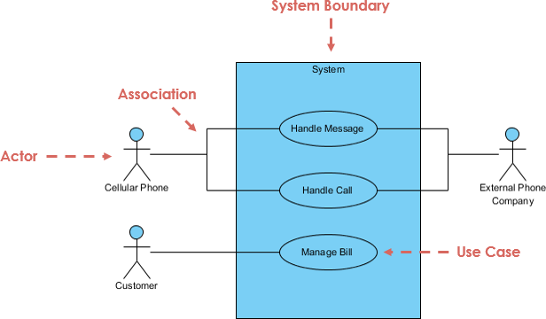

|  |
| --- |
| **Use Case Relationship** |
| **Extends**   * Indicates that an **"Invalid Password"** use case may include (subject to specified in the extension) the behavior specified by base use case **"Login Account"**. * Depict with a directed arrow having a dotted line. The tip of arrowhead points to the base use case and the child use case is connected at the base of the arrow. * The stereotype "<<extends>>" identifies as an extend relationship |
| **Include**   * When a use case is depicted as using functionality of another functionality of another use case, this relationship between the use cases is named as an include or uses relationship. * A use case includes the functionality described in another use case as a part of its business process flow. * A uses relationship from base use case to child use case indicates that an instance of the base use case will include the behavior as specified in the child use case. * An include relationship is depicted with a directed arrow having a dotted line. The tip of arrowhead points to the child use case and the parent use case connected at base of the arrow. * The stereotype "<<include>>" identifies the relationship as an include relationship. |
| **Generalization**   * A generalization relationship is a parent-child relationship between use cases. * The child use case in the generalization relationship has the underlying business process meaning, but is an enhancement of the parent use case. * Generalization is shown as a directed arrow with a triangle arrowhead. * The child use case is connected at the base of the arrow. The tip of the arrow is connected to the parent use case. |

Class Diagram

## **Purpose of Class Diagrams**

1. Shows static structure of classifiers in a system
2. Diagram provides basic notation for other structure diagrams prescribed by UML
3. Helpful for developers and other team members too
4. Business Analysts can use class diagrams to model systems from business perspective

A UML class diagram is made up of:

* A set of classes and
* A set of relationships between classes

## **What is a Class**

A description of a group of objects all with similar roles in the system, which consists of:

* **Structural features** (attributes) define what objects of the class "know"
  + Represent the state of an object of the class
  + Are descriptions of the structural or static features of a class
* **Behavioral features** (operations) define what objects of the class "can do"
  + Define the way in which objects may interact
  + Operations are descriptions of behavioral or dynamic features of a class

## **Class Notation**

A class notation consists of three parts:

1. **Class Name**
   * The name of the class appears in the first partition.
2. **Class Attributes**
   * Attributes are shown in the second partition.
   * The attribute type is shown after the colon.
   * Attributes map onto member variables (data members) in code.
3. **Class Operations** (Methods)
   * Operations are shown in the third partition. They are services the class provides.
   * The return type of a method is shown after the colon at the end of the method signature.
   * The return type of method parameters are shown after the colon following the parameter name.
   * Operations map onto class methods in code

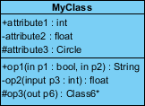

**USE CASE DIAGRAM:** The use case diagram implemented for our case study

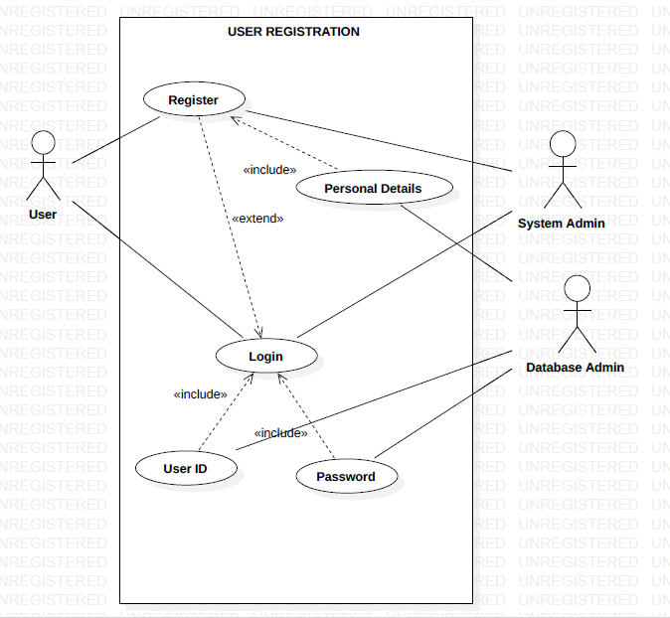

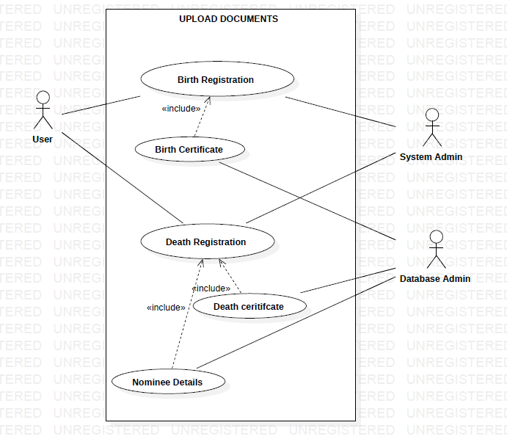

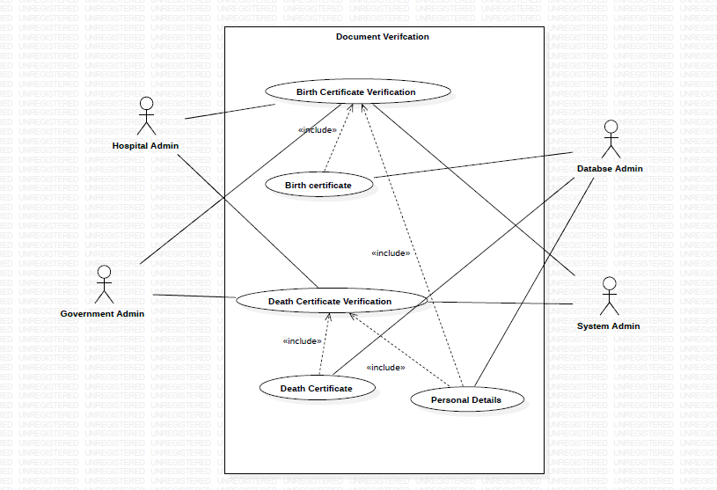

**CLASS DIAGRAM:**

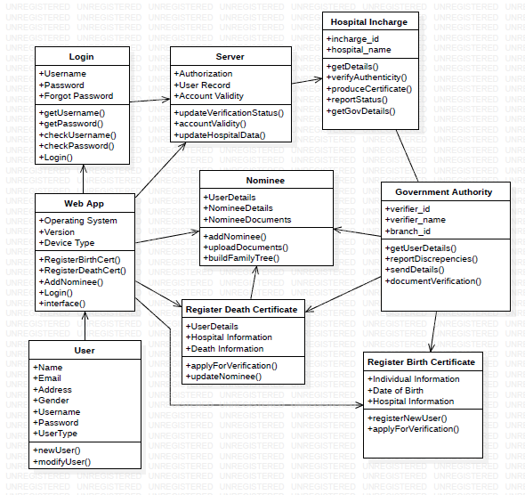

**Conclusion:**

Thus, we have implemented the concepts of use-case diagram and class diagram for our Birth and Death registration portal. It helps in the visualization and understanding the working of the case study. Furthermore, it gives clear meaning to your project design.