**Experiment No: 06**

**Aim:** To draw DFD (2 levels) and prepare Data Dictionary for the selected case study.

**Theory:**

DFD graphically representing the functions, or processes, which capture, manipulate, store, and distribute data between a system and its environment and between components of a system. The visual representation makes it a good communication tool between User and System designer. Structure of DFD allows starting from a broad overview and expand it to a hierarchy of detailed diagrams. DFD has often been used due to the following reasons:

* Logical information flow of the system
* Determination of physical system construction requirements
* Simplicity of notation
* Establishment of manual and automated systems requirements

DFD Symbols:



**DFD LEVEL 0:**

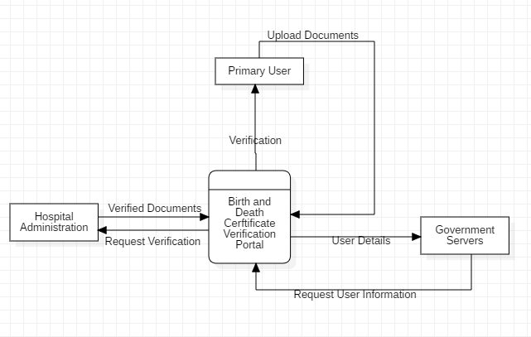

**DFD LEVEL 1:**

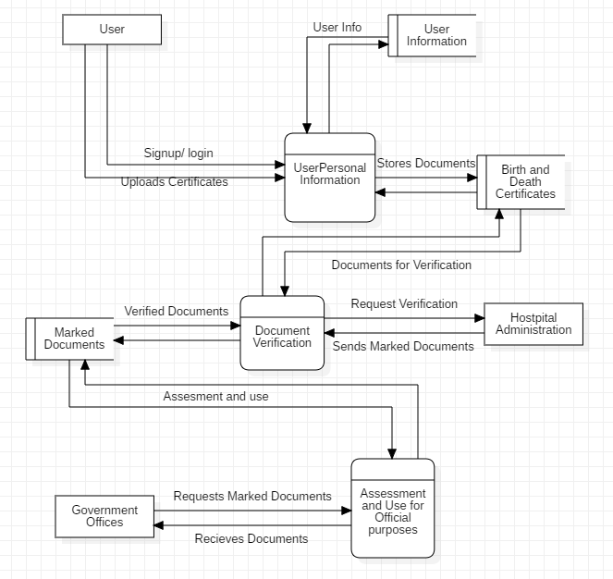

**DFD LEVEL 2:**

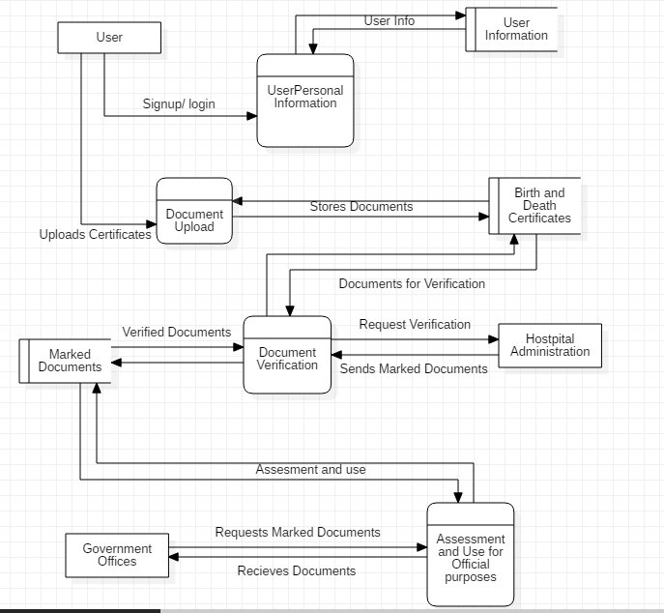

**Conclusion:**

We have successfully understood and implemented the Data flow diagrams for our project. It gives the developers the understanding about the flow of the diagram. Thus, making it easy for them to implement the same in the project.