**Experiment No: 07**

**Aim:** To develop Activity diagram for the selected case study.

**Theory:**

Steps to draw Activity diagram

1. Identify candidate use cases, through the examination of business workflows
2. Identify pre- and post-conditions (the context) for use cases
3. Model workflows between/within use cases
4. Model complex workflows in operations on objects
5. Model in detail complex activities in a high level activity Diagram

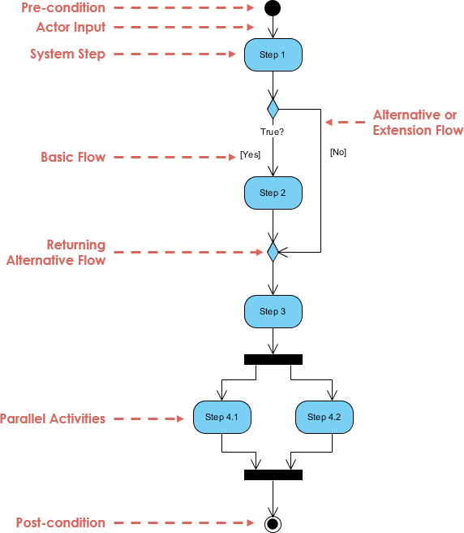

**ACTIVITY DIAGRAM:**

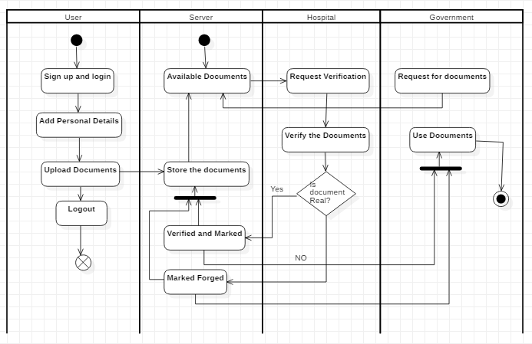

**Conclusion:**

Thus, we have implemented the activity diagram for our case study. It tells us about the candidate use-cases and the business workflow of the model. The flow of the functons in the project can be clearly understood by the activity diagram.