**Experiment No: 08**

**Aim:** To develop Sequence and Collaboration diagram for the selected case study.

**Theory:**

Purpose of Sequence Diagram

* Model high-level interaction between active objects in a system
* Model the interaction between object instances within a collaboration that realizes a use case
* Model the interaction between objects within a collaboration that realizes an operation
* Either model generic interactions (showing all possible paths through the interaction) or specific instances of a interaction (showing just one path through the interaction)

### Sequence Diagram Example: Hotel System

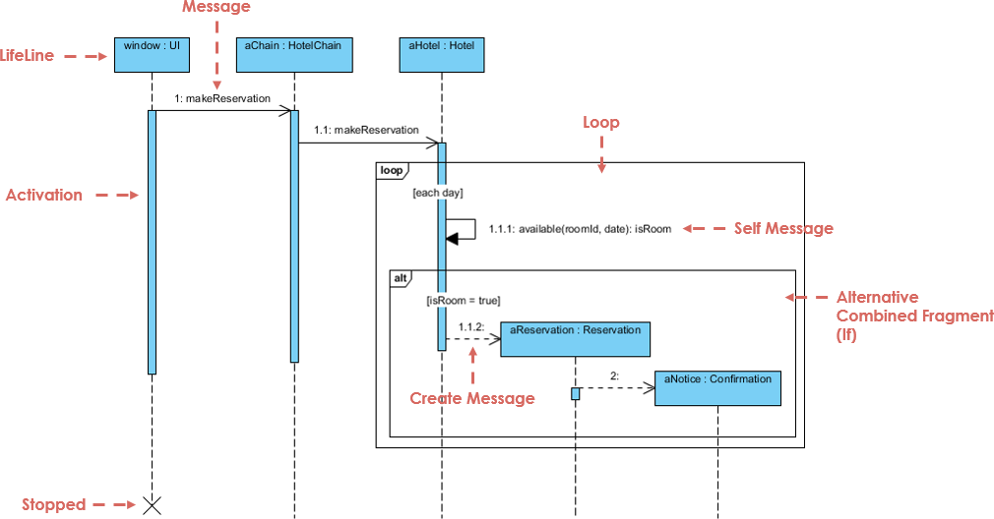

## **Steps for Creating Collaboration Diagrams**

1. Identify behavior whose realization and implementation is specified
2. Identify the structural elements (class roles, objects, subsystems) necessary to carry out the functionality of the collaboration
   * Decide on the context of interaction: system, subsystem, use case and operation
3. Model structural relationships between those elements to produce a diagram showing the context of the interaction
4. Consider the alternative scenarios that may be required
   * Draw instance level collaboration diagrams, if required.
   * Optionally draw a specification level collaboration diagram to summarize the alternative scenarios in the instance level sequence diagrams

## **Collaboration Diagram Example**

## **Collaboration Diagram Example**

**SEQUENCE DIAGRAM:**

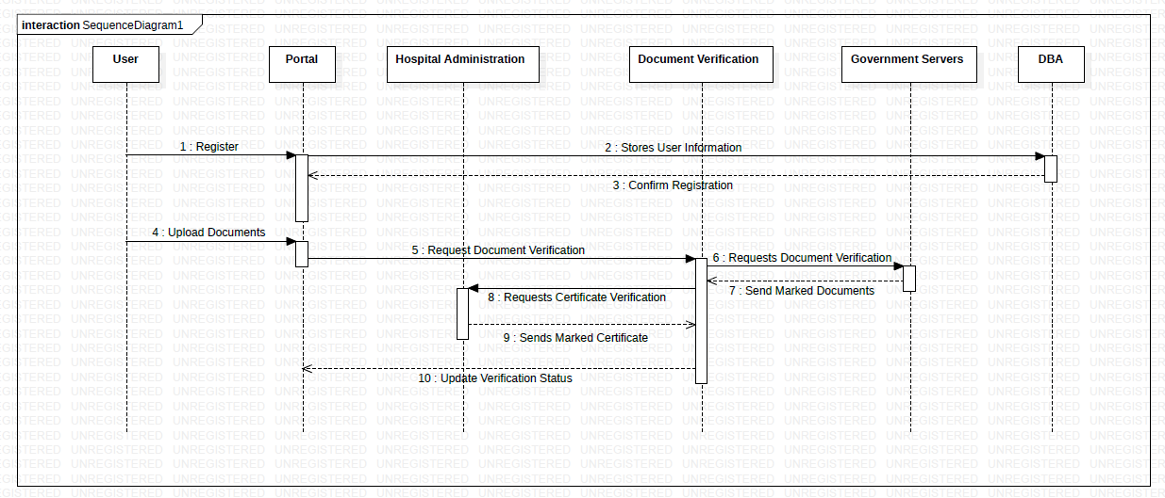

**COLLABORATION DIAGRAM:**

