**Experiment No: 09**

**Aim:** To prepare Change specifications and make different versions of selected case study using GitHub tool.

**Theory:**

## Version Control System

Version Control System (VCS) is a software that helps software developers to work together and maintain a complete history of their work.

Listed below are the functions of a VCS –

Allows developers to work simultaneously.

Does not allow overwriting each other’s changes.

Maintains a history of every version.

Following are the types of VCS −

* Centralized version control system (CVCS).
* Distributed/Decentralized version control system (DVCS).

Let us see the basic workflow of Git.

Step 1 − You modify a file from the working directory.

Step 2 − You add these files to the staging area.

Step 3 − You perform commit operation that moves the files from the staging area. After push operation, it stores the changes permanently to the Git repository.

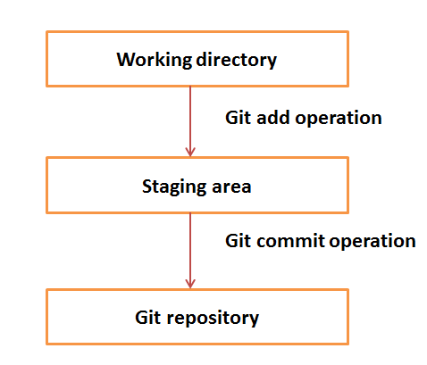

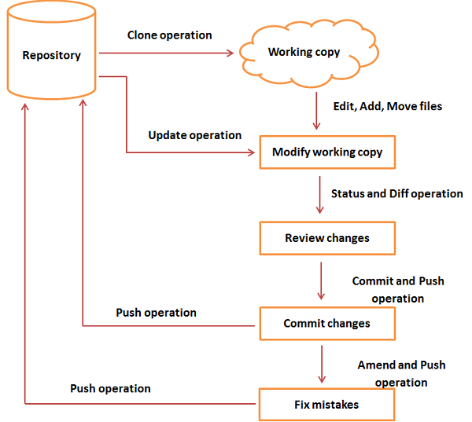

**Creating project directory**

* Open Terminal
* Use git bash
* Create repository using git terminal

**Initializing the repository**

Git init – makes a hidden .git folder in the folder where the command is run. This hidden folder indicates that this folder is a git repository. This folder keeps track of the changes that occur locally in this repository.

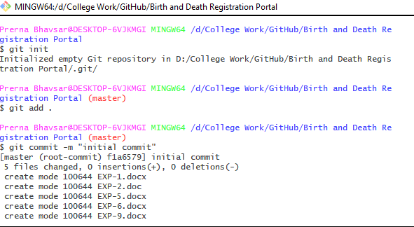

After some files are added in the repository initiated folder, Git Status – tells us whether the changes to the files are tracked locally or in the staging directory or in the repository itself

**Adding commits**

Git commit -m “message to be given for the commit ” – git commit adds the changes made locally to the staging area

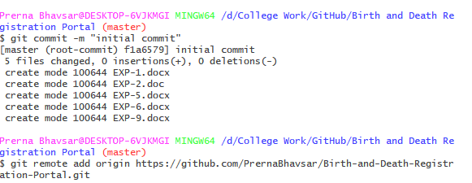

**Pushing the repository**

Git push repository_http_url branch name pushes the file from the staging area to the github repository, now you can access your files in the github repository from anywhere

Git push origin master pushes the git to a remote repository. Origin is the name for remote git url.

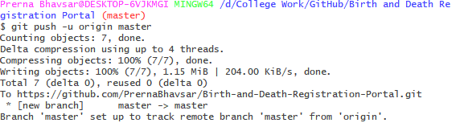

**Github Page:**

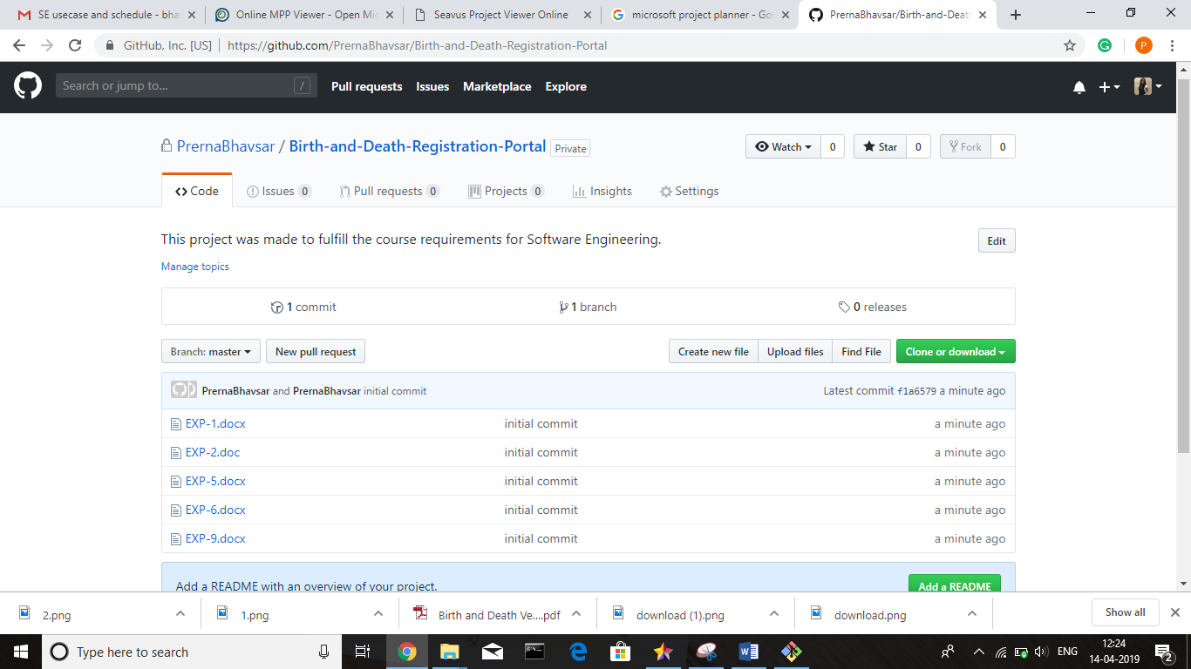

**Change before and after version control**

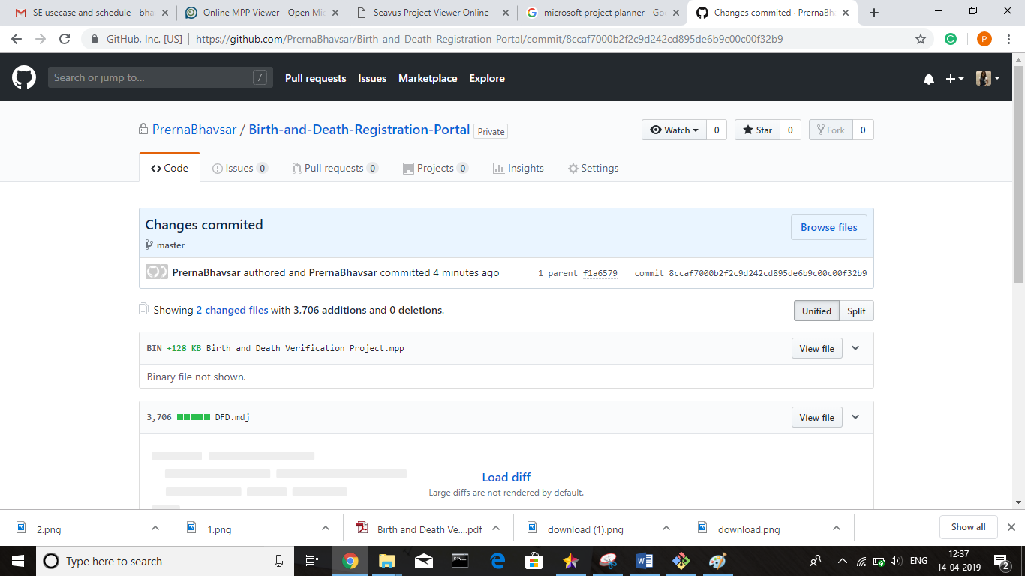

**Conclusion:**

Thus we have successfully installed , configurated and used git as an SCM tool.