**MINI PROJECT**

**TOPIC: STUDENT INFORMATION SYSTEM**

**AIM:** To implement a Student Information System in Java using databases.

**IDE AND DATABASE USED:** NetBeans IDE 8.2, Microsoft Access 2010, UCanAccess-4.0.2 Driver.

**THEORY:**

* **FEATURES:**

The program designed maintains a record of students that enable the user to:

* Signup as a new user
* Login and Update/ Enter their Personal and Academic details that include marks scored in each subject wherein the total, can be calculated within the program itself.
* All the data entries can be reset as well as updated into the database, managed.
* **EXECUTION:**

Using Netbeans, we can design the layout for the activity screens which are:

1) Login form

2) Student Database

3) Student Result Record

There are three databases in the system, which are linked to Netbeans using the UCanAccess Driver in every form.

Images, Textboxes, Labels and Radio Buttons, can be inserted using Swing/AWT.

The three databases maintain a record of users that have signed up, general details and marks of the user respectively.

The SAP ID of every user ensures there is no repetition of a student record within any database.

**OUTPUT:**

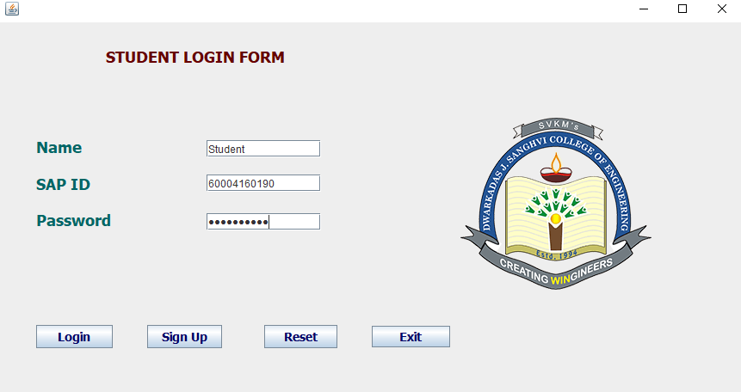

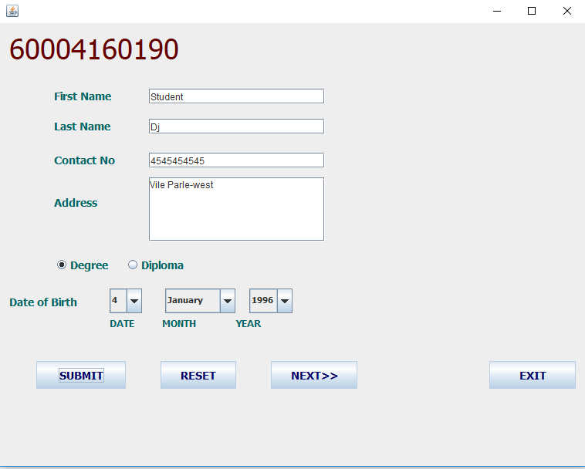

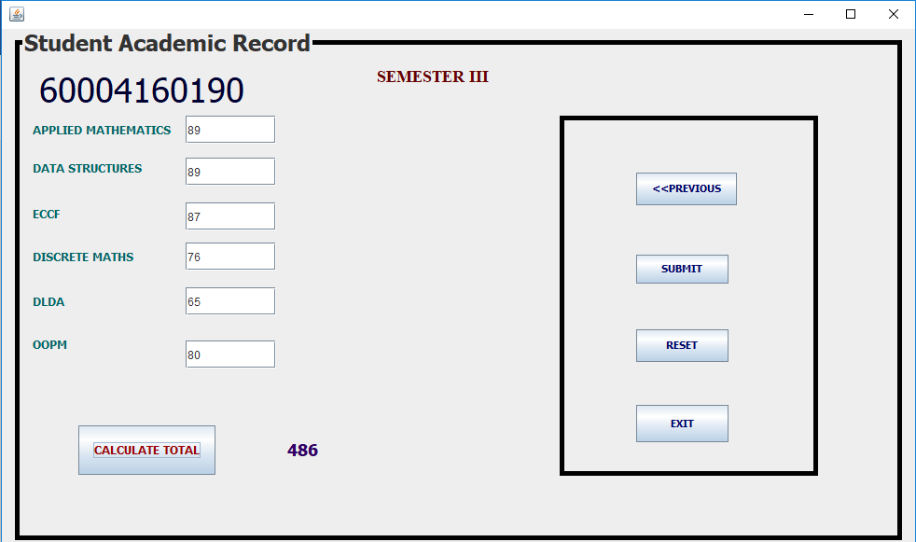

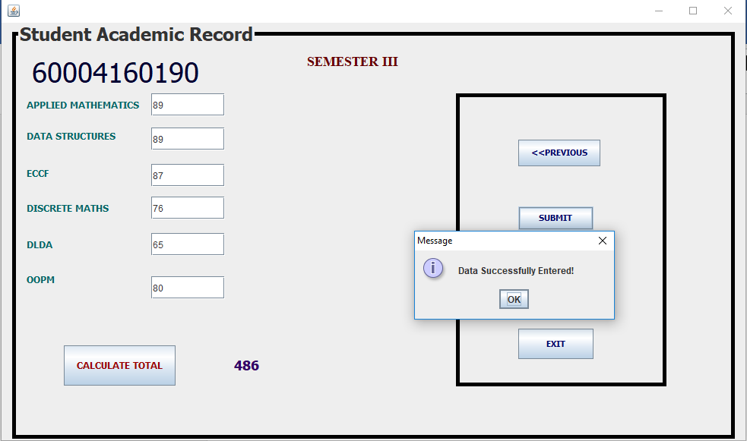

**CONCLUSION:** Thus, we have successfully implemented student information system using the concepts of AWT and GUI.