**PROBLEM STATEMENT WITH SQL QUERIES**

1. **KPI’s REQUIREMENTS: -**
2. **TOTAL REVENUE: The sum of the total price of all pizza orders.**



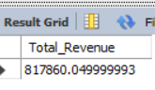

1. **AVERAGE ORDER VALUE: Dividing the total revenue by the total numbers of orders.**

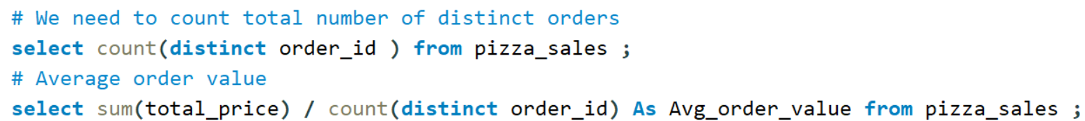

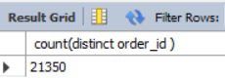

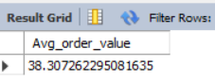

1. **TOTAL PIZZAS SOLD: The sum of the quantities of all pizzas sold.**



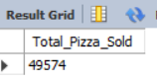

1. **TOTAL ORDERS: The total number of orders placed.**



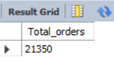

1. **AVERAGE PIZZA PER ORDER: how many pizzas sold per order, dividing total number of pizzas sold by the total number of orders.**



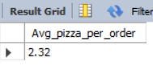

1. **CHART REQUIREMENTS: -**
2. **DAILY TREND FOR TOTAL ORDERS: COLUMN CHART**

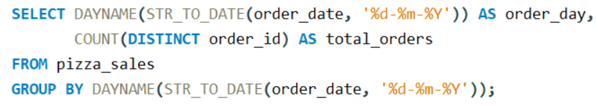

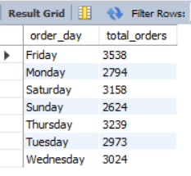

1. **MONTHLY TREND FOR TOTAL ORDERS: AREA CHART**

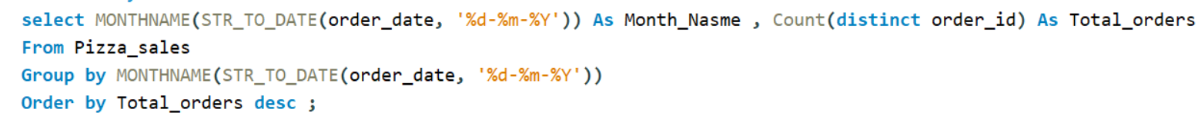

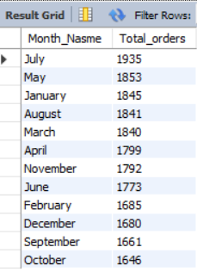

1. **PERCENTAGE OF SALE BY PIZZA CATEGORY: DONUT CHART**

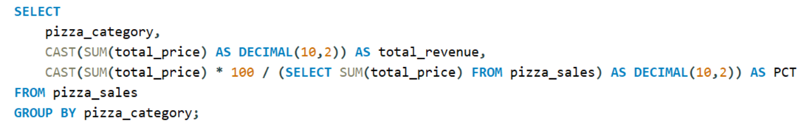

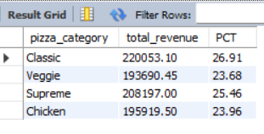

1. **PERCENTAGE OF SALE BY PIZZA SIZE: WATERFALL CHART**

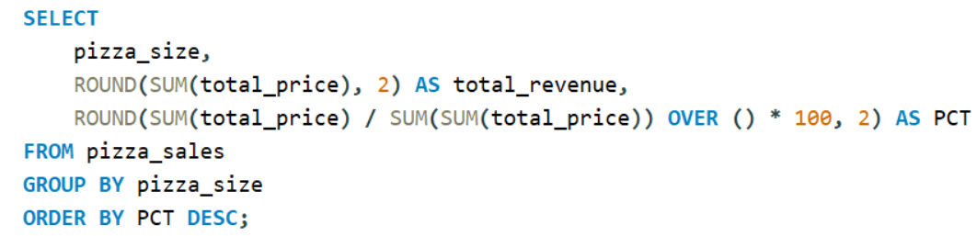

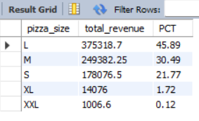

1. **TTOTAL PIZZAS SOLD BY PIZZA CATEGORY: FUNNEL CHART**

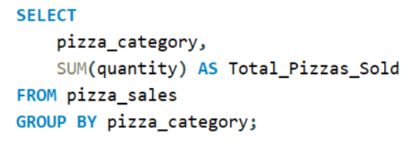

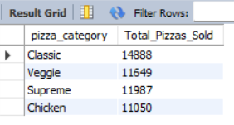

1. **TOP 5 BEST SELLERS by Total revenue, Total quantity and Total Orders: BAR CHART**

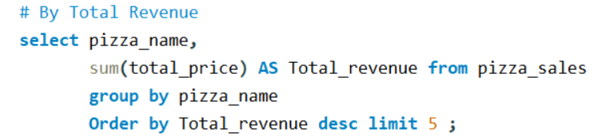

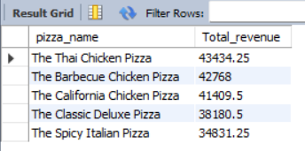

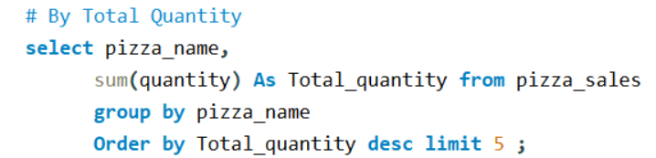

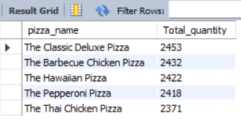

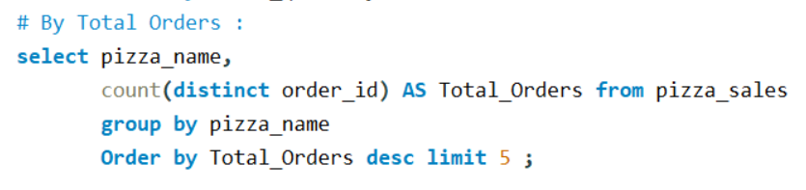

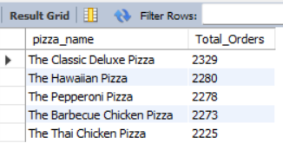

1. **BOTTOM 5 WORST SELLERS by Total revenue, Total quantity and Total Orders: BAR CHART**

