ASSIGNMENT1

create the following tables with the given structures and insert sample data as specified:

SALESPEOPLE

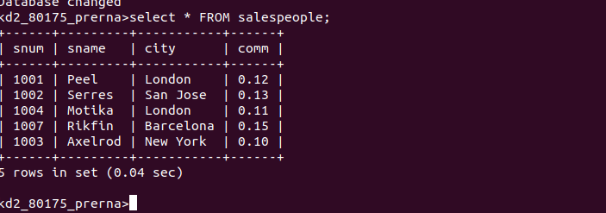

CUSTOMERS
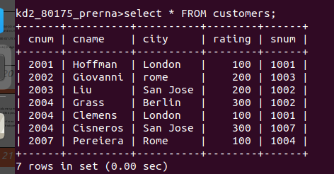

Orders

