Assignment-9

Q1.Write a query that lists each order number followed by the name of the customers
who made the order.
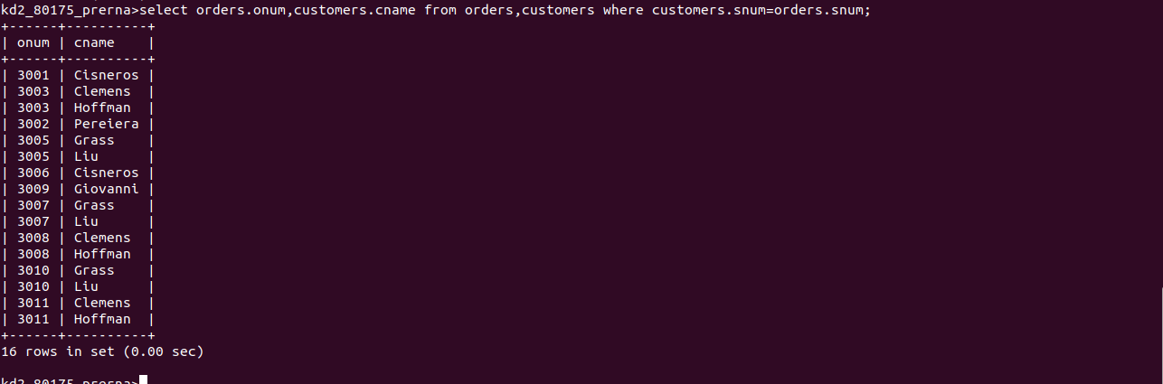
Q2.Write a query that gives the names of both the salesperson and the customers for each order along with the order number.
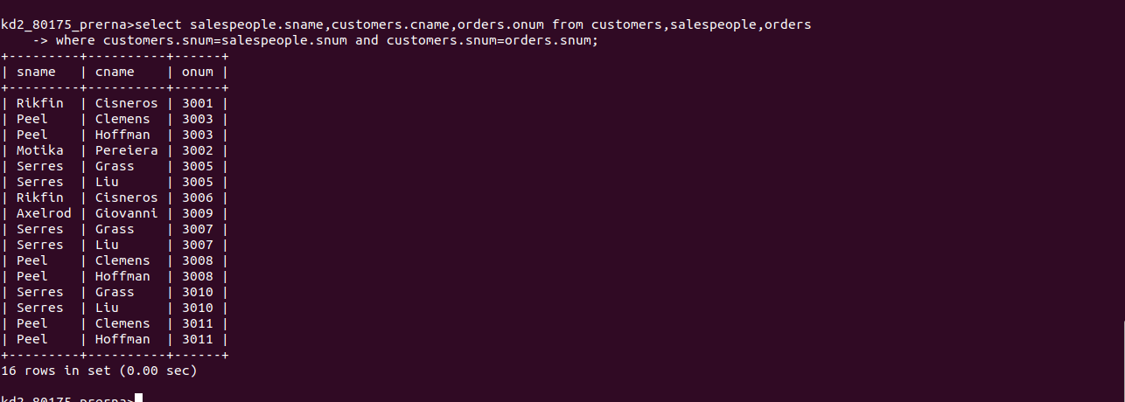
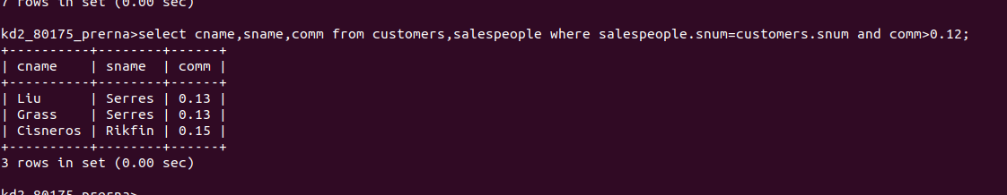
Q3.Write a query that produces all customers serviced by salespeople with a commission above 12%. Output the customer’s name ,the salesperson name,and the salesperson’s rate of commission.
Q4.Write a query that calculates the amount of the salesperson’s commission on each order by a customer with a rating above 100.
