SQL ASSIGNMENT-8

1.ASSUME EACH SALESPEOPLE HAS A 12% COMMISSION.WRITE A QUERY ON THE ORDERS TABLE THAT WILL PRODUCE THE ORDER NUMBER ,THE SALESPEOPLE NUMBER ,AND THE AMOUNT OF SALESPEOPLE COMMISSION FOR THAT ORDER.
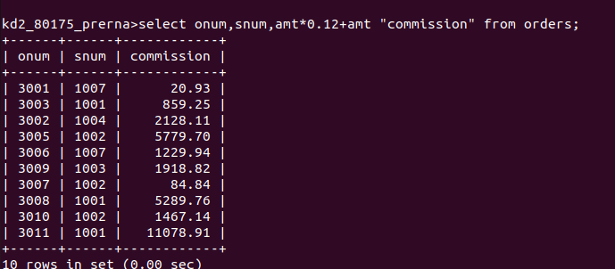

2.WRITE A QUERY ON THE CUSTOMERS TABLE THAT WILL FIND THE HIGHEST RATING IN EACH CITY .PUT THE OUTPUT IN THIS FORM:
FOR THE CITY (CITY), THE HIGHEST RATING IS (RATING)
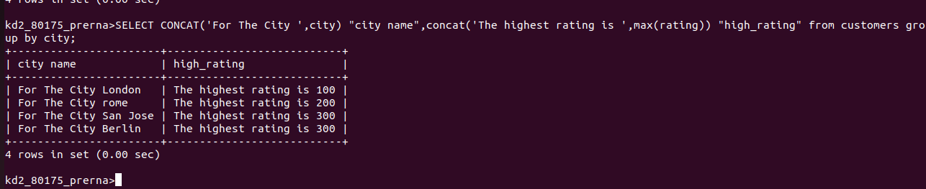

3.WRITE A QUERY THAT LISTS CUSTOMERS IN DESCENDING ORDER OF RATING.
OUTPUT THE RATING FIELD FIRST, FOLLOWED BY THE CUSTOMER’S NAME AND NUMBER.
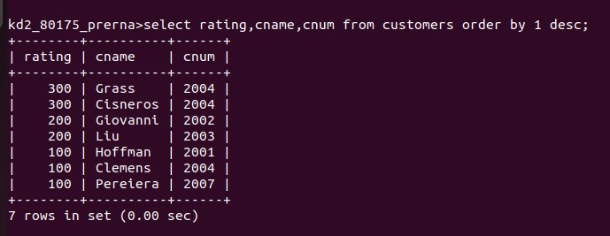

4.WRITE A QUERY THAT TOTALS THE ORDERS FOR EACH DAY AND THE PLACES THE RESULTS IN DESCENDING ORDER.
