ASSIGNMENT -10

Q1.Write a query that produces all pairs of salespeople who are living in the same city . Exclude combinations of salespeople with themselves as well as duplicates rows withe the order reversed.
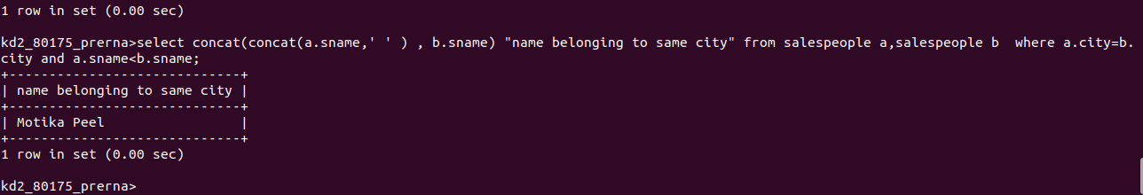
Q2.Write a query that produces the names and cities of all customers with the same rating as Hoffman.
