Assignment -14

Q1.Write a command that puts the following values ,in their given order ,into the salespeople table:
city-San Jose, name-Blanco,comm-null,snum-1100.

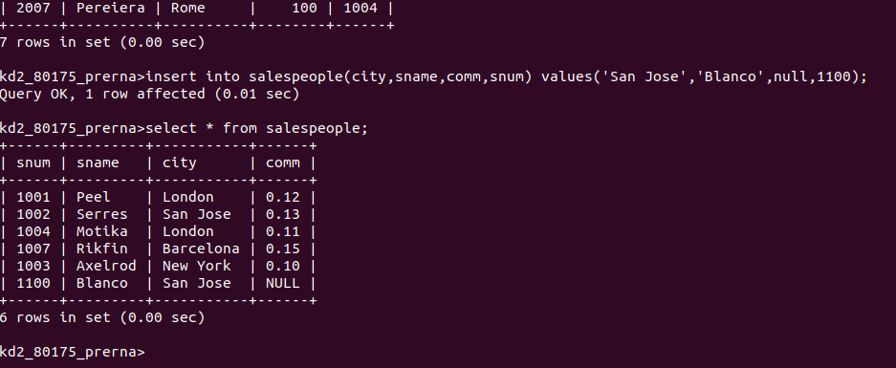
Q2.Write a command that removes all orders from customers clemens from the orders table.
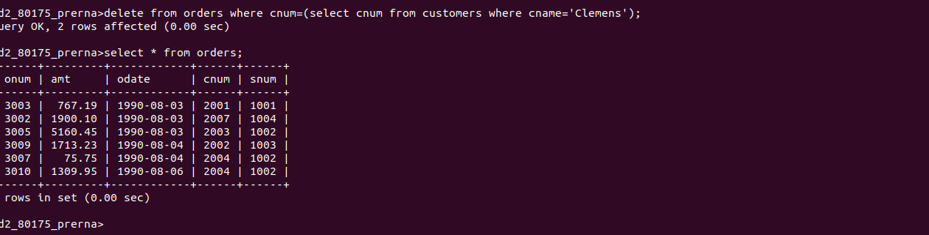

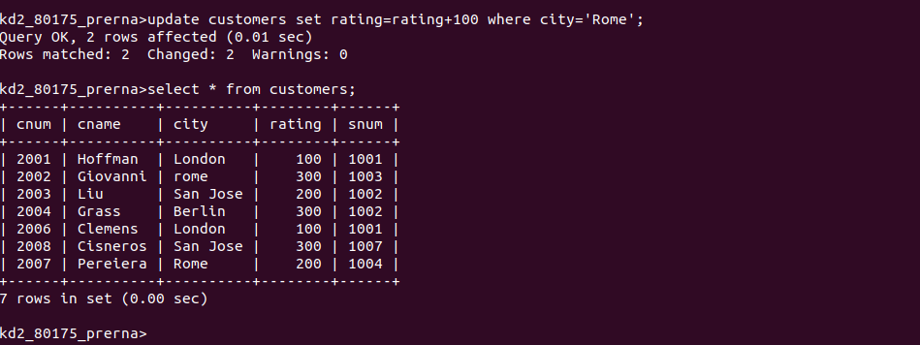
Q3.Write a command that increases the rating of all customers in Rome by 100.

Q4.Salesperson Serres has left the company .Assign her customers to Motika.
