Assignment 11

Q1.Write a query that uses a subquery to obtain all orders for the customers named Cisneros .Assume you do not know his customer number (cnum).
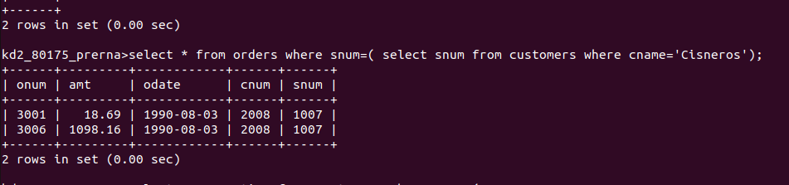
Q2.Write a query that produces the names and ratings of all customers who have above=average orders.
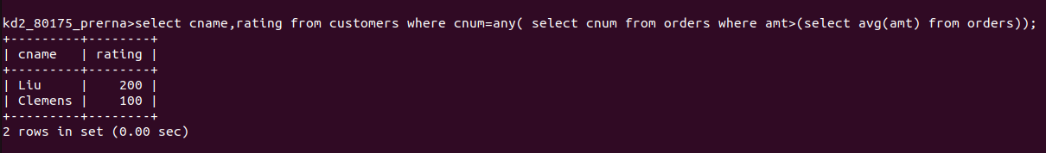
Q3.Write a query that selects the total amount in orders for each salesperson for whom this total is greater than the amount of the largest order in the table .
