ASSIGNMENT-4

1. WRITE A SELECT COMMAND THAT PRODUCES THE ORDER NUMBER,AMOUNT, AND DATE FOR ALL ROWS IN THE ORDERS TABLE.

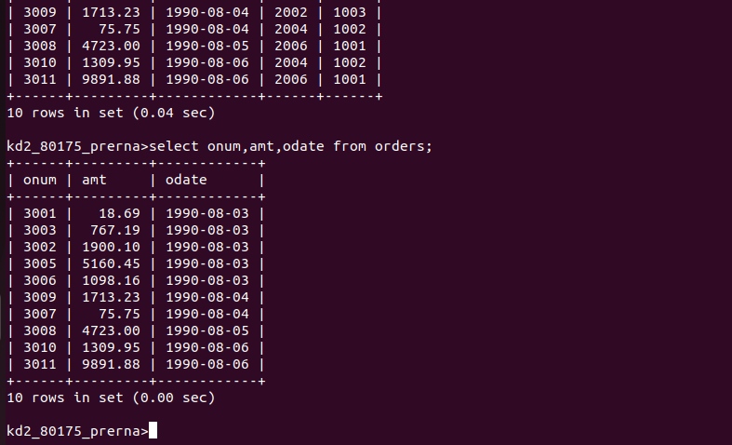

Q2. WRITE A QUERY THAT PRODUCES ALL ROWS FROM THE CUSTOMERS TABLE
FOR WHICH THE SALESPERSON’S NUMBER IS 1001.
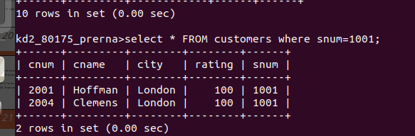

Q3. WRITE A QUERY THAT DISPLAYS THE SALESPEOPLE TABLE WITH THE COLUMNS IN THE FOLLOWING ORDERS:CITY ,SNUM, COMM.

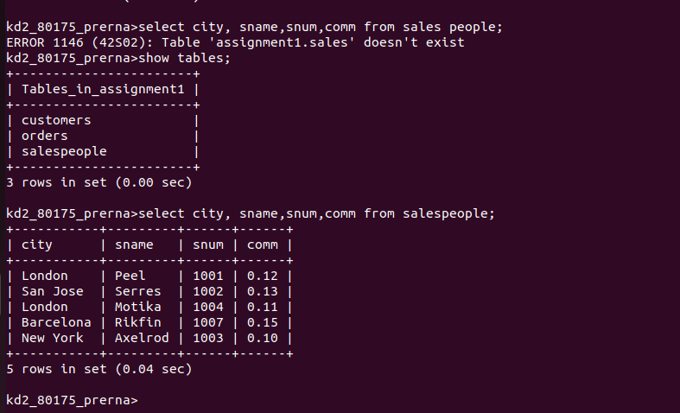

Q4 WRITE A SELECT COMMAND THAT PRODUCES THE RATING FOLLOWED
BY THE NAME OF EACH CUSTOMERS IN SAN JOSE.

