ASSIGNMENT-5

1.WRITE A QUERY THAT WILL GIVE YOU ALL ORDERS FOR MORE
THAN RS 1000.
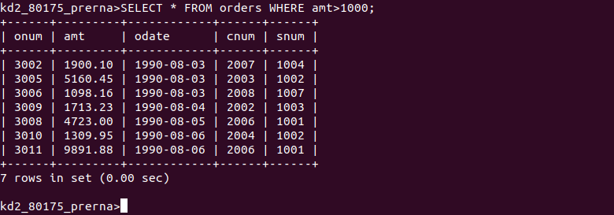

2.WRITE A QUERY THAT WILL GIVE YOU THE NAMES AND CITIES OF ALL SALESPEOPLE IN LONDON WITH A COMMISSION ABOVE .10.
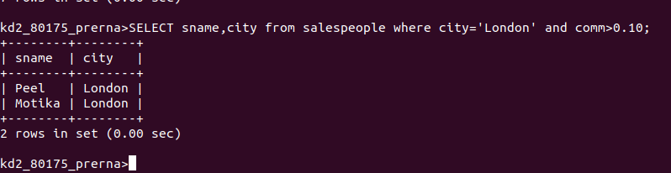
3.WRITE A QUERY ON THE CUSTOMERS TABLE WHOSE OUTPUT WILL EXCLUDE ALL CUSTOMERS WITH A RATING <=100, UNLESS THEY ARE LOCATED IN ROME.
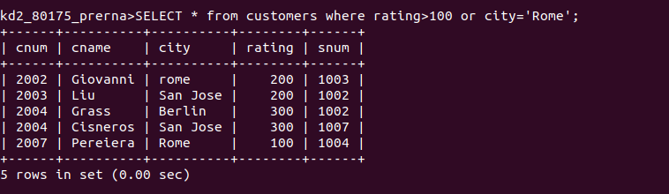
4.WHAT WILL BE THE OUTPUT FROM THE FOLLOWING QUERY?
SELECT * FROM ORDERS
WHERE (AMT<1000 OR NOT(ODATE=’1990-10-03’ AND CNUM>2003));
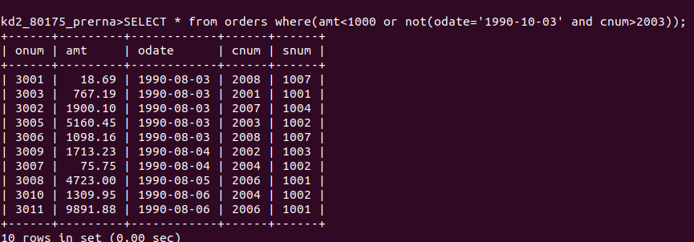
5.WHAT WILL BE THE OUTPUT ?
SELECT*FROM ORDERS
WHERE NOT((ODATE=’1990-10-03’ OR SNUM>1006)AND AMT>=1500);
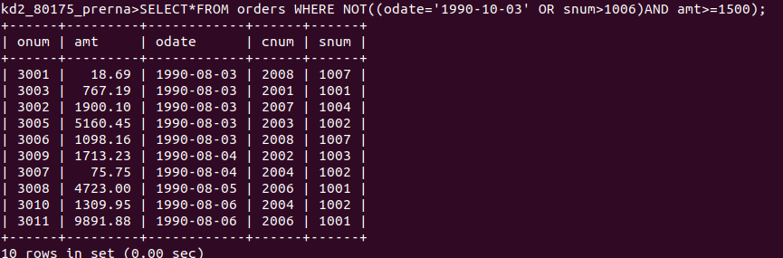
6.WHAT IS A SIMPLER WAY TO WRITE THIS QUERY?
SELECT SNUM,SNAME ,CITY, COMM FROM SALESPEOPLE WHERE (COMM>.12 OR COMM<.14;
