ASSIGNMENT-12

1.Write a query that selects all customers whose ratings are equal to or greater than
any of Serres.
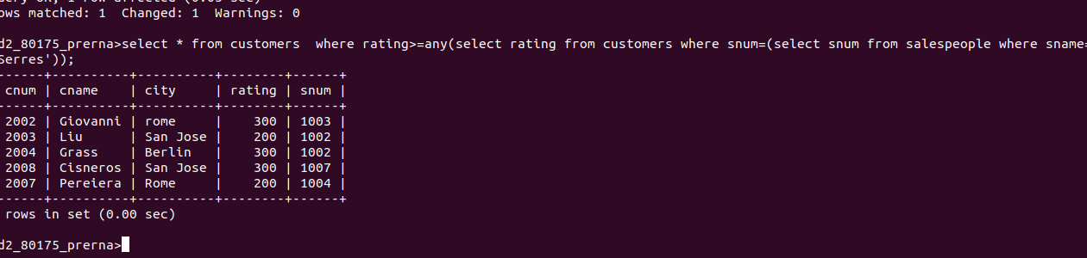
2.Write a query using any or all that will find all salespeople who have no customers located in their city.
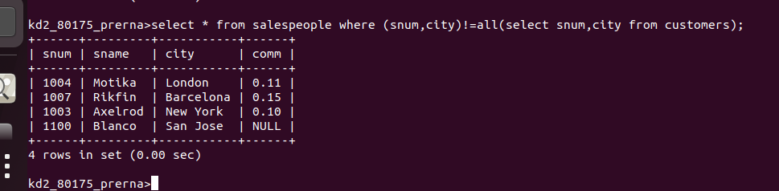
3.Write a query that selects all orders for amounts greater than any for the customers in london.
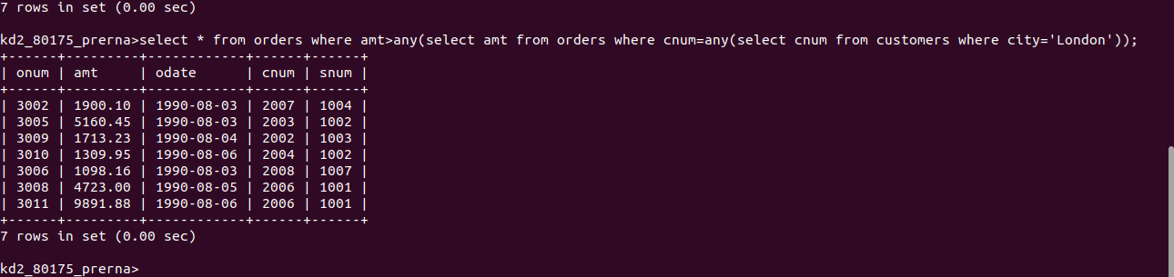
4.Write the above query using min or max.
