6th February 2019
INTRODUCTION TO DATABASE

* Problem Statement: There can be multiple customers, who can place multiple orders on the site. Now a sales person can handle these orders will distribute into multiple sales persons (One order will be assign to one salesperson only). So a sales person can have multiple orders of multiple customers

* Create Database
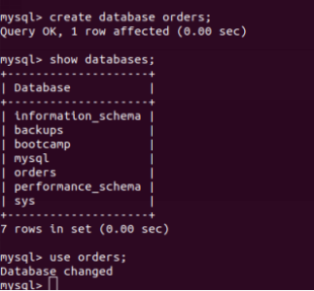

At first database is created and then we can use the command show databases in order to check all the data bases present.

* Design Schema

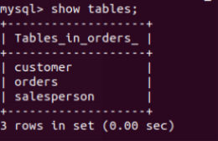

* Create tables

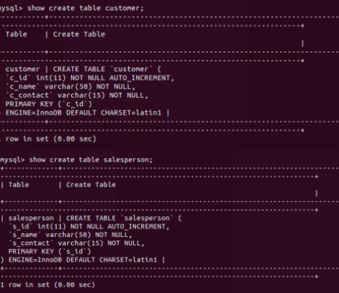

Here the table is created named customer with c_id, c_name,c_contact
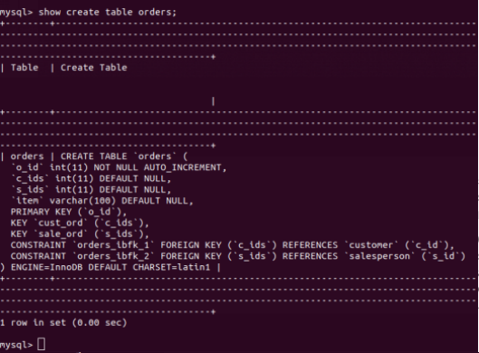

Here table is created named orders o_id, c_ids, s_ids,item

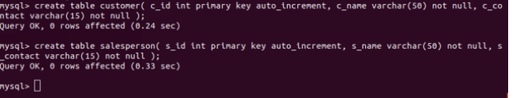

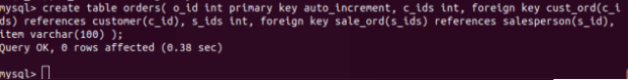

* Insert sample data

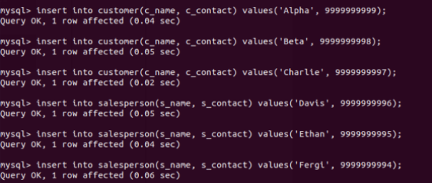
This is the inserted data in table customer
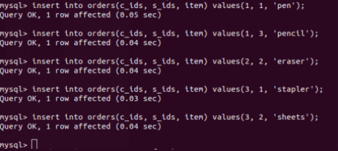

This is the inserted data in table orders

* Find the sales person have multiple orders

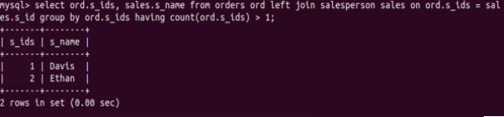
This describes the customers who have multiple orders with the help of left join placing the count >1

* Find the all sales person details along with order details

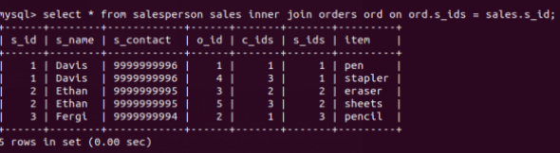
The inner join matches rows in one table with the rows of other table that is order and as a result allows to query rows that contain columns from both tables.

* Create index

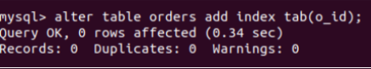

* How to show index on a table

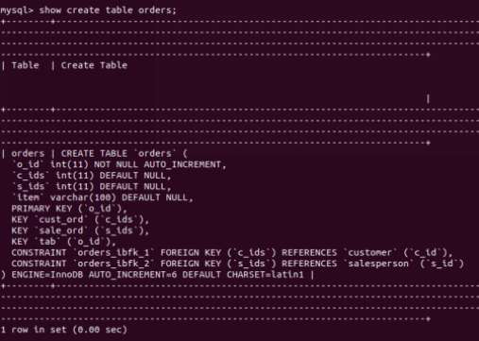

* Find the order number, sale person name, along with the customer to whom that order belongs to

