Q1. Given this array: `[3,62,234,7,23,74,23,76,92]`, Using arrow function, create an array of the numbers greater than `70`.

ANS:
<html>
<body>
<script>
document.write("<h3>Using arrow function finding array element greater than 70</h3>"+ "<br>");
const number=[3,62,234,7,23,74,23,76,92];
document.write("Array elements:- "+ number +"<br>");
number.sort(function(a, b){return a – b});
document.write("Array elements after sorting:- "+ number +"<br>");
const greater=number.filter(number => number >= 70)
document.write("Array elements greater than 70 :- "+ greater);
</script>
</body>
</html>

OUTPUT
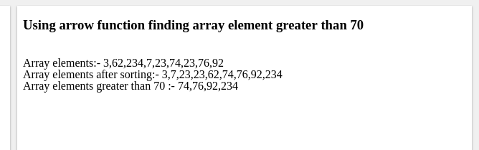

Q2.
<ul>
<li data-time="5:17">Flexbox Video</li>
<li data-time="8:22">Flexbox Video</li>
<li data-time="3:34">Redux Video</li>
<li data-time="5:23">Flexbox Video</li>
<li data-time="7:12">Flexbox Video</li>
<li data-time="7:24">Redux Video</li>
<li data-time="6:46">Flexbox Video</li>
<li data-time="4:45">Flexbox Video</li>
<li data-time="4:40">Flexbox Video</li>
<li data-time="7:58">Redux Video</li>
<li data-time="11:51">Flexbox Video</li>
<li data-time="9:13">Flexbox Video</li>
<li data-time="5:50">Flexbox Video</li>
<li data-time="5:52">Redux Video</li>
<li data-time="5:49">Flexbox Video</li>
<li data-time="8:57">Flexbox Video</li>
<li data-time="11:29">Flexbox Video</li>
<li data-time="3:07">Flexbox Video</li>
<li data-time="5:59">Redux Video</li>
<li data-time="3:31">Flexbox Video</li>
</ul>

- Select all the list items on the page and convert to array.
- Filter for only the elements that contain the word 'flexbox'
- map down to a list of time strings
- map to an array of seconds
- reduce to get total using .filter and .map

ANS:
<!DOCTYPE html>
<html>
<head>
<title>Javascript</title>
</head>
<body>
<ul>
<li data-time="5:17">Flexbox Video</li>
<li data-time="8:22">Flexbox Video</li>
<li data-time="3:34">Redux Video</li>
<li data-time="5:23">Flexbox Video</li>
<li data-time="7:12">Flexbox Video</li>
<li data-time="7:24">Redux Video</li>
<li data-time="6:46">Flexbox Video</li>
<li data-time="4:45">Flexbox Video</li>
<li data-time="4:40">Flexbox Video</li>
<li data-time="7:58">Redux Video</li>
<li data-time="11:51">Flexbox Video</li>
<li data-time="9:13">Flexbox Video</li>
<li data-time="5:50">Flexbox Video</li>
<li data-time="5:52">Redux Video</li>
<li data-time="5:49">Flexbox Video</li>
<li data-time="8:57">Flexbox Video</li>
<li data-time="11:29">Flexbox Video</li>
<li data-time="3:07">Flexbox Video</li>
<li data-time="5:59">Redux Video</li>
<li data-time="3:31">Flexbox Video</li>
</ul>

<p></p>

<script type="text/javascript">

//Question 1: Select all the list items on the page and convert to array.

let selectItems=(element)=>Array.from(document.querySelectorAll(element));

//Question 2: Filter for only the elements that contain the word 'flexbox'

let filtered_items=selectItems('li').filter(element=> element.innerText==="Flexbox Video");

//Question 3: map down to a list of time strings

let list_time=selectItems('li').map(element=>element.getAttribute('data-time'))

//Question 4: map to an array of seconds

let list_seconds=list_time.map(element=> element.substr(element.indexOf(':')+1,element.length))

//Question 5: reduce to get total using .filter and .map

let reduce_total_seconds=list_time.reduce((accumulator,element)=>{
let hour=+parseInt(element.split(":")[0])*60;
let seconds=parseInt(element.split(":")[1]);
return accumulator+hour+seconds;

},0);

//Testing all Functions
console.log(selectItems("li"));
console.log(filtered_items);
console.log("list time "+list_time);
console.log("list seconds "+list_seconds);
console.log("total seconds "+reduce_total_seconds);

</script>
</body>
</html>

OUTPUT
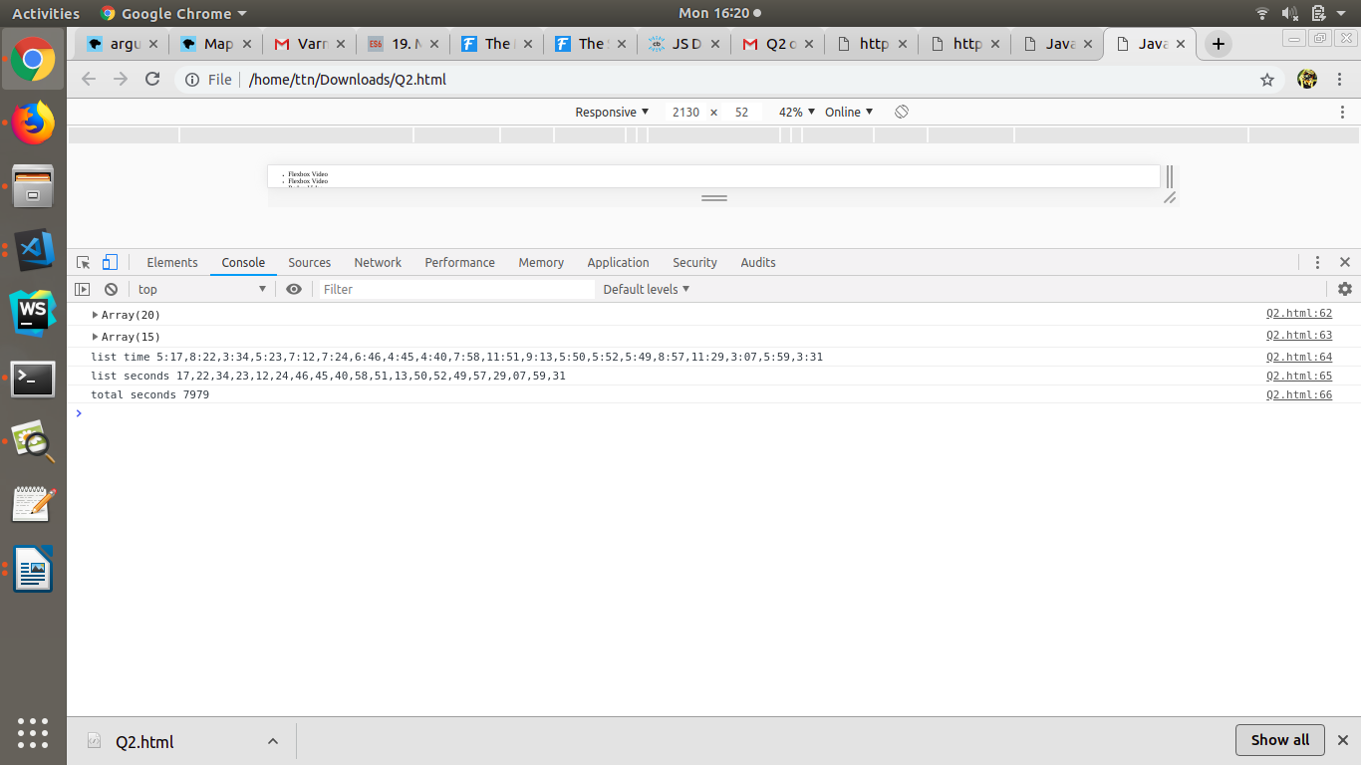

Q3. Create a markup template using string literal.

const song = {
name: 'Dying to live',
artist: 'Tupac',
featuring: 'Biggie Smalls'
};

Result:
"<div class="song">
<p>
Dying to live — Tupac
(Featuring Biggie Smalls)
</p>
</div>
“
ANS:
<html>
<head>
<style>
.song
{
background-color:pink
}
p
{
font-size:30px;
text-align:center;
}
</style>
</head>
<body>

<div class="song">
<p id="demo"></p>
</div>
<script>
const song = { name: 'Dying to live', artist: 'Tupac', featuring: 'Biggie Smalls' };

document.getElementById("demo").innerHTML = song.name + " - " + song.artist + "<br>" + "( Featuring " + song.featuring + ")";
</script>
</body>
</html>
OUTPUT
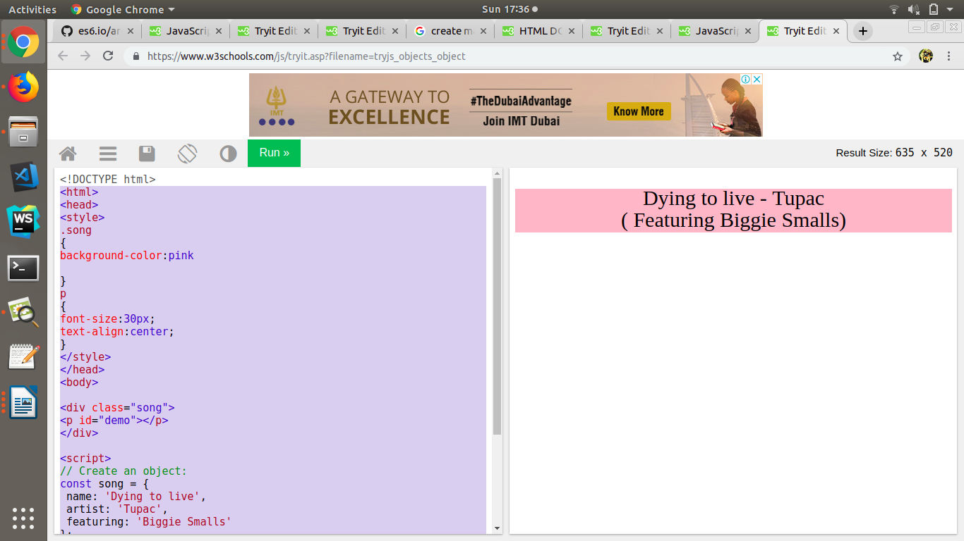

Q4. Extract all keys inside address object from user object using destructuring ?

const user = {
firstName: ‘Sahil’,
lastName: ‘Dua’,
Address: {
Line1: ‘address line 1’,
Line2: ‘address line 2’,
State: ‘Delhi’,
Pin: 110085,
Country: ‘India’,
City: ‘New Delhi’,
},
phoneNo: 9999999999
}

ANS:

<html>
<body>
<h2>Destructuring</h2>

<script>

const user={
firstName: 'Sahil',
lastName: 'Dua',
Address: {
Line1:'address line 1',
Line2:'address line 1',
State: 'Delhi',
Pin: 110085,
Country: 'India',
City: 'New Delhi'
},
phoneNo: 9999999999
};

const {Address: { Line1, Line2,State,Pin,Country,City}} = user;

document.write( "Line1: "+Line1 +"<br>"+ "Line2: " + Line2 + "<br>" +"State: " + State +"<br>"+ "Pin: " + Pin +"<br>"+ "Country: "+ Country +"<br>"+"City: "+ City );
</script>

</body>
</html>

OUTPUT

