- Filter unique array members using Set.
ANS:
<html>
<body>
<script>
var items = [1,2,3,4,22,1,2,45,34,22,3,4,2]
var uniqueItems = Array.from(new Set(items));
console.log(uniqueItems);
</script>
</body>
</html>
OUTPUT
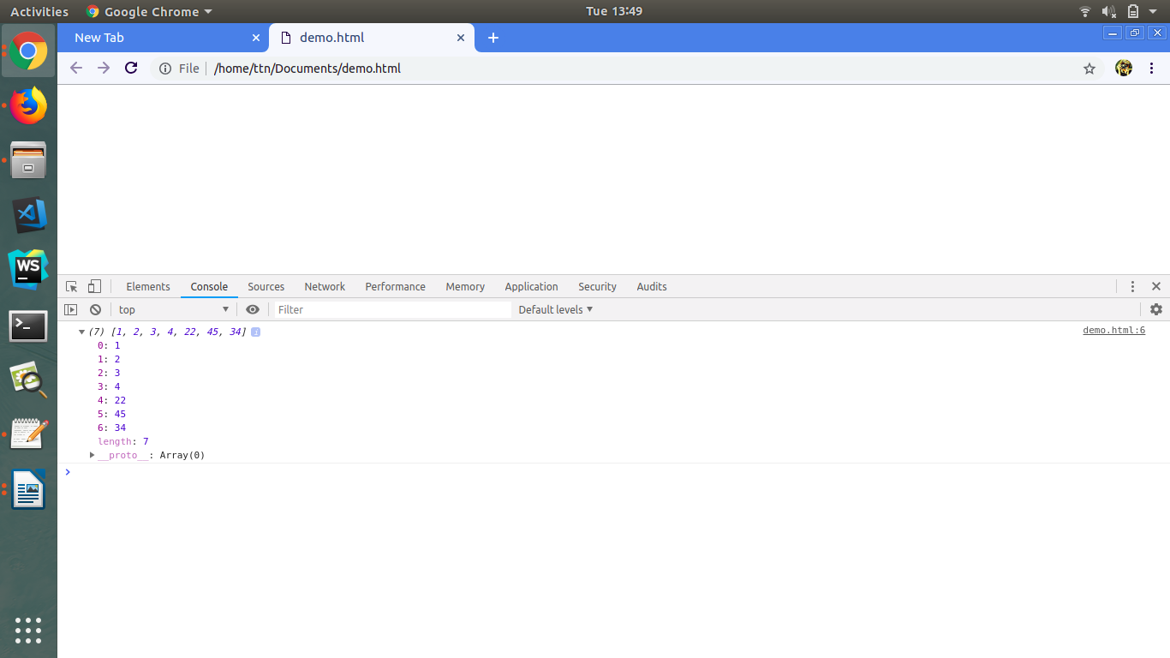

- Find the possible combinations of a string and store them in a MAP?
<!DOCTYPE html>
<html lang="en">
<head>
<meta charset="UTF-8">
<title>Title</title>
</head>
<body>
<script>
let map_index=0;
let findCombo=function combo(map,str,l,r){
if(l==r){
map_index++;
insertInToMap(map,map_index,str);
}
else{
for(let i=l; i<=r; i++){
str=swap(str,l,i);
combo(map,str, l+1, r);
str = swap(str,l,i);
}
}
}
let swap= function (a, i, j)
{ let strToArr=a.split('');
temp = strToArr[i];
strToArr[i] = strToArr[j];
strToArr[j] = temp;
return strToArr.join('');
}
let insertInToMap=function (map,key,value)
{
map.set(key,value);
}
//Testing function
let map=new Map();
findCombo(map,"abc",0 ,2);
console.log(map);
</script>
</body>
</html>
OUTPUT
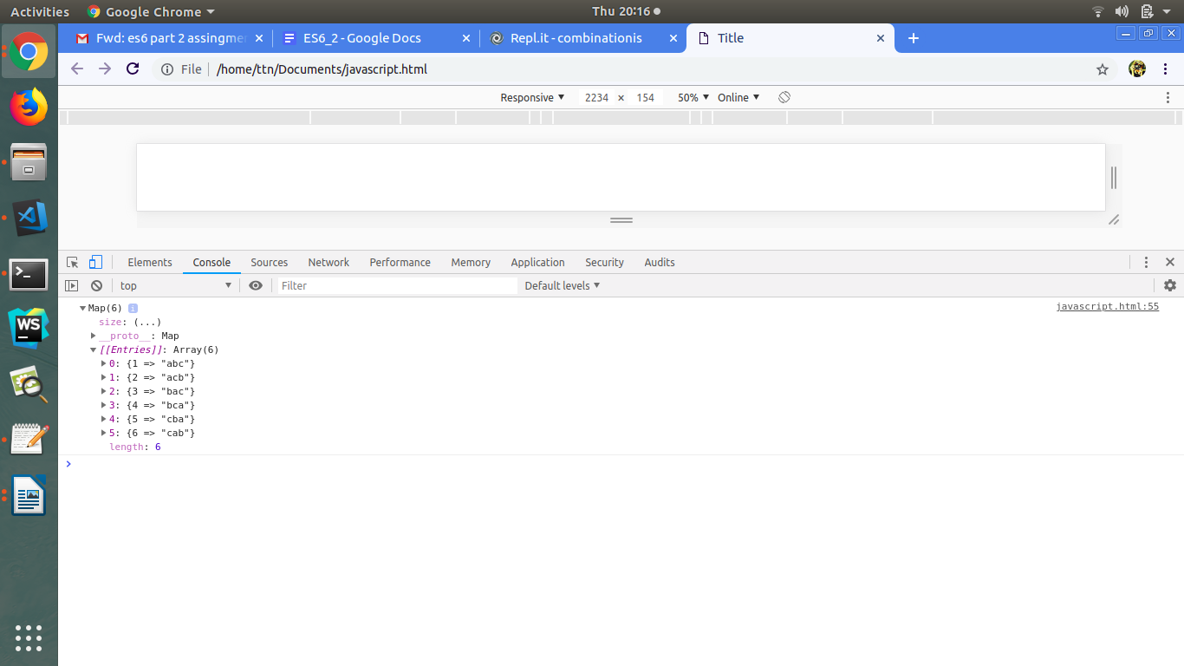

- Write a program to implement inheritance upto 3 classes.The Class must public variables and static functions.
<!DOCTYPE html>
<html lang="en">
<head>
<meta charset="UTF-8">
<title>Title</title>
</head>
<body>
<script >
class Person{
minAge=1;
constructor(name){
this.name=name;
}
static MaxAge(){
return 125;
}
}
class Employee extends Person{
constructor(name,salary){
super(name);
this.salary=salary;
}
}
class Developer extends Employee{
constructor(name,salary,competency){
super(name,salary);
this.competency=competency;
}
}
//Testing code
let dev=new Developer('john',2000,'MEAN');

console.log(dev);
//Testing static method
console.log(Person.MaxAge());
//Testing public variables
console.log(dev.minAge);
</script>
</body>
</html>

OUTPUT
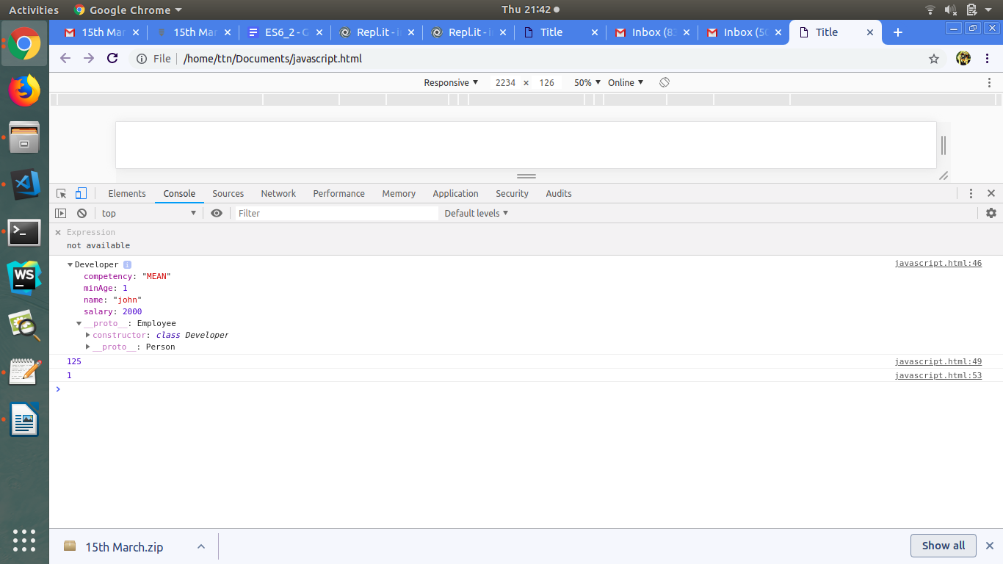

- Write a program to implement a class having static functions.
<!DOCTYPE html>
<html lang="en">
<head>
<meta charset="UTF-8">
<title>Title</title>
</head>
<body>
<script>
class Test{

f()
{ console.log("success");
}
static operation()
{
let a=20;
let b=20;
console.log("Multiplication of two no: " + a*b);
}
}
Test.operation();
var c=new Test();
c.f();
</script>
</body>
</html>
OUTPUT
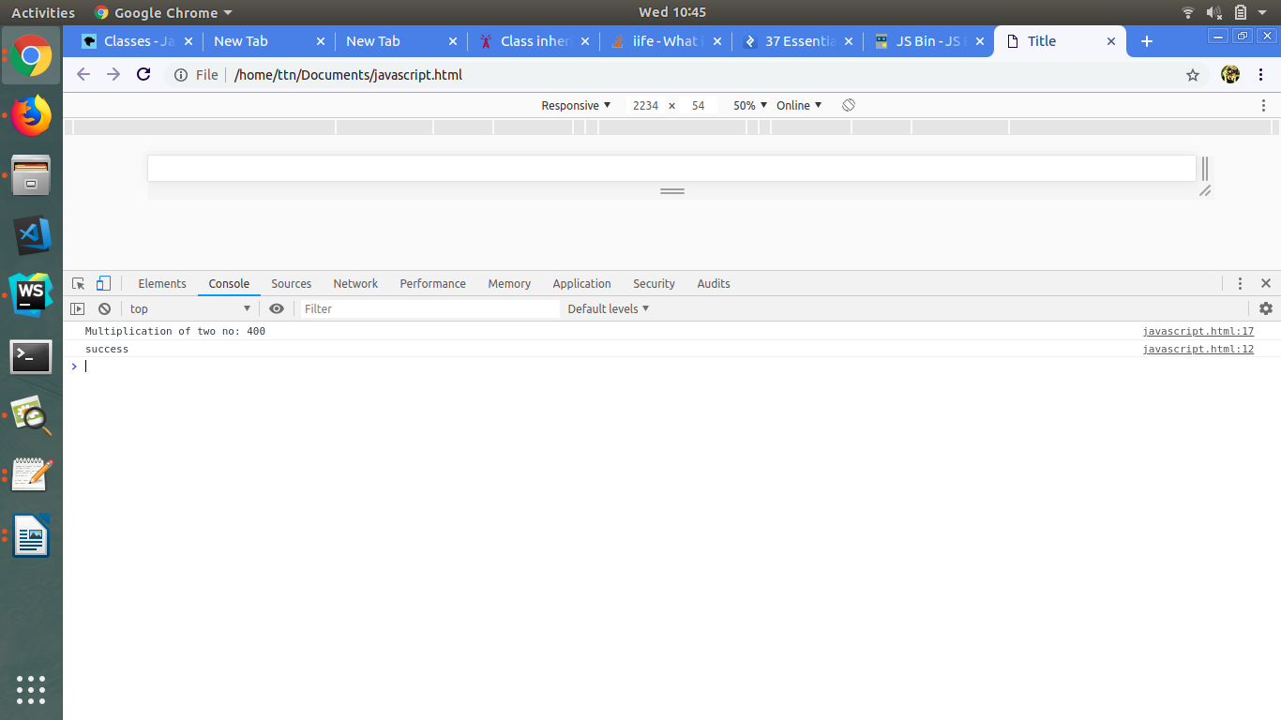

- Import a module containing the constants and method for calculating area of circle, rectangle, cylinder.
<!DOCTYPE html>
<html lang="en">
<head>
<meta charset="UTF-8">
<meta name="viewport" content="width=device-width, initial-scale=1.0">
<meta http-equiv="X-UA-Compatible" content="ie=edge">
<title>Document</title>
</head>
<body>
<center>
<h1>AREA OF THE FOLLOWING:</h1>
<p id="circle"></p>
<p id="rectangle"></p>
<p id="cylinder"></p>
</center>
<script type="text/javascript" src="ES6.js"></script>
</body>
</html>

----------------------------------------------------- ES6.js-------------------------------------------------
const pie = 3.14159
let circle = () =>
{
let radius = 3;
return pie * radius * radius;
}
let rectangle = () =>
{
let length = 5;
let breadth = 6;
return length * breadth;
}

let cylinder = () =>
{
let radius = 5;
let height = 7;
return 2 * pie * radius * (height + radius);
}
document.getElementById("circle").innerHTML = "Area of circle = " + circle();
document.getElementById("rectangle").innerHTML = "Area of rectangle = " + rectangle();
document.getElementById("cylinder").innerHTML = "Area of cylinder = " + cylinder();

OUTPUT
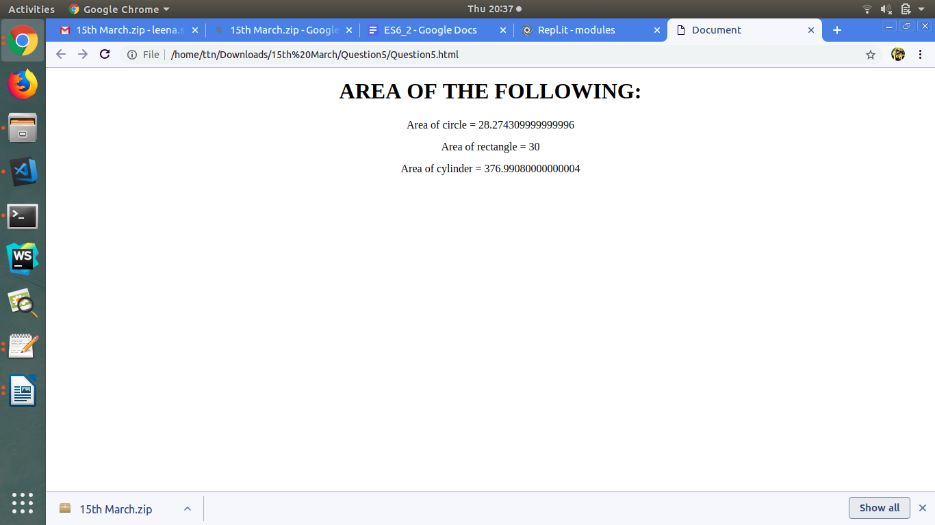

- Import a module for filtering unique elements in an array.
<!DOCTYPE html>
<html lang="en">
<head>
<meta charset="UTF-8">
<meta name="viewport" content="width=device-width, initial-scale=1.0">
<meta http-equiv="X-UA-Compatible" content="ie=edge">
<title>Document</title>
</head>
<body>
<center>
<h1>Filtering unique elements:</h1>
<p id="unique"></p>
</center>
<script type="text/javascript" src="ES6.js"></script>
</body>
</html>

------------------------------------------------ES6.js------------------------------------------------------------
let unique = () =>
{
var a = [2,5,5,7,3,9,8,9];
return [...new Set(a)];
}

document.getElementById("unique").innerHTML = "Original Array = [2,5,5,7,3,9,8,9] <br /> and Unique Array = " + unique();

OUTPUT
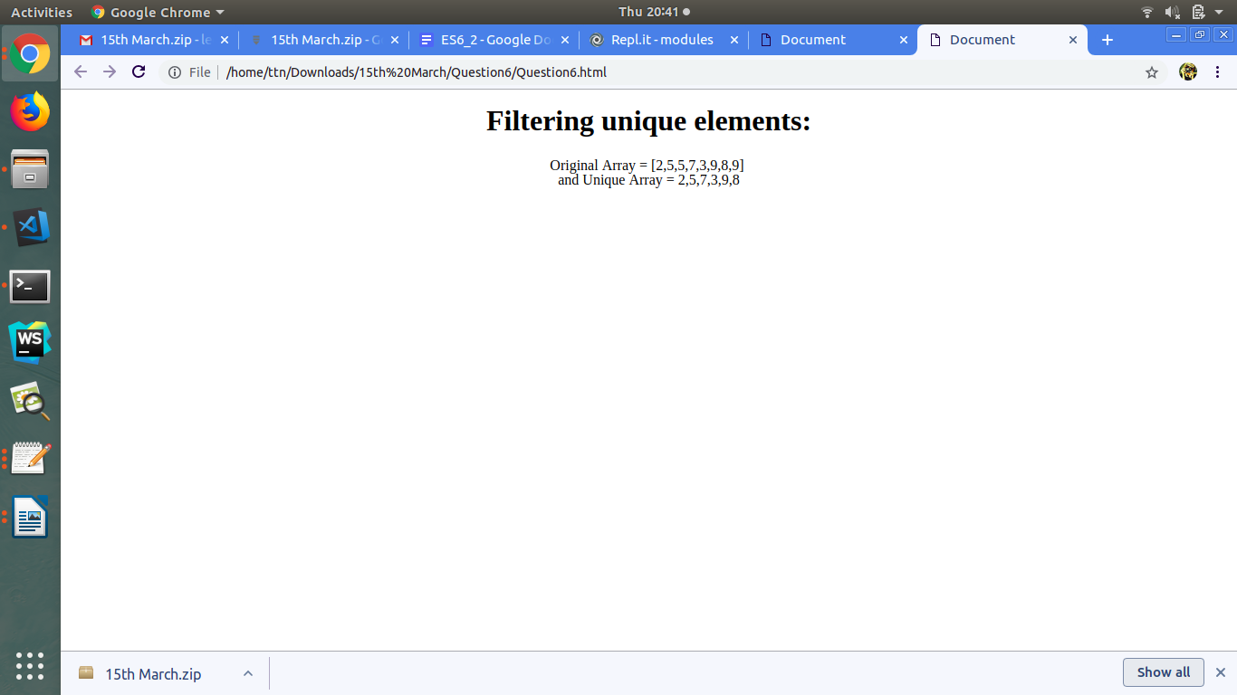

- Write a program to flatten a nested array to single level using arrow functions.
<!DOCTYPE html>
<html lang="en">
<head>
<meta charset="UTF-8">
<meta name="viewport" content="width=device-width, initial-scale=1.0">
<meta http-equiv="X-UA-Compatible" content="ie=edge">
<title>Document</title>
</head>
<body>

<script>
let flatten = (arr) =>
{
var array = [];
while(arr.length) {
var value = arr.shift();
if(Array.isArray(value)) {
// this line preserve the order
arr = value.concat(arr);
} else {
array.push(value);
}
}
return array;
}
console.log(flatten([1,2,3,[5,6,7,[4,5,6],7], 23,76, [45,67]]));
</script>
</body>
</html>

OUTPUT

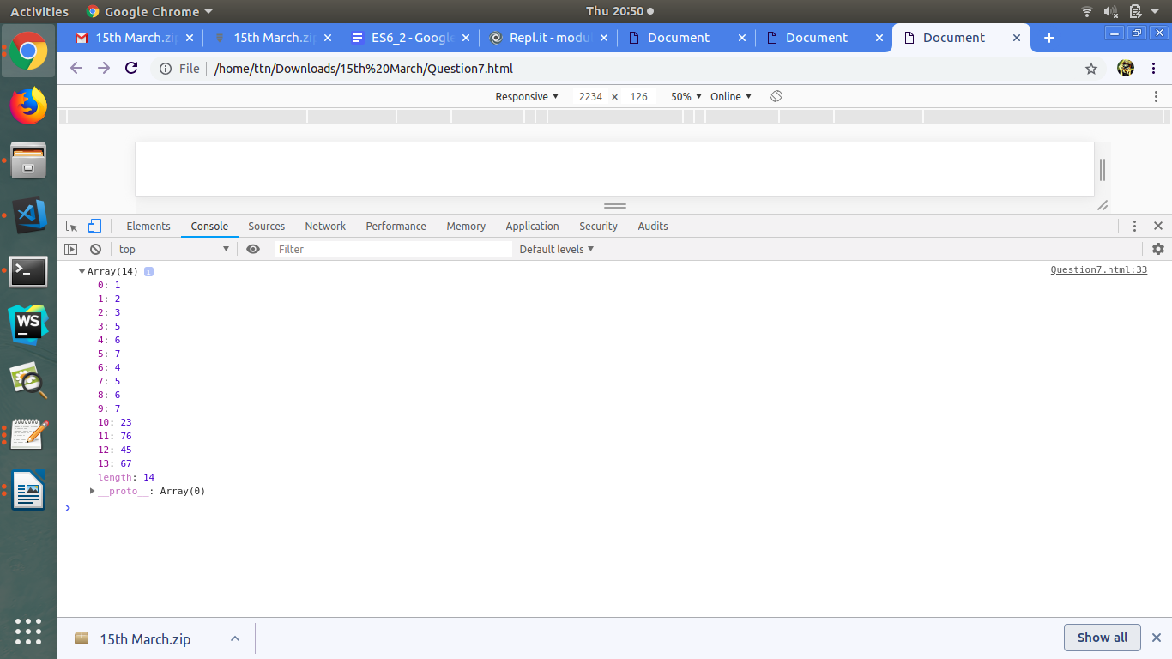

- Implement a linked list in es6 and implement addFirst() addLast(), length(), getFirst(), getLast().
<!DOCTYPE html>
<html lang="en">
<head>
<meta charset="UTF-8">
<title>Title</title>
</head>
<body>
<script >
class Node{
constructor(value){
this.data = value;
this.next = null;
}
}

class LinkedList{
constructor(value){
this.head = new Node(value);
this.tail = this.head;
// console.log(this.head);
// console.log(this.tail);
}

addFirst(value){
console.log(this.head);
let new_node = new Node(value);
new_node.next = this.head;
this.head = new_node;
console.log(this.head);
}
addLast(value){
let new_node = new Node(value);
this.tail.next = new_node;
this.tail = new_node;
}

length(){
let temp_head = this.head;
let length = 0;
while(temp_head.next != null){
length++;
temp_head = temp_head.next;
}
return length;
}

getFirst(){
return this.head;
}

getLast(){
return this.tail;
}

toString = () => {
let temp_head = this.head;
let str = '';
while(temp_head != null){
str += `${temp_head.data}`;
if(temp_head.next!=null){
str+=` ---> `
}
temp_head = temp_head.next;
}
return str;
}
}
let my_linkedList = new LinkedList(1);
my_linkedList.addFirst(2);
my_linkedList.addFirst(3);
my_linkedList.addFirst(4);
my_linkedList.addFirst(5);
my_linkedList.addFirst('START');
my_linkedList.addLast("END");
console.log(my_linkedList + '');
console.log(my_linkedList.getFirst());
console.log(my_linkedList.getLast());
</script>
</body>
</html>
OUTPUT

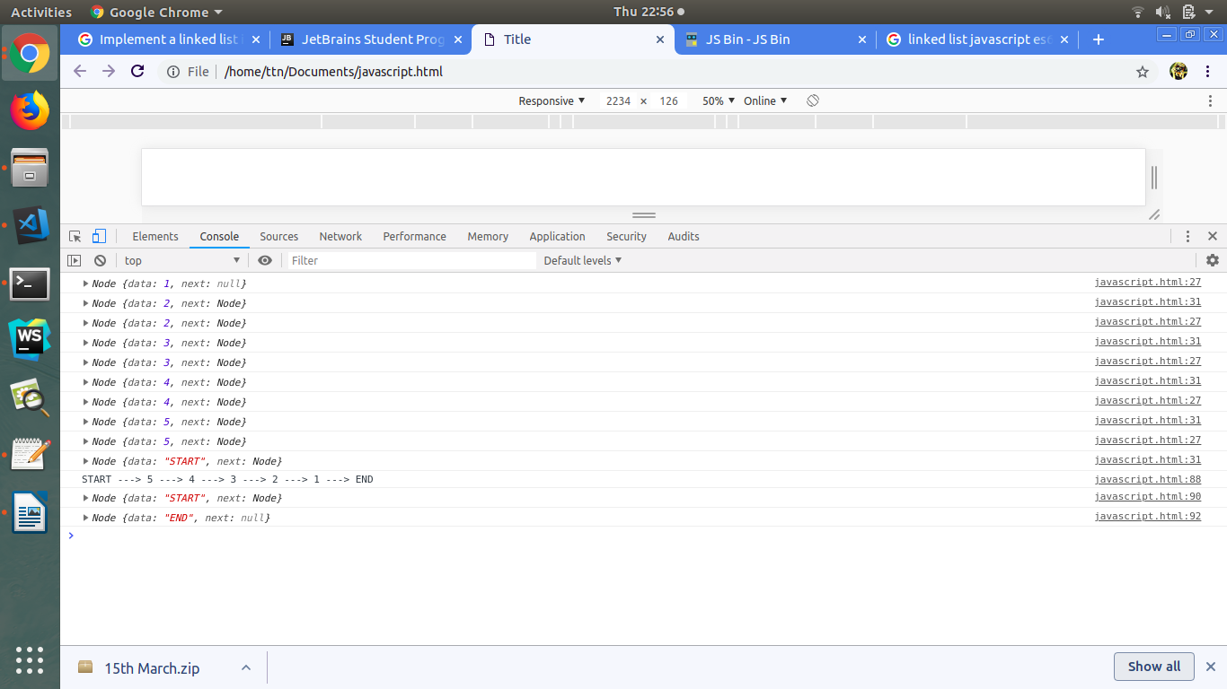

- Implement Map and Set using Es6?
<!DOCTYPE html>
<html lang="en">
<head>
<meta charset="UTF-8">
<meta name="viewport" content="width=device-width, initial-scale=1.0">
<meta http-equiv="X-UA-Compatible" content="ie=edge">
<title>Document</title>
</head>
<body>
<script>
var map = new Map();
map.set("First Name", "Leena");
map.set("Last Name", "Sharma");
map.set("Competency", "FEEN");
console.log(map);
</script>
</body>
</html>
OUTPUT

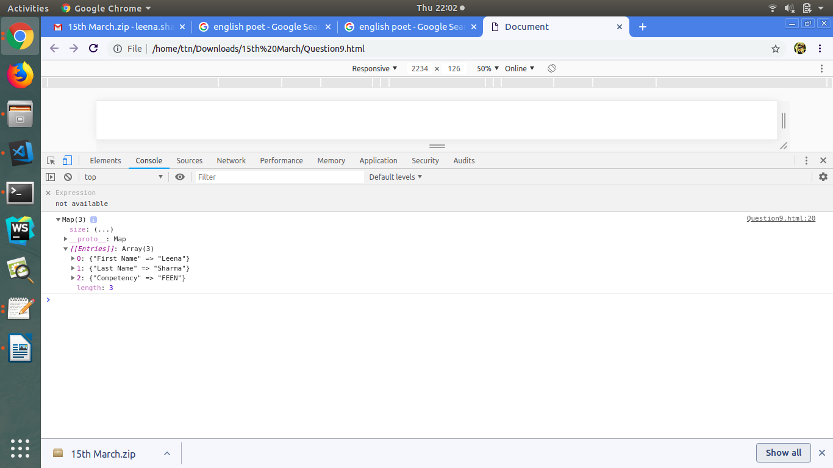

- Implementation of stack ?
<!DOCTYPE html>
<html lang="en">
<head>
<meta charset="UTF-8">
<meta name="viewport" content="width=device-width, initial-scale=1.0">
<meta http-equiv="X-UA-Compatible" content="ie=edge">
<title>Document</title>
</head>
<body>
<script>
class Stack {
constructor()
{
this.items = [];
}

push(element)
{
this.items.push(element);
}

pop()
{
if (this.items.length == 0)
return "Underflow";
else
return this.items.pop();
}

peek()
{
return this.items[this.items.length - 1];
}

printStack()
{
var str = "";
for (var i = 0; i < this.items.length; i++)
str += this.items[i] + " ";
return str;
}
}

var stack = new Stack();
stack.push(100);
stack.push(200);
stack.push(300);

console.log("Elements of stack are = " + stack.printStack());
console.log("Last element of stack = " + stack.peek());
console.log("Element removed = " + stack.pop());
console.log("Elements of stack after pop() operation = " + stack.printStack());

</script>
</body>
</html>

OUTPUT
