**Part C:**

1. **Pinging from h1 to h5**:

When we ping h5 from h1, packets from h1 travel through the switches s3, s2, s1, s5 and s6 in order.

The controller first gets the MAC and IP addresses of h1 and h5 in the following outputs:

host_tracker:Learned 3 1 00:00:00:00:00:01

host_tracker:Learned 3 1 00:00:00:00:00:01 got IP 10.0.0.1

host_tracker:Learned 6 1 00:00:00:00:00:05

host_tracker:Learned 6 1 00:00:00:00:00:05 got IP 10.0.0.5

Then the controller installs only flows necessary for the packet to travel from h1 to h5 via s3 -> s2 -> s1 -> s5 -> s6 and vice versa.

The forwarding.l2_learning logs only display source and destination matching MAC addresses and the input and output ports. There are 5 entries for flows required starting from h1 and 5 entries for flows required for travelling in the reverse direction for all the 5 switches in the path.

1. **RTT for first 5 pings**:

The first ping takes more time as it needs to send out an additional ARP request to figure out the MAC address of the destination host in the network, which is then stored in its ARP cache. Hence, the subsequent pings do not take a lot of time since there is no additional latency introduced due to ARP cache miss and the host already has the required MAC address.

1. **Flow table comparisons**:

Figure 1: s1 before ping

Figure 2: s3 before ping

All the flow tables for all switches before pinging contained two entries and both pointed towards the controller. This is the initial state of flow tables and shows that whenever the first packet arrives, it would be sent to the controller whose destination MAC address is stated in the flow table.

Figure 3: s1 after ping

After the ping, flow tables for all switches that the packet had passed through (namely, s1, s2, s3, s5, s6) were installed with required new entries for communication between hosts h1 and h5.

The match criteria in these flows is only dl_src (source MAC address) and dl_dst (destination MAC address) which shows that all the flows follow destination-based forwarding. In part-A, we had implemented a more general match plus action rule by matching over multiple fields and multiple actions were taken such as modifying source and destination MAC addresses along with changing the output port.

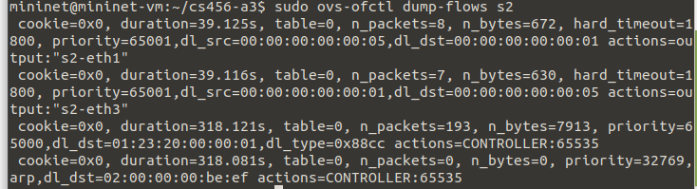

Figure 4: s2 after ping

Figure 5: s3 after ping

Figure 6: s5 after ping

Figure 7: s6 after ping

After the ping, switch 4 and 7 flow tables still do not have any new entries as the packet never had to pass through these switches from h5 was pinged from h1. So, no new entries have been installed by the controller.

Figure 8: s4 after ping

Figure 9: s7 after ping